**MUSE Basis of Estimate**

**Element WBS #6**

I. General Information

Task Name: Electronics

Unique ID Number

Date of Estimate: March 19, 2014 (last update)

Estimate Generator: E. Downie, R. Ransome

Cost Category:

X M&S

SWF

Comments:

Vendor Quote Number if Applicable_________________________

Drawing Reference Number or Attachment:

Costing Method: Quotes, given in BOE subdirector

Total Task Cost: $314,428

Total Contingency: $59,398

II. Cost Estimate Breakdown

Cost of each element, along with justification

Electronics will be bought in two batches. Numbers of each item are listed in table below.

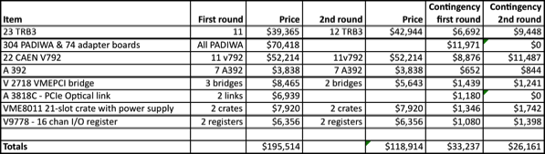

III. Contingency and risk analysis

For first year items, we add 5% for possible currency fluctuations, for a contingency of 17%. For second year items we use a 10% currency fluctuation, for a total of 22%.



