**Some rules and suggestions for writing lab reports.**

1. Use *MS Word* for text.

2. Add formulas or equations by using MS Word Equations (available for *.docx files), or by copy-pasting the example formula below into your report and editing it there:

(1)

3. In MS Word, you can insert Greek symbols. Do not just use “w” for ω, “p” for ρ, “phi” for ϕ, etc.

4. Use *Origin* for plotting data and analysis. It is ok to use *Excel* for some tasks, such as diagrams, statistical plots, histograms, etc.

5. In Origin, you can save plots as *.bmp, *.jpg, or *.png graphics files, so that they can be inserted to your *.docx report.

6. Label all axes and add units of physical quantities on your graphs, where those are necessary.

7. Insert your graphs, tables or formulas on the page, where they are actually discussed, if possible. It is better *not* to stack all of the data and plots to the back of the report.

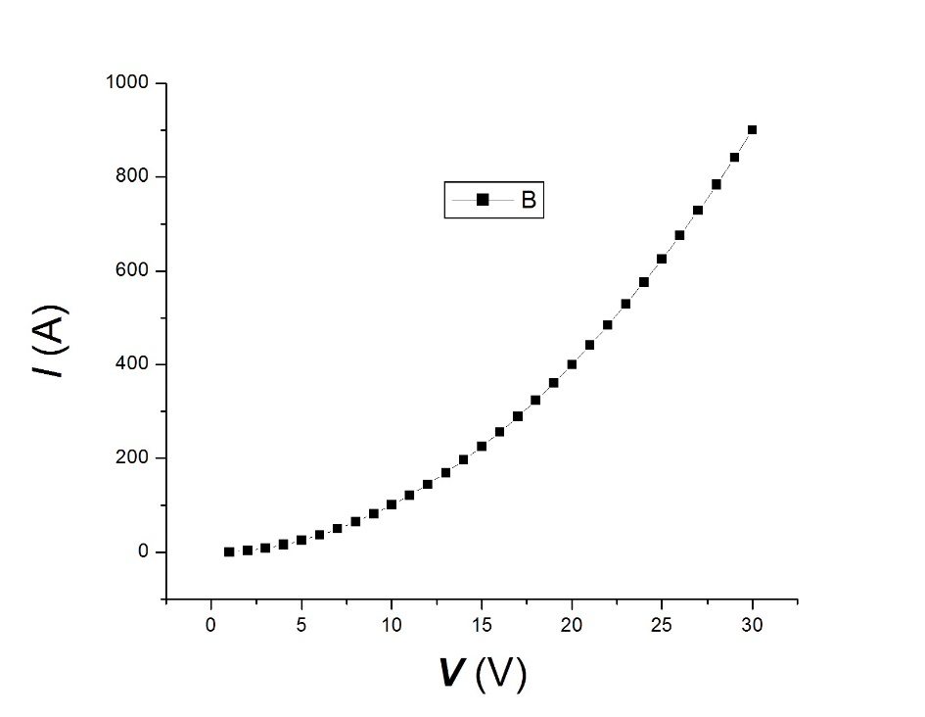

**Fig. 1.** Always add a figure caption that provides a concise but sufficient description of what is shown.

8. Each lab report should have a short *Introduction* (one paragraph) describing the purpose of the lab and basic ideas. Do not just copy the lab description or manual into your report. A good strategy is to (a) read the lab manual carefully, (b) understand it, and (c) describe the essence in your own words in a single paragraph.

9. You can copy circuit diagrams into your report from the lab manual (downloadable at the course page in Canvas) or draw them in any software you prefer.

10. After the introduction, there must be an *Experimental* section, where you show the data you obtained and analyze them. All the tables, plots, calculations etc should be in this section.

11. Then, please include a brief *Conclusion*.

12. Please do not forget to include: (a) your *Name*, (b) the *date*, and (c) the *title* of the lab on top of the front page of the report.

13. Each lab partner must hand in their own individual report. Only raw data can be shared by partners. Do not copy reports from your partners.

14. The report is due at the day we start working on the next lab.

15. Grading the labs.

Max. grade is 15 pts. Things that could result in a lower grade:

1. Missing parts of a lab or unanswered questions;

2. Missing units;

3. Missing axes labels on plots;

4. Not properly rounded numerical answers;

5. Failure to submit the report on time;

6. Missing raw data (actual measurements);

7. Unclear or messy reports.

16. The attendance of the labs will be taken down*.* You have to actually attend the lab class to complete the lab. You are not allowed to write your report based on borrowed data. If you have to miss a lab, please arrange going to another section the same week to join someone and actually do the lab.