**Some rules and suggestions for writing literate lab reports.**

1. Using *MS Word* for text is recommended.

2. You can add formulas or equations either by handwriting them or via copy&paste. Ideally, you would learn to use the Equation function in MS Word. For instance:

. (1)

3. In MS Word, you can insert Greek symbols. Please avoid using non-Greek symbols as a replacement (such as w for ω, or p for ρ, etc).

4. Use *Origin* software for plotting your data and analysis. It is ok to use *Excel* for some tasks, such as diagrams, histograms, etc, but Origin is preferred for scientific work.

5. In Origin, you can save plots as *.bmp or *.jpg files, so that they can be later inserted to your *.doc lab report.

6. Label the axes and add units on your graphs where necessary (see example below in Fig. 1).

7. Try inserting your graphs, tables or formulas on the page, where they are actually discussed, if possible. It is better not to stack all of the data and plots to the back of your report.

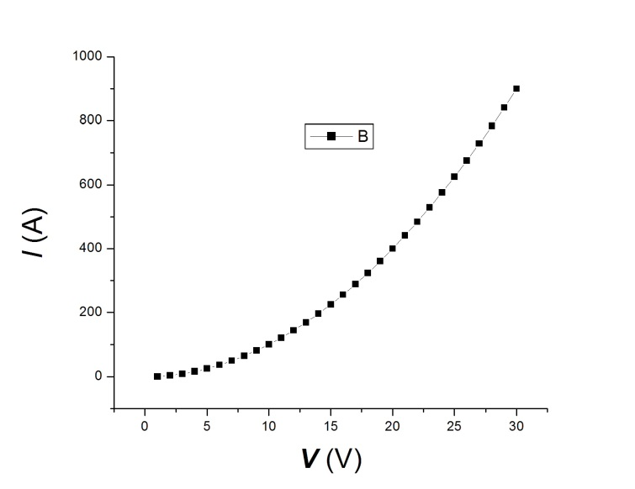

**Fig. 1.** The current flowing through a resistor measured as a function of applied voltage. The experiment was performed at room temperature.

8. Each lab report should have a short *Introduction* (one paragraph) describing the purpose of the lab and basic ideas. Do not just copy the lab description or manual into your report. A good strategy is to (a) read the lab manual carefully, (b) understand it, and (c) describe the essence in your own words in a single paragraph.

9. You can copy circuit diagrams into your report from the lab description (downloadable at the course web page) or draw them by hand.

10. After the introduction, there must be an *Experimental* section, where you show the data you obtained and analyze them. All the tables, plots, calculations etc should be in this section.

11. Then, please include a brief *Conclusion*.

12. Please do not forget to include: (a) your *Name*, (b) the *date*, and (c) the *title* and the *number* of the lab on top of the front page.

13. Each student must submit his/her own individual report. Do not just copy reports from your classmates.

14. The report is due at the due date specified on the course’s webpage.

15. Grading the labs.

Max. grade is 15 pts. Things that could result in a lower grade:

1. Missing parts of the lab or unanswered questions;

2. Missing units;

3. Missing axes labels on the plots;

4. Not appropriately rounded numbers;

5. Failure to submit the report on time;

6. Missing raw data (your actual measurements);

7. Unclear or messy reports;

8. Wrong data analysis leading to incorrect conclusions.