Using the HEASARC Archive and FTOOLS:
Analysis of GK Per Data from ROSAT

This tutorial is designed to build upon your current knowledge of FTOOLS and to give you further experience with its wide range of capabilities. It is thus strongly recommended that you complete the main tutorial, FTOOLS for Windows 95/98/NT, before beginning this tutorial, as this tutorial will be difficult to understand without the background that FTOOLS for Windows 95/98/NT provides. For troubleshooting, check out the Troubleshooting Guide located both at the end of this tutorial and on the FTOOLS webpage. It contains useful tips, known problem areas, and solutions to common questions. In addition, the words highlighted in blue throughout this tutorial can be found, along with many other terms, in the glossary compiled by the Chandra X-ray Observatory Center. Just go to http://chandra.harvard.edu/resources/glossaryA.html.
The source you will be examining in this tutorial is GK Per, also known as The Firework Nebula. As its name suggests, GK Per is the result of a nova—an explosion, as NASA’s Robert Nemiroff explains, in which “a very compact star called a white dwarf blasts away gas that has accumulated on its surface. In this case, the nova occurred in the year 1901 and is called Nova Persei 1901. This nova became as bright as one of the brighter stars we see in the night sky, but then faded until only a telescope could see it. Soon astronomers could see an expanding shell of gas that eventually became this spectacular nebula.” The data you will be analyzing this time was gathered by the Roentgen-Satellit, or ROSAT. ROSAT, a German-led endeavor also involving the UK and US, was designed to perform the first deep survey of the entire sky in soft X-rays (0.1-2keV) and the EUV (extreme ultraviolet, 60-300 Angstroms).

I. Preparing Data Files for Analysis

- To begin, open and minimize your X-Server, and open FTOOLS (your BASH window). Using the commands you’ve learned, create a directory in FTOOLS called gkper. (NOTE: If you have already completed the EXOSAT tutorial, creating a gkper folder here is unnecessary, as you already have one.)

- Now, open Netscape and go to the HEASARC web page by typing http://heasarc.gsfc.nasa.gov in the ‘Location’ entry field.

- Once the HEASARC home page is finished loading, click on Data Archive at the top of the page.

- Click on the Browse archive in the yellow bar on the left side of the screen.

- Select the Basic option.

- Select ROSAT under Past Mission Archives (by clicking on the small box to its left). Then type gk per in the Object Name or Coordinates field back at the top of the page.

- Click Submit Query.

- In the ROSAT Archival Data (HEASARC ROSPUBLIC) table, select the second observation whose instrument is the PSPCB.

- Click on the Submit button to the right of the Categories of data products available for HEASARC_ROSPUBLIC box. (You may receive a security warning message from Netscape: just click Continue.)

- This page displays all of the possible data that can be examined from the observation you chose and based on the criteria you entered. Select the Basic Science Events file by clicking on the small box to its left (NOT by clicking on the filename). Note that the filename, rp300217n00_bas.fits.Z, has a .fits.Z extension. What does this indicate?

- Finally, click on Retrieve Data Products.

- The screen that appears should list the pathname of the file you chose. Click on Download TAR file which appears right below the filenames. A warning window will pop up. Its purpose is just to warn you about security considerations when downloading. Make sure that ‘Save it to disk’ and ‘Always ask before opening this type of file’ are selected. Then click ‘OK’. Now, a window entitled ‘Save As’ will appear. Just like in the last tutorial, make sure it says [C:] (or whatever the letter is of the drive in which your FTOOLS package is stored), and then find and double-click on your gkper folder in the list of file folders below ‘Save in’. Click ‘Save’.

- As you know from the previous tutorial, it is now necessary to untar and uncompress the file you’ve downloaded. Minimize Netscape and go back to your BASH window. At the prompt, use the commands you know to reach your gkper directory. Typing pwd should return /c/ftools/gkper. Now use ls to look at the contents of your gkper folder. It should contain the file ‘w3browse-<nnn…>.tar’.

- Just as you did before, type tar –xvf w3browse-<nnn…>.tar (replacing <nnn…> with the correct numbers, of course). The following pathname will be returned to you: rp300217n00/rp300217n00_bas.fits.Z. (Note: you may also receive a warning message concerning an “unexpected EOF on archive file.” If this occurs, go back and try the download process again to get a different .tar file.)

- Recall that in order to decompress a file, you must get to the directory in which it is located. Looking at the pathname of the file indicates that you now need to type cd rp300217n00. Subsequently typing ls should return rp300217n00_bas.fits.Z.

- Time to decompress the file. After doing this (using the gunzip command you learned in the FTOOLS for Windows tutorial), typing ls should display for you the GK Per data file rp300217n00_bas.fits, ready for analysis. The final step: go back and delete the .tar file.

II. Light Curve, Energy Spectra and Image Analysis Using Xselect and SAOIMAGE

- To examine light curves, power spectra and other images of your ROSAT dataset, you will be using the xselect subprogram that you are familiar with from the FTOOLS for Windows tutorial. You may want to take a minute now to go back and review the various commands you may use in the xselect environment. When you are finished, go to your BASH window and make sure that you are in the directory /c/ftools/gkper/rp300217n00. Then type xselect at the prompt. After loading, FTOOLS will step you through the inputs to xselect. As you may remember from your previous exercises, the inputs are as follows: session name, event file directory, event file list

- You will first be prompted for a session name. Call you session session1.

- Notice that the information that subsequently appears on the screen is specific for ASCA – a different satellite. This will need to be changed, since you are analyzing ROSAT data. At the next prompt (session1:ASCA >), type read events. You will be asked for the ‘Event file directory’, the directory where your data file exists. Since you called xselect from the directory where your data file exists, you can type ‘./’ (which means current directory).

- Next, you will be asked for an ‘Event file list’. Enter the name of your file, rp300217n00_bas.fits.

- xselect now realizes that you are using ROSAT, not ASCA. You will be asked if you would like to reset the mission. Enter yes.

- The data that appears on your screen describes how the program is now configured to handle your data. It also prints the directory where your data is located. Finally, the program outputs information about your object, GK Per, including its position in the sky, the livetime (how long the detector was taking data on this object), and the date of observation. At this point, your screen should look like Figure 1.

- Next, you want to actually look at an image of GK Per. At the prompt, type extract image. Again, xselect prints out information on the screen (Figure 2). The important facts are the seconds and the counts that provide a count-rate for the image. A high count-rate means the object was giving off photons at a high rate and will therefore be bright. A very low count-rate implies a faint image, or no image at all (just noise).

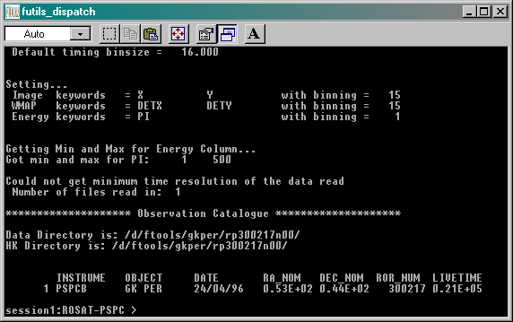
Figure 1: Data output by xselect after configuration for your data set is completed

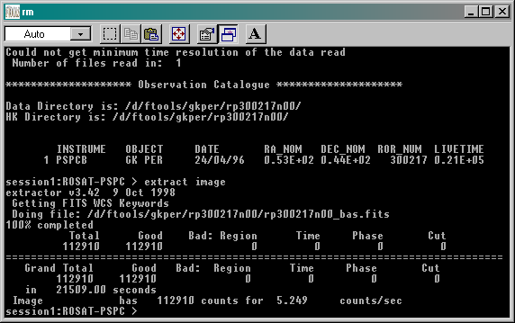

Figure 2: Output resulting from entering extract image into xselect

Image Analysis with DS9

Now that the image has been extracted from the data, you need an imaging tool to view it. This section of the tutorial is incomplete. The tool you will be using, DS9, is not yet complete, and will be made available to you as soon as possible. Announcements about new versions of the FTOOLS tutorials, complete with DS9, will be posted on the webpage, so please check it frequently. Thanks so much for your patience. For the time being, please skip to the next section.

Examining Lightcurves

- You will now use the extract command to make a light curve of your observation. Make sure you are at the xselect prompt, session1:ROSAT-PSPC>. Then type extract curve.

- Next you must set a program device upon which your light curve can be plotted. Type set device /XW. Once you receive the xselect prompt again, plot your curve by typing plot curve.

- Upon maximizing your X-Server, you will notice that all of your data is in the center of the plot and a curve or spectrum is hard to make out. Also, notice that at the top of your plot you are told that the binsize is 16.000s. This means that the total livetime has been divided into 16-second intervals and plotted accordingly. Back in your xselect environment, your prompt has changed from session1:ROSAT-PSPC> to PLT>. This means you are in an interactive mode with the plot window: commands you give the screen will be received by the plot window. (See the FTOOLS for Windows tutorial for more information on commands for the PLT> environment.)

- The next thing you might want to do is reset the x- and y-axes to zoom in on part of the light curve. Try typing rescale x 4e5 6e5. You’ll see in your plot that this displays the data points across more of the screen. You can zoom in even more by typing rescale x 4.8e5 5.5e5. (To rescale the y-axis, you would replace the x with a y.) Finally, type exit to return to the xselect environment.

- It is useful to be able to define a region of interest from your image and extract the events from that region. Since you already extracted the light curve, you can define a time interval through which you can filter the data. Type filter time cursor. You will receive some general instructions on how to utilize filters. Again, you will enter PLT> mode. The first thing to do is to enter quit as you are told to do on the screen. Then in the plot itself, click to the right of the curve (around x = 5.5e5) and to the left of the curve (around x = 4.8e5). A horizontal line should have connected your clicks. Now type x while still in the plot window, to exit this mode. (Note: Do not attempt to try the other commands that appear in the instructions on your screen unless you have plenty of time to “play around”. One can get tangled up very quickly while in this mode. The instructions above will be sufficient for our purposes right now.)

- Minimize your X-Server. Back at the prompt, type show status to see that the file of time selections was added to the filters. It also shows what you have done so far under PRODUCTS. (It should say that a curve has been accumulated.)

- Type extract curve since now there has been a filter applied to it. The type plot curve. You now have a light curve like that in Figure 3. You can rescale this curve as you did before. Typing rescale with no argument will return the original curve.

- Finally, you might want to make a hardcopy (printout) of your light curve. To create a postscript file that can be printed, type hardcopy /PS at the PLT> prompt. This will make a postscript file (a file with extension .ps) in your current directory that you can later print out using Ghostview.

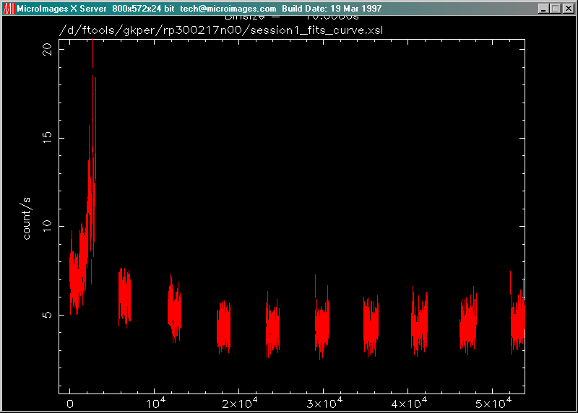
Figure 3: Light curve for GK Per after applying a filter

Extracting an Energy Spectrum from the Light Curve

- To further analyze the light curve you extracted, it is useful to make an energy spectrum. An energy spectrum tells you the intensity of the radiation as a function of energy. By looking at the shape of this energy spectrum, we can tell a lot more about the nature of the processes that give rise to the x-rays that we see. Type exit to return to the xselect environment. At the xselect prompt, type extract spectrum. Wait for the next prompt and then type plot spectrum. Upon maximizing the X-Server, you’ll see a plot of COUNTS vs. CHANNEL.

- When you are finished, type exit at the PLT> prompt to leave the pgplot environment, and then type exit again to terminate xselect. Save the session so that all of the images, curves and spectra remain in your directory as independent files that you can go back to, manipulate and study to learn more about GK Per.

III. Troubleshooting

This section contains some common problems that may be encountered when using the FTOOLS package and tutorials and also some known bugs in the software.

- Some of the FTOOLS functions will not work if you are using Windows 95. Windows 98 or NT is required to maximize FTOOLS’ capabilites.

- In order for FTOOLS to work, you must have the X-Server running. Thus, before beginning each section, double click on the Microimages X-Server icon on your desk top to open the X-Server window, and then click on the ‘-‘ in the upper right hand corner of the window to minimize it.

- The first time you use the X-Server in each session, (by employing lcurve, xselect, powspec or fplot), you may get a box that pops up with an error message that says “This program has performed an illegal function and will be shut down…” Just hit ‘OK’. The program will not be shut down. You may also get a message in your BASH window that says “To plot vs. Time(s) , please enter PGPLOT file/type:” Enter /xw (even if you already entered that earlier when you were prompted for a device), and the program should then proceed correctly, plotting the graph in your X-Server window and providing you with a PLT> prompt.

- In order to analyze a data set, you must be in the directory in which that file is located. Anytime you get a message saying something like “file not found”, chances are, you’re in the wrong directory. Likewise, if you would like to access a directory, like gkper for example, and you are in another directory outside of gkper, like amher or cygx-1, you must go back up to the parent directory, ftools, before you can type cd gkper. The directory gkper is located in ftools, not in amher or cygx-1: amher and cygx-1 are other subdirectories of ftools.

- If, during the untarring and decompression process, you receive a message in the BASH window about and “EOF exception”, go back and download the data again to get a different .tar file. This error may indicate that there is something wrong with the data.

- Filenames are NOT case sensitive under Cygwin BASH. Also important to note, the command cd IS case sensitive: thus the command CD gkper will not be recognized.

- Cygwin BASH is unstable under Windows 95/98 when running large and complex shell scripts. Particularly, after the FTOOLS hard disk version performs its additional setup steps when being run for the first time, you may find that some commands do not work, or that commands are echoed on a separate line before being executed. Currently, the only solution is to exit from FTOOLS and restart. In severe cases, Cygwin BASH may cause the computer to lock up, in which case you’ll have to reboot your computer.

- FTOOLS plotting using the X Windows driver does not work under Windows 95. For FTOOLS installed to run off a CD-ROM under Windows 98, plotting using the X Windows driver also does not work, but plotting does work under Windows 98 when FTOOLS is installed to run off a hard disk. Plotting works in all cases under Windows NT.

- The Windows version of fv can only print line plots. Any images in a graph being printed will be ignored.

