Using FTOOLS and ds9 for
Data Analysis: Chandra

This tutorial is designed to build upon your current knowledge of FTOOLS and to also provide an introduction to the imaging program ds9. It is strongly recommended that you complete the main tutorial, FTOOLS for Windows 95/98/NT, before beginning this tutorial, as this tutorial will be difficult to understand without the background that FTOOLS for Windows 95/98/NT provides. For troubleshooting, check out the Troubleshooting Guide located both at the end of this tutorial and on the FTOOLS webpage. It contains useful tips, known problem areas, and solutions to common questions. In addition, the words highlighted in blue throughout this tutorial can be found, along with many other terms, in the glossary compiled by the Chandra X-ray Observatory Center. Just go to http://chandra.harvard.edu/resources/glossaryA.html.
The tutorial is separated into three main sections. In the Part I, we will be using FTOOLS and ds9 to examine Quasar 3c273. In Part II, we will analyze the jet associated with this source. Finally, in Part III, we will use what we have learned to study the x-ray source Cassiopeia A.
Quasar is short for Quasi-stellar radio source. Quasars emit massive amounts of radio energy; they are the most distant and energetic objects that can be observed with our current instrumentation. However, while some quasars are brighter than many galaxies put together, others are smaller than our own Milky Way galaxy. 3c273 is of particular significance because it was one of the first quasars to be identified. It’s name comes from its identification in the 3rd Cambridge catalog as the 273rd radio source identified. It lies approximately 3 billion light-years away, and at 5 trillion times the brightness of the sun, 3c273 is the brightest quasar known. (Check out http://chandra.harvard.edu/xray_sources/3c273/3c273_2.html for more information on the unique importance of 3c273 to astronomers. You’ll find optical and x-ray images, too!)

Part I: Compiling Light Curves and Spectra

- Double click on the FTOOLS icon to setup the FTOOLS environment. Once the BASH window is ready and you have been given a prompt, create a folder for your 3c273 data by typing mkdir 3c273. (Make sure that you are in the general FTOOLS directory before you do this.)

- Open Netscape and go to http://asc.harvard.edu.

- At the top of the page, you’ll see various buttons: click on the one that says Archive.

- A page will open that says “Welcome to the Chandra Data Archive”. You’ll see a list of links: click on Search and Retrieve.

- The next page will be “Search and Retrieval from the Chandra Data Archive”. If you scroll down the page a bit, you will see Provisional Web Interface for Browsing and Retrieval in blue. Click on this link.

- You have now entered the Chandra Data Archive. Scroll down to “View Information About Public Observations Available for Retrieval from the Archive…”. Below this heading there will be four buttons. Click on Sort by RA & Dec.

- Upon scrolling down the next page, you’ll see a long table of observations. Find the observation whose ObsId is 1711, whose Object Name is 3C 273, and whose RA (right ascension) is 12:29:07. Click on 1711.

- You’ll then be returned to the Chandra Data Archive page that you were at earlier. This time, however, if you scroll down, you’ll see that 1711 has been entered into the Enter ObsId box. Scroll down a little bit more and make sure that the fully processed science products box is checked, inside the Product Categories box. Click on Browse Archive and Retrieve Data Products.

- You will receive a list of four files. Upon scrolling down further, you’ll see the instructions “Select files to retrieve from archive”. In the white box below, click on the first file, hold down the shift key, and then click on the fourth file. This will allow you to select all four files. With all four files selected, click on RETRIEVE from Archive.

- The next page will give you the name of your tar file. After copying this filename down for future reference, find the sentence that says “Or you may download it directly here”. Click on here.

- A window will appear which asks you whether you’d like to save the file to disk or open it. Select Save to disk and then click OK.

- Next, a window entitled “Save As…” will open. In the File name: field, the name of your tar file will already be entered. In the Save in: field, make sure that you are saving the tar file into your 3c273 folder. Once this is done, click Save.

- Minimize Netscape and then return to your BASH window.

- At the prompt, use the commands you know to enter the 3c273 directory. Once you are in this directory, type ls to view its contents. You will see the file you downloaded. (It should look something like retrieve_1711_26079.tar, but the last five numbers may be different.)

- Type tar xvf <filename.tar>, replacing <filename.tar> with the name of the file you downloaded. This will untar the data and save it into the directory 3c273.
- When the untarring is complete, a directory structure similar to the one above will have been created. (Directories are shown in boxes, and filenames are in ovals.) The last step is to gunzip the files. We are only concerned with acisf01711N001_evt2.fits.gz for now, so get into the ‘primary’ directory by typing cd primary. Then type gunzip acisf01711N001_evt2.fits.gz to gunzip the file.

- Once you are given a prompt again, type ls. You should see three files, one of which is acisf01711N001_evt2.fits. This file is now ready for analysis.

- At the BASH prompt, type f2dhisto acisf01711N001_evt2.fits. You will be asked for a variety of information:

- Name of output FITS file []: firstout (make sure that this filename does not already exist.
- X BINSIZE [INDEF]: 4
- Y BINSIZE [INDEF]: 4
- Name of x column to generate histogram [X]: X
- Name of y column to generate histogram [Y]: Y
- Enter the X-RANGE(Eg: 10.0,20.0)[INDEF,INDEF]: 3000.0,6000.0
- Enter the Y-RANGE(Eg: 10.0,20.0)[INDEF,INDEF]: 3000.0,6000.0

(‘Binsize’ refers to the shrinking of the data into something like a summary of its original form. In an image, every place that a photon ends up represents one spot in the sky. By ‘binning’ the data in 4’s, you are averaging 4 adjacent sky positions (or a total of 16 points) at a time, as in the following diagram. The X-RANGE and Y-RANGE represent the area in which almost all of the parts of the usable image are located.)

- FTOOLS will state a summary of what you entered and then return the BASH prompt. At this point, find the ds9 icon on your desktop and double-click on it.
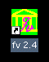
- The ds9 window will open. Select the ‘file’ menu and select ‘open’. You want to find the output file you just created, firstout. Double-click on 3c273/, then on primary/. You should then see four filenames, one of which is firstout. Click on firstout, and then click on the ‘ok’ button.

- The ds9 window will display your image. Move the window so that it is as close to the top of your screen as possible. Then, select the ‘zoom’ button, and select ‘4’. You’ll see the blue box around the picture in the upper right hand corner get smaller. Click on the blue box and drag it so that it is centered on the image. (The image should look something like a small blob right now.)

- Place the cursor (without clicking) on the center of the circular part of the image. Look at the box in the upper left hand corner, labeled ‘Image Pixel’. It should contain numbers close to ( 278, 236 ). Copy down these numbers on a piece of paper and then close all of the ds9 windows.

- Back in your BASH terminal, type f2dhisto <filename>, and again replace <filename> with acisf01711N001_evt2.fits.

- You will be prompted for the same information as before, except this time your answers will be slightly different:

- Name of output FITS file[firstout]: output2 (Again, make sure that this file name doesn’t already exist.)
- X BINSIZE [4]: 1
- Y BINSIZE [4]: 1
- Name of x column to generate histogram [X]: X
- Name of y column to generate histogram [Y]: Y

- X-RANGE and Y-RANGE: For this information, you need to do some calculations. For the X-RANGE, you must first correct for the binsize of 4 from earlier. To do this, multiple the X value from your ‘Image Pixel’ coordinates (~278) by 4. Add this number to your initial starting value for X, 3000. This should give you a number similar to 4112. Your X-RANGE needs to encompass about 100 on either side of this number. Thus, enter 4000.0,4200.0 for the X-RANGE.
For the Y-RANGE, follow the same process. Multiply the Y value from your ‘Image Pixel’ coordinates (~236) by 4 and then add this to your initial starting value for Y, 3000. This should give you a number close to 3944. Therefore, enter 3850.0,4050.0 for your Y-RANGE.

- FTOOLS will summarize the information it will be entering into f2dhisto, and then return the BASH prompt. Now, find the ds9 icon on your desktop and double-click on it to begin ds9.

- Select ‘file’ and go to ‘open’. Select output2, and click the ‘ok’ button. (Hint: Follow the path 3c273/primary/output2.)

- A window will open which contains your image of 3c273. Move the window as close to the top of your screen as possible and use the scroll bar on the right hand side to scroll so that you can view the entire image. Select the ‘Zoom’ menu and select ‘4’. Move the blue box in the upper right hand corner so that it is centered on the circular part of the source. (The other part of the image is a jet. We will be analyzing that part later.)

- Click on the center of the main source and, holding the mouse button down, pull the cursor away from the center. This will drag a circle around the source. Make the circle big enough to encompass the entire main source, and then release the mouse button. Clicking and holding the mouse button anywhere inside the circle allows you to then move the circle if you wish.

- Select the ‘region’ menu and select ‘get info...’ . Copy onto a piece of paper the numbers that you see there. These are the Selection Expression values that you will use in the next step. Once you have recorded these values, you can close all of the ds9 windows and return to your BASH terminal.

- At the prompt, type fselect. You will be asked for the following information:
- Name of FITS file and [ext#][]: acisf01711N001_evt2.fits
- Name of output FITS file[]: region1.fits

- Enter these values for the Selection Expression[] EXACTLY as follows: (The only difference might be the actual values, which may differ by a small amount.)
“circle(4109.05,3941.8499,13.3185,x,y)”

- At the next prompt, type fhisto region1.fits 3c273_lcurve.fits time 100 (This represents the input file, the output file, the keyword and the binsize in seconds, respectively.) FTOOLS will repeat the information you just entered, and then return a prompt. Go back to your desktop, and open ds9.

- Find the file you just created, 3c273_lcurve.fits (using the path 3c273/primary/3c273_lcurve.fits) by selecting ‘open’ from the ‘file’ menu. Select it and click on the ‘ok’ button.

- Select the ‘Analysis’ menu and click on ‘Load Analysis Commands...’. A window will open and select ‘funtools.ds9’ and press ‘ok’. Now click on the center of the main source and drag a circle around the source. Select the ‘Analysis’ menu and select ‘light curve’. A window will open asking for the number of bins. Enter the desired number of bins (100) and press ‘ok’. A window will appear containing a light curve for 3c272!

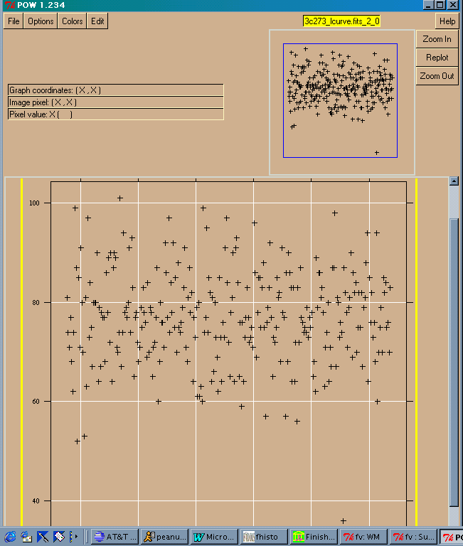

- Next, we will obtain the plot of a spectrum.

- Select the ‘analysis’ menu and select ‘Energy Spectrum’. A window will appear, containing an image. This is a plot of a spectrum of 3c273!

Part II: The Jet

- In this part of the tutorial, we will be examining the jet of 3c273 in the same way that you analyzed the main source. Close any ds9 windows you may still have open from Part I. Reopen ds9.

- We will begin with the unbinned data file, output2. In the ‘file’ menu select ‘open’, find output2, select it and click the ‘ok’ button. (Hint: Follow the path 3c273/primary/output2.)

- The ds9 window will display the image of 3c273. Move the window as close to the top of your screen as possible and use the scroll bar on the right hand side to scroll so that you can view the entire image. Use the ‘Zoom’ menu and select ‘4’. Move the blue box in the upper right hand corner so that it is centered on the jet.

- Click on the center of the jet and, holding the mouse button down, pull the cursor away from the center. This will drag a circle around the source. Make the circle big enough to encompass the entire jet, and then release the mouse button. Clicking and holding the mouse button anywhere inside the circle allows you to then move the circle if you wish.

- Select the ‘region’ menu and select ‘get info...’ . Copy onto a piece of paper the numbers that you see there. These are the Selection Expression values that you will use in the next step. Once you have recorded these values, you can close all of the ds9 windows and return to your BASH terminal.

- Make sure that you are in the 3c273/primary/ directory. At the prompt, type fselect. You will be asked for the following information:

- Name of FITS file and [ext#][]: acisf01711N001_evt2.fits
- Name of output FITS file[]: jetreg.fits

- Selection Expression[]: This is where you will use the numbers you copied down from the ‘get info’ window. First, add the starting X value that you entered into the f2dhisto method earlier (4000), to the first number in the Circle expression from the ‘get info’ window (~131.924). Next, add the starting Y value that you entered into f2dhisto (3850) to the second number in the Circle expression (~66.8295). Record these two values on a piece of paper.

- Enter these values for the Selection Expression[] EXACTLY as follows: (The only difference might be the actual values, which may differ by a small amount.)
“circle(4131.924,3916.8295,12.5408,x,y)”

- At the next prompt, type fhisto jetreg.fits 3c273_jet_lcurve.fits time 100 (This represents the input file, the output file, the keyword and the binsize in seconds, respectively.) FTOOLS will repeat the information you just entered, and then return a prompt. Go back to your desktop, and open ds9.

- Find the file you just created, 3c273_jet_lcurve.fits (using the path 3c273/primary/3c273_jet_lcurve.fits), select it and click on the ‘ok’ button from the ‘file’ menu.

- Select the ‘Analysis’ menu and click on ‘Load Analysis Commands...’. A window will open and select ‘funtools.ds9’ and press ‘ok’. Now click on the center of the jet and drag a circle around it. Select the ‘Analysis’ menu and select ‘light curve’. A window will open asking for the number of bins. Enter the desired number of bins (100) and press ‘ok’. A window will appear containing a light curve for 3c272! (See Figure 4)

- Next, we will obtain a plot of the spectrum. Select the ‘analysis’ menu and select ‘Energy Spectrum’.

- A window will appear, containing an image. This is a plot of a spectrum of the jet! (See Figure 5.) You can use the scroll bar to try to view more of the image. Also, clicking on ‘Edit’ and then ‘Choose Graph Size’ will allow you to set the dimensions of the graph.
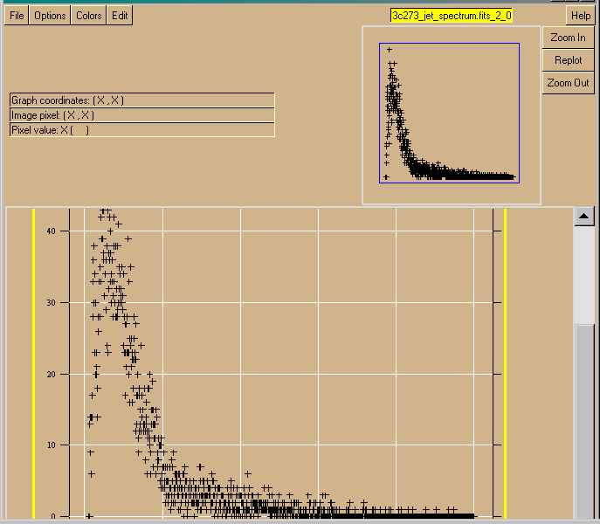

Figure 5

Part III: Cassiopeia A
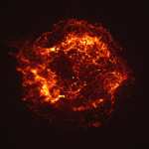
Cassiopeia A (Cas A) is a 320-year-old supernova remnant. A massive star exploded, ejecting a shell of matter that created a bubble of gas 10 light years in diameter with a temperature of about 50 million degrees. As this hot gas expands, (and it will continue to do so for thousands of years), it produces x-rays. Astronomers can use this data to find x-ray spectra and then use these spectra to determine the chemical makeup of Cas A. The image to the right was made with the Advanced CCD Imaging Spectrometer (ACIS) over the span of 5,000 seconds. The outer shock wave can be compared to a sonic boom. (Check out http://chandra.harvard.edu/press/casfact.html for more about supernovae and Cas A.)

- Begin by closing all of the ds9 windows you have open from the previous sections. In your BASH window, type cd /ftools to get back to your main directory. Create a folder for your Cas A data by typing mkdir cas_a.

- Open Netscape and go to http://asc.harvard.edu.

- At the top of the page, you’ll see various buttons: click on the one that says Archive.

- A page will open that says “Welcome to the Chandra Data Archive”. You’ll see a list of links: click on Search and Retrieve.

- The next page will be “Search and Retrieval from the Chandra Data Archive”. If you scroll down the page a bit, you will see Provisional Web Interface for Browsing and Retrieval in blue. Click on this link.

- You have now entered the Chandra Data Archive. Scroll down to “View Information About Public Observations Available for Retrieval from the Archive…”. Below this heading there will be four buttons. Click on Sort by RA & Dec.

- Upon scrolling down the next page, you’ll see a long table of observations. Find the observation whose ObsId is 1512, whose Object Name is CAS A, CHIP S2 and whose RA (right ascension) is 23:22:46. Click on 1512.

- You’ll then be returned to the Chandra Data Archive page that you were at earlier. This time, however, if you scroll down, you’ll see that 1512 has been entered into the Enter ObsId box. Scroll down a little bit more and make sure that the fully processed science products box is checked, inside the Product Categories box. Click on Browse Archive and Retrieve Data Products.

- You will receive a list of four files. Upon scrolling down further, you’ll see the instructions “Select files to retrieve from archive”. In the white box below, click on the first file, hold down the shift key, and then click on the fourth file. This will allow you to select all four files. With all four files selected, click on RETRIEVE from Archive.

- The next page will give you the name of your tar file. After copying this filename down for future reference, find the sentence that says “Or you may download it directly here”. Click on here.

- A window will appear which asks you whether you’d like to save the file to disk or open it. Select Save to disk and then click OK.

- Next, a window entitled “Save As…” will open. In the File name: field, the name of your tar file will already be entered. In the Save in: field, make sure that you are saving the tar file into your cas_a folder. Once this is done, click Save.

- Minimize Netscape and return to your BASH window.

- At the prompt, use the commands you know to make your way to the cas_a directory. Once you are in this directory, type ls to view its contents. You will see the file you downloaded. (It should look something like retrieve_1512_7166.tar, but the last four numbers may be different.)

- Type tar xvf <filename.tar>, replacing <filename.tar> with the name of the file you downloaded. This will untar the data and save it into the directory cas_a.

- When the untarring is complete, a directory structure similar to the one set up for 3c273 will be created. The last step is to gunzip the files. We are only concerned with acisf01512N001_evt2.fits.gz for now, so enter the primary/ directory by typing cd primary. Then type gunzip acisf01512N001_evt2.fits.gz to gunzip the file.

- Once you are given a prompt again, type ls. You should see three files, one of which is acisf01711N001_evt2.fits. This file is now ready for analysis.

- At the BASH prompt, type f2dhisto acisf01512N001_evt2.fits. You will be asked for a variety of information:

- Name of output FITS file []: casfirstout (make sure that this filename does not already exist.
- X BINSIZE [INDEF]: 4
- Y BINSIZE [INDEF]: 4
- Name of x column to generate histogram [X]: X
- Name of y column to generate histogram [Y]: Y
- Enter the X-RANGE(Eg: 10.0,20.0)[INDEF,INDEF]: 3000.0,6000.0
- Enter the Y-RANGE(Eg: 10.0,20.0)[INDEF,INDEF]: 3000.0,6000.0

- FTOOLS will state a summary of what you entered and then return the BASH prompt. At this point, find the ds9 icon on your desktop and double-click on it.

- The ds9 window will open. Select the ‘file’ menu and select ‘open’. You want to find the output file you just created, casfirstout. Double-click on cas_a/, then on primary/. You should then see four filenames, one of which is casfirstout. Click on casfirstout, and then click on the ‘ok’ button.

- The ds9 window will display your image. Move the window so that it is as close to the top of your screen as possible. Then, select the ‘zoom’ button, and select ‘4’. You’ll see the blue box around the picture in the upper right hand corner get smaller. Click on the blue box and drag it so that it is centered of Cas A.

- Place the cursor (without clicking) on the center of the circular part of the image. Look at the box in the upper left hand corner, labeled ‘Image Pixel’. It should contain numbers close to ( 116, 167 ). Copy down these numbers on a piece of paper and then close all of the ds9 windows.

- Back in your BASH terminal, type f2dhisto acisf01512N001_evt2.fits.

- You will be prompted for the same information as before, except this time your answers will be slightly different:

- Name of output FITS file[firstout]: casoutput2 (Again, make sure that this file name doesn’t already exist.)
- X BINSIZE [4]: 1
- Y BINSIZE [4]: 1
- Name of x column to generate histogram [X]: X
- Name of y column to generate histogram [Y]: Y

- X-RANGE and Y-RANGE: For this information, you need to do some calculations. For the X-RANGE, you must first correct for the binsize of 4 from earlier. To do this, multiple the X value from your ‘Image Pixel’ coordinates (~116) by 4. Add this number to your initial starting value for X, 3000. This should give you a number similar to 3464. Your X-RANGE needs to encompass about 100 on either side of this number. Thus, enter 3360.0,3560.0 for the X-RANGE.
For the Y-RANGE, follow the same process. Multiply the Y value from your ‘Image Pixel’ coordinates (~167) by 4 and then add this to your initial starting value for Y, 3000. This should give you a number close to 3668. Therefore, enter 3560.0,3760.0 for your Y-RANGE.

- FTOOLS will summarize the information it will be entering into f2dhisto, and then return the BASH prompt. Now, find the ds9 icon on your desktop and double-click on it to begin ds9.

- In the ‘open’ window from the ‘file’ betu, find casoutput2, select it and click the ‘ok’ button. (Hint: Follow the path cas_a/primary/casoutput2.)

- A window will open which contains your image of Cas A on a grid. However, the image is too big! To fit the entire image on the grid, you need to go back and try a different X-RANGE and Y-RANGE. Close all ds9 windows and return to your BASH window. Again, type f2dhisto acisf01512N001_evt2.fits at the prompt. This time, enter casout for the output filename, 1 for each binsize, X and Y for the column names; finally, try 3100.0,3800.0 for the X-RANGE and 3250.0,3950.0 for the Y-RANGE.

- Once a prompt is returned, find the ds9 icon on your desktop and double-click on it to open ds9.

- In the ‘open’ window found in the ‘file’ menu, find casout, select it and click the ‘ok’ button.

- This time when the picture opens, you should see that the image just about fits on the grid. This is sufficient, but you can go back and make the grid slightly larger if you wish.

- Click on the center of the main source and, holding the mouse button down, pull the cursor away from the center. This will drag a circle around cas A. Make the circle big enough to encompass the entire main source, and then release the mouse button. Clicking and holding the mouse button anywhere inside the circle allows you to then move the circle if you wish.

- Select the ‘region’ menu and select ‘get info...’ . Copy onto a piece of paper the numbers that you see there. These are the Selection Expression values that you will use in the next step. Once you have recorded these values, you can close all of the ds9 windows and return to your BASH terminal.
- At the prompt, type fselect. You will be asked for the following information:

- Name of FITS file and [ext#][]: acisf01512N001_evt2.fits
- Name of output FITS file[]: cas_a_reg.fits

- Selection Expression[]: This is where you will use the numbers you copied down from the ‘Edit Region’ box. First, add the starting X value that you entered into the last f2dhisto method (3100), to the first number in the Circle expression from the ‘Edit Region’ box (~370.1). Next, add the starting Y value that you entered into f2dhisto (3250) to the second number in the Circle expression (~419.1). Record these two values on a piece of paper.

- Enter these values for the Selection Expression[] EXACTLY as follows: (The only difference might be the actual values, which may differ by a small amount.)
“circle(3470.1,3669.1,309.176,x,y)”

- When a prompt is returned (Note: processing the last step may take awhile), type fhisto cas_a_reg.fits cas_a_lcurve.fits expno 1 (The first two parts are the input file and output file, respectively. The third piece of information, the keyword expno, is the exposure number for the observation. Finally, the last part, 1, is the binsize. Specifically, 1 indicates that every exposure interval is plotted separately.) FTOOLS will repeat the information you just entered, and then return a prompt. Go back to your desktop, and open ds9.

- Find the file you just created, cas_a_lcurve.fits (using the path cas_a/primary/cas_a_lcurve.fits), select it by using ‘open’ from the ‘file’ menu and click on the ‘ok’ button.

- Select the ‘Analysis’ menu and click on ‘Load Analysis Commands...’. A window will open and select ‘funtools.ds9’ and press ‘ok’. Now click on the center of the main source and drag a circle around the source. Select the ‘Analysis’ menu and select ‘light curve’. A window will open asking for the number of bins. Enter the desired number of bins (100) and press ‘ok’. A window will appear containing a light curve for Cas A! (It should look similar to Figure 6.)

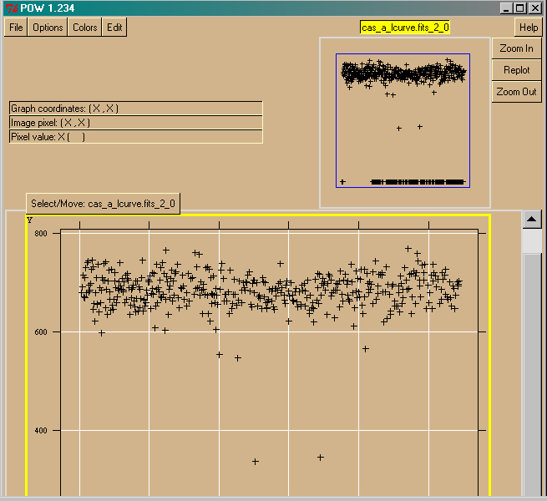
Figure 6

- Next, we will obtain a plot of the spectrum. Select the ‘analysis’ menu and select ‘Energy Spectrum’. A window will appear, containing an image. This is a plot of a spectrum of 3c273!

