In 2008 I sat with my mother and took notes as she spoke about her family and her life. To compile this story I've combined information from my mother with a family history written by my second cousin, Phillip Alloy, for a college class he took in 1995. I've also been speaking with Phillip's father Irv (Lil's first cousin) and my cousin Miriam, as well as my mother's sister Sema and brother Earl and long lost (to me) second cousin Eda Hallinan.

````````````````````````````````````````````````````````````
FAMILY MOTTO: Nothing rolls off our backs

2008 -- "This happens to be a very good time in my life. If only I had someone to talk to."

In her early nineties my mother, Lilian Greenberg Friedner Suslow, was extremely deaf, even with hearing aids, and had lost most of her useful vision. She refused to use the white cane that would identify her as blind, but was thrilled when her doctor prescribed a walker. Watching her use it to climb up and down curbs and cross streets was terrifying for me, but she had great confidence in that walker and was proud to use it.

Lil absolutely refused to hire someone to drive her to stores or to social events, but even when she took the bus to the supermarket or got a neighbor to drive her to synagogue, it was challenging to interact with others. The world at large generally doesn't know how to approach a visually handicapped person or how to speak loudly to a hearing impaired person. Unless people came up to her, she wouldn't know who was there, and when people spoke with her, the background noise made it difficult to follow conversations. But still she went. She had lived alone since my step-father Harry passed away in 1996 and she did not want anyone to tell her what to do.

Because my sister was willing to take her to doctors, handle finances, deal with logistical crises and just be available, Lilian lived alone until she was nearly 95 years old.

I live in Highland Park, New Jersey. Once upon a time, my mother lived just an hour or so away from me, in Spring Valley, New York, where I went to high school. Then my father died in 1974 and Lil wanted a change -- so in 1979 she followed my sister Sheryl and our Aunt Sema and her family to California. Soon after, my grandmother Bessie and my aunt Sara and her husband Ray followed. For me this meant that for the past 36 years there were no casual visits -- only week or two week intensives --

If you asked my mother, she'd tell you she had a wonderful life -- "Some people say their cups are half empty. I always say my cup is half full."

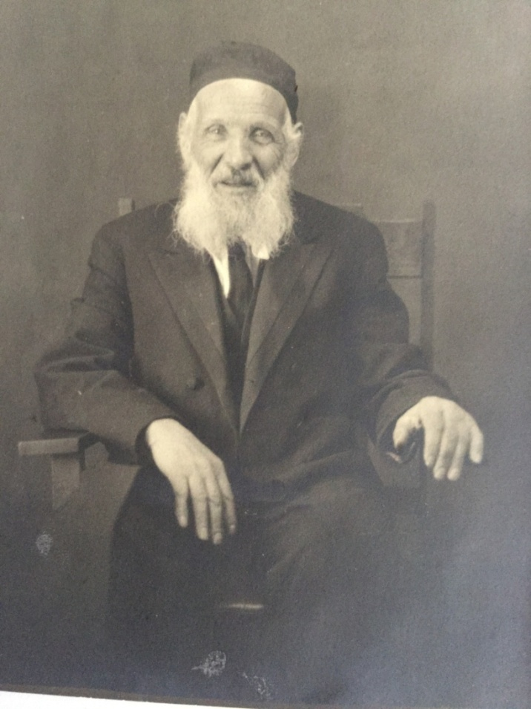

All About: GREAT GRANDFATHER Israel, known as "LITTLE ZEIDA" AND MY Grandfather Lipa

Lil Greenberg was born in Grand Forks, North Dakota on December 23, 1915 .The night she was born someone stole the family's chickens and geese.

"When I was very young, we moved to Toledo with my 'Little Zeida' -- my father's father -- 'He was a jolly man.' He never worked, because he was a scholar. His three wives supported him " She also told me that Little Zeida was married to his first wife for 10 years, but no children were born, and he divorced her.
I am named for little Zeide's mother, Rivka. When I was born, my mother did not want my father's family to pick my name so she asked her parents what to name me.

"Name her after my Bubbie," said my grandfather Lipa.

And so in English my name became Ruth, and when I went to Hebrew School I was called Rivka. At the time I thought it was an unfortunate choice.

A few years ago LIl told me that not only was I named after Lipa's Bubbie, but also my Grandmother's sister Rochel who drowned herself.

Israel and his wife Sima emigrated to the U.S. through Canada, in 1904, along with my grandfather Lipa, who would have been about 18, and siblings Jake, Schreuven and Nessa.

When they got to Canada, the medical examiners diagnosed Lipa's mother Sima --Little Zeida's wife -- with an eye infection; she had to return to England. Lipa went with her and supported her while they were in England. I don't know how long they were in England or how they lived but they returned about a year later and made their way to North Dakota to join the rest of the family. Land was being given to homesteaders, including new immigrants.

I don't know anything about the family life in North Dakota except that Lipa got married and was pressured by his uncle to divorce his wife when she didn't bear children. He was so distressed about it that he moved to Philadelphia, where he met Basha -- Lil's mother and my grandmother.

DOKSCHITZY

On official papers belonging to Uncle Sam Alloy (Basha's brother) it says that his and Basha's family was from Glubokie, Russia 70 miles north of Minsk.

But Uncle Sam used to tell his family that in fact, he came from a town with a name "that sounded like dog shit." In 1994, Phillip Alloy, grandson of Sam, located a detailed Russian language map and saw that six miles south of Glubokie was the village of Dokschizy, pronounced 'dock-shee-zee'. And while once it was Russia, now it is Poland.

BASHA COMES TO AMERICA AND MARRIES LIPA

Basha's mother -- Chana Libby Alloy -- died at the age of 39 from influenza, leaving three daughters and a son. Basha was the first of her immediate family to make the trip to America. She entered the U.S. in 1910 at Baltimore and went to Philadelphia to live with cousins -- a married couple and their baby. She had to get up at 4 A.M. to take care of the baby and do housework, and when she got back from working in a button factory it was more of the same. But far worse -- the husband molested her.

Cousin Eda visited my grandmother at the end of her life, when she was living in a nursing home in Los Angeles. She relates the following story.

"When she came to Baltimore,[Eda thought that Basha lived and worked in Baltimore, but my mother and her siblings are pretty sure it was Philadelphia] Basha got a job in a button factory. There was a union organizer who was trying to sign people up to join the union. A supervisor on the floor confronted the organizer, there was a yelling altercation and the management person filed a complaint against the organizer, claiming that the organizer picked up a pair of scissors to attack him.

Basha was the only witness to the altercation, and was brought into court to testify. I don't know if it was management or the union who brought her in….she did not say. But she was scared because she spoke no English and she was very young. The judge or the arbitrator -- (she said Judge) -- was very kind to her, because she was very frightened and was afraid to speak….But the judge spoke Yiddish. He told her not to be afraid but to just tell the truth.

She said, while the organizer did have a pair of scissors in his hands when approached by the supervisor, he was working, and that he dropped the scissors to the ground when the supervisor began to yell at him. As a result of her testimony, the organizer was found Not Guilty. She had never forgotten the story and waited 75 years to tell this story to someone who would appreciate her action. She was proud of herself because she had been so scared, and that she did the right thing."

My mother never told me about this, and my Aunt Sema didn't know about it either. Eda said my grandmother hadn't told anyone because she didn't think anyone would be interested.

My mother said that Basha was pretty, with a nice figure. This one particular day she had a bad cold and was in a pharmacy asking for advice at the same time as Lipa Greenberg, my grandfather-to-be. He must have overheard her talking to the clerk, and family lore says he advised her to use vaseline -- one thing led to another and they got married. My mother thought Basha was 20, but other evidence says she was probably more like 17, or 18 which means they were married by 1911 or 1912. When they found out she was getting married, the cousins threw her out.

My Aunt Simmy thought that they met when Lipa was hired to work on the roof of the house where Basha lived.

And Cousin Eda has a totally different version.

"She told me that she and Lipa lived in the same boarding house in Baltimore [Simmy and my mother and Earl were pretty sure that it was Philadelphia and not Baltimore] while she was working at the Button Factory. It is possible that the factory closed….but for some reason she no longer had a job at the Button Factory. … which I don't think was related to the Union Story -- or maybe it was and that the factory decided to close its doors rather than unionize (I don't know the answer to this). But she was out of a job and was very anxious about where to get another job. Lipa liked her and said 'Let's get married'."

A SIDETRACK:

The story about meeting in the pharmacy is my personal favorite because true or not, it tells something about my grandfather who was evidently a big believer in natural healing. My cousin Miriam tells this story about our grandfather:

"Grandpa loved Vicks [Vapo Rub]. He thought it was a cure all for every ailment. He used it so much that his bedroom smelled like Vicks. He would always rub it on me if I had a cold and once, maybe because I was coughing, he wanted me to eat some of it. That is where my mother drew the line. I have to admit that I have gone through stages when I used a lot of Vick,s and I love walking through Eucalyptus groves even today. I must have gotten that from him."

BACK TO THE WEDDING:

The landlady in Lipa's rooming house made the wedding party. Louis paid, but they knew no one to invite and Lil didn't know who attended. Upon getting married they Americanized their names from Basha and Lipa to Bessie and Louis, although when I spoke to Cousin Irv he said that he'd only known them by their Yiddish names.

Uncle Charlie, Lil's older brother, was born 11 months after the wedding.

In her later years, Basha indicated to my cousin Miriam that the marriage was not a love match.

"The one thing Grandma did tell me not long before she died was, 'He had nobody and I had nobody, so we decided to get married.' This might explain a little about the dynamics of their marriage."

By 1912 Basha had saved enough money to buy a ticket for her brother, Sam Alloy, to emigrate, and he came to live with Louis and Basha in Philadelphia.

GRAND FORKS

A couple years later, the wife of Uncle Schreuven (Lipa's brother) died, leaving behind five children. Lipa and Basha, with baby Charlie and brother Sam, moved to North Dakota, and Basha found herself taking care of all the children. - In 1915 Lil was born; when she was born the midwife pronounced her dead.

Obviously that was a mistake.

According to Eda, it was around this time that my grandmother learned about birth control.

"I like this story because it is so telling about women and the times and how little they were told about their bodies. When she and Lipa got married, they moved [to Grand Forks] and she found herself with two babies very quickly and close together. . . . She had a neighbor and friend who also had a few children [who] were spaced out over a longer span of time between them. She was so curious about this, that she finally asked her neighbor how she did that…how she controlled the time between her children, and the woman explained a diaphragm to her. I have no idea why Bess told me this story, but she did."

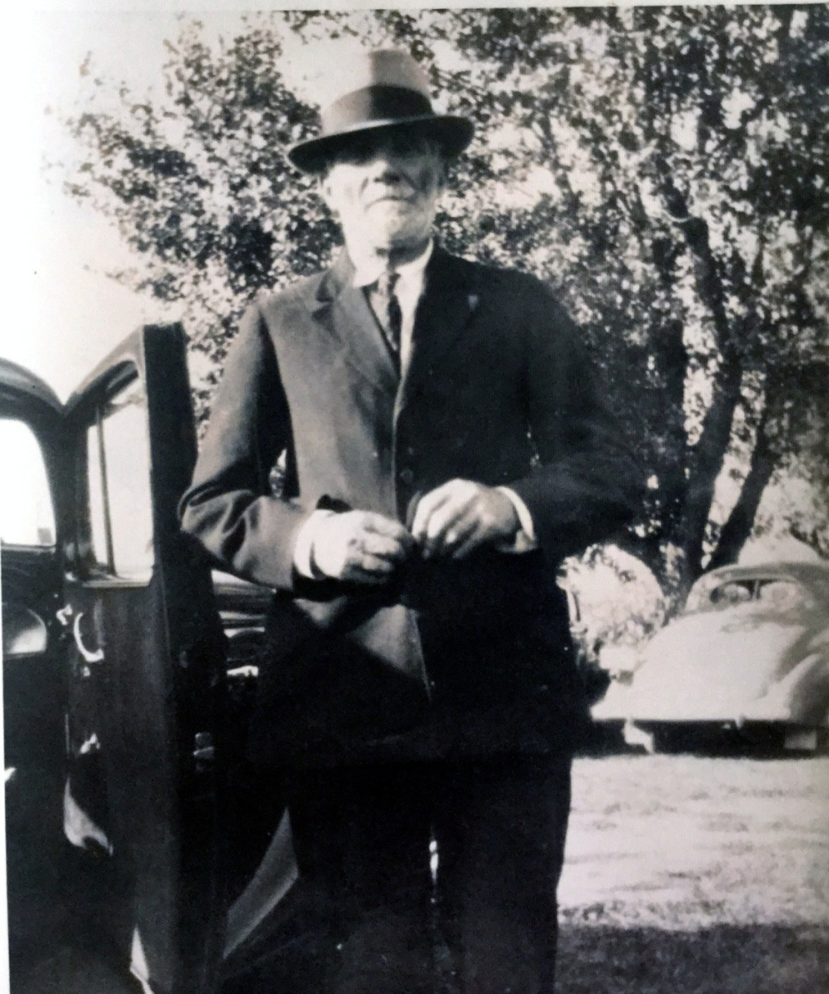

By 1918 Moishe Gerson Alloy, my great grandfather and the father of Sam and Basha, had joined his children in Grand Forks. He lived in a boarding house with Sam. Two girls were left behind to be raised by an aunt. One of the girls was Eda's mother Chaya Sarah. The other sister, Rochel, drowned, and there is mystery surrounding that. My mother intimated to me that Rochel was raped and killed herself. Great Aunt Chaya Sarah told daughter Eda a different version:

"She [Rochel] was my mother's favorite sister and [my mother] was so heart broken when she died, that it confirmed to Mom that there was no God. She suspected this earlier because she thought he had very silly rules…. like not carrying anything on the Sabbath … even a small lunch for when she would walk to the country from the village to play in the fields. So when she would walk to the country on Saturday, she wanted to take some bread with her for a little lunch so she would not get that hungry, but the aunt and uncle that she and Rochel lived with, were very orthodox and would not let her carry anything in her pockets.

It was returning from a walk in the country that she saw a group of people at the edge of the river….and when she approached she saw it was her sister who had drowned. She would still cry when she told me this story 40 years later. But I did not ask her about it -- was anyone with her? or was there a boat? and she never said

If I had to guess their ages when this happened….I would say mom was 12 or 13 to Roquel's 14 or 15.

I know this sounds odd, but I think there was some speculation that she committed suicide, because she liked a boy who did not return her feelings. Possibly she was pregnant. I think it was winter….and the speculation about the suicide was based on the fact that no one would go swimming in the river, particularly in the winter, or go alone.

So all I can say is that she was dearly loved by my mother."

How awful it must have been for Basha and Sam and their father to hear about Rochel's death. And then World War I came and they thought that Chaya Sarah was dead too. In 1917 Basha gave birth to their third child, and they named her Sarah. It is a Jewish superstition to name a child after a dead relative so that is why I have an Aunt Sarah, even though it turns out that Chaya Sarah was not, in fact, dead.

Moishe, the father of Basha, Sam, Sarah and Rochel, was the only one of his siblings to have the surname Alloy -- Eda said that the rest were named Kaplan but my mother said that all of the brothers had different last names. This had something to do with the custom of giving a child the name of a dead person. The idea was to confuse the military authorities in Russia into thinking the child was dead so he'd escape the draft. (Being conscripted into the army meant 25 years of service and usually lifetime estrangement from family.) However, Cousin Eda says that Moishe was actually adopted by a farm family named Alloy that had no sons -- that this would be a way to avoid the draft. I don't know whether the adoption was just on paper or if he actually lived with a different family.

Phil Alloy says that Uncle Sam joined the U.S. Army in the fall of 1918 , spurred on by the promise of U.S. citizenship in exchange for military service, as well as patriotic fervor. Maybe it was more patriotism than the financial benefits of joining the army, because it seems that the rest of the family was able to become American citizens without joining the army. And I'm told that Uncle Sam was a fervent patriot all his life.

I wish I knew what the Greenbergs did in Grand Forks. I used to think they were farmers, but when they moved from Grand Forks, Lipa and Basha had enough money to buy a house in Toledo, and they probably didn't make that from raising chickens. So I assume Lipa was a carpenter in Grand Forks. My Uncle Earl says he did well there and liked it, but my mother said it was difficult for my Grandmother Basha -- being at home with her own children, as well as the children of Uncle Schreuven, and living in the same town as the woman who'd been married to my grandfather. The Jewish community couldn't have been that large -- everyone must have known everyone else, and my grandmother would have lived under a microscope.

My grandmother was tough -- definitely not a Jewish Princess. Consider that she travelled to this country on her own when she was a young teenager and made her way, knowing nothing of the language. In addition to that, Cousin Miriam tells me that she saw her kill water bugs with her hands. Definitely NOT a Jewish Princess.

While they were still in Grand Forks, the Alloy-Greenberg family learned that sister Chaya Sarah was still alive in Dokshitzy. This was a miracle. My mother had told me about this but Cousin Eda supplied me with the details:

EDA: HOW MY MOTHER, SARAH, CAME TO THE US…..AS TOLD TO ME BY BASHA

The family -- Bess and Lipa, their children [and Sam and Moshe] were living in North Dakota (I almost fell off my chair I was so surprised there were any Jews living in either of the Dakotas)… and it was a Jewish neighborhood that was large enough to support a Rabbi. In those days, one of the jobs of the Rabbi in the community was to read all the Personal Ads at the back of the Jewish Newspapers to see if there was anything there relevant to their 'flock'.

I am guessing it was 1919 because it was just after WW1 ended. Basha was walking down the street when the Rabbi stopped her and asked her if she knew a Sarah Alloy. Basha said, 'Yes, it is my sister, but she is dead. She died during the war.' And he said, 'No, she is alive and she is looking for you' Basha said that she fainted right there onto the sidewalk.

NOTE:
Common practice at the time -- because families had been so dislocated by the war, was that they would take ads in the personals at the back of the Jewish press looking for relatives. How my mother knew which paper or how to take an ad out -- or how many ads she took out, I have no idea because she was not the one to tell me this story, it was Basha. And my mother had already died so I could not ask her.

BACK TO THE STORY:
Once the family knew my mother was alive, they wanted to bring her to the US, but they needed $1000 (really, she said $1,000 in 1919), that was demanded as bond by the US for any entering immigrant. The US did not want anyone coming here who could not support themselves, and that money had to be in place before a person would be granted a visa or permission, etc. Of course, the family did not have that kind of money, but there was a cousin (I have no idea who this could have been), who lived in New York City, who had done well enough that he gave (or loaned) them the money to post the bond for her.

By the time all those arrangements were made and my mother arrived on the boat in 1921, the family had moved to Toledo. I do know that Sam went to New York to get her. However, he had to wait three days for her to be released. Mom had contracted head lice, and they quarantined her and shaved her head. She cried for the entire time, thinking they were going to return her to Europe (because, of course, they did not tell her anything).

Sam went to the dock every day to meet the boats carrying people from Ellis Island, until she was released -- I suspect she was wearing a scarf so I don't know his reaction to her shaved head. There is a picture of her and of Sam -- taken at the same time -- and my mother's hair is very very short as her hair began to grow in."

THE MOVE TO TOLEDO

After a few years in Grand Forks, Basha convinced Lipa to move to Toledo, Ohio, where her Aunt -- Tante Hinde -- was living with her husband Lazer, the shoemaker. Hinde was much younger than her brother Moishe -- she was only 10 years older than Basha -- they were more like sisters than aunt and niece. Louis went to Toledo, found a house in need of repair and got a job. Basha followed with Charlie, 3 1/2 and Lily 2, and Sarah, who was a baby.

And now for something about little Zeida, Lipa's father. My mother told me he traveled with Basha and the children to Toledo by train, but that meant they had to travel on Shabbos, and he point blank refused to continue when the sun went down. So he stayed in a train station over night. Basha, on the other hand had three little children to take care of, so she continued on.

After the war, brother Sam also moved to Toledo, and at some point so did Moishe Alloy, Sam and Basha's father. Sam met Celia Barkan -- his future wife -- in Toled.

SO WHAT WAS LIFE LIKE FOR THE GREENBERGS IN TOLEDO?

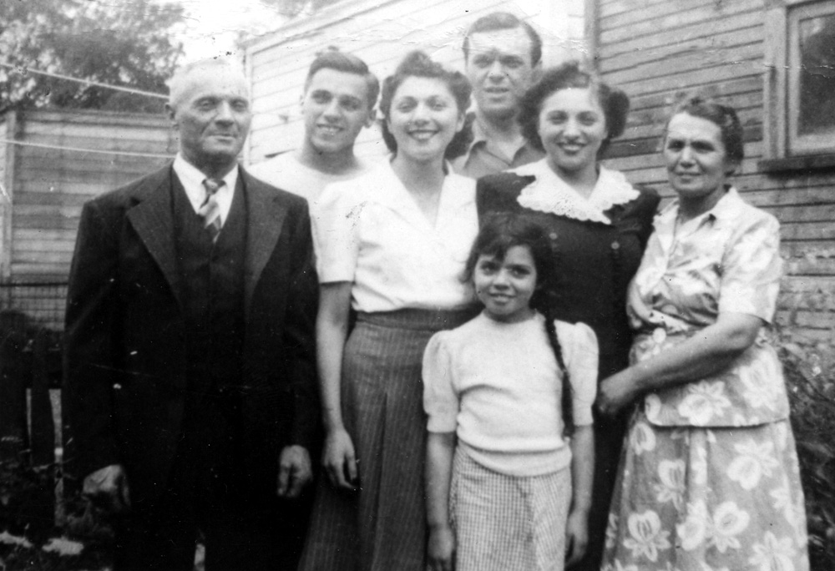

rule to live by: wE nEVER fORGIVE AND WE NEVER FORGET

The Greenberg family's first home in Toledo did not have a bathroom; there was an outhouse in the backyard. Eventually a bathroom was put in, and by that time there were four children -- Charlie, Lily, Sarah and Earl plus both grandfathers and Basha and Lipa. Simmy wasn't born until 1933, when Lil was 18.

Life was sometimes a bit tense.

Lil said that she grew up thinking other families never had arguments because that's what my grandmother told her. It was ingrained very young that you did not talk about family problems outside the home. And that was true of my house growing up as well. My mother might have been upset with me, but to the outside world there was never a hint of family unrest. Family problems were NOBODY'S BUSINESS.

The grandfathers got along with each other, but Lipa and Basha's father Moishe had their issues. Moishe insisted on being served first at meals and Lipa resented that Basha put her father first. Lipa didn't like meat, but Moishe wanted meat, so meat was served. The Little Zeida died when Earl was young, but he has vivid memories of Big Zeida. He particularly remembers arguing with him about religion. He said that Big Zeide would frequently say, "Americana Mishegash." Earl doesn't remember Big Zeide living in their house -- By that time things had gotten so unpleasant that Big Zeide moved into an apartment over the shoe store of his brother-in-law, Lazer the shoemaker, and eventually moved in with sister Hinde and Lazer.

By my calculations, the Greenbergs lived in Toledo about ten or twelve years before the crash of 1929. They owned their house and rented out the upstairs. Then Lipa was able to buy land to build a four family house on the corner. According to Uncle Earl, my grandmother was the rent collector, and when given a hard luck story she would give people a break.

Things were okay until 1929, and then my grandfather "lost everything." He had to declare bankruptcy, and the upstairs tenants ended up buying the house. Uncle Earl says that for the rest of his life Lipa remained bitter that his lawyer had advised him to file for bankruptcy. Earl now has some regrets that after the war he didn't choose to go into the construction business with Lipa. The time was right, but Earl's heart was not in construction -- he had other things he wanted to do.

Add my grandfather's anger about losing his houses to his voiced bitterness about divorcing his first wife, plus his increasing deafness and you have one unhappy man. But something else happened -- I think just before Simmy was born, when Lipa was in his mid forties, he had a brain tumor that was removed. It was benign, but my mother said that it changed him. Much later, when we were children, he was hospitalized for a mental breakdown. Miriam remembers visiting him in the hospital.

When I was growing up, our grandparents visited separately. Lipa would stay for weeks at a time -- on one visit he built an addition onto our house. He was very deaf by this time, was missing a lot of teeth and I could not understand him when he spoke. He also smelled from Vicks, and unlike my cousin Miriam, I didn't find it endearing. It's too bad.

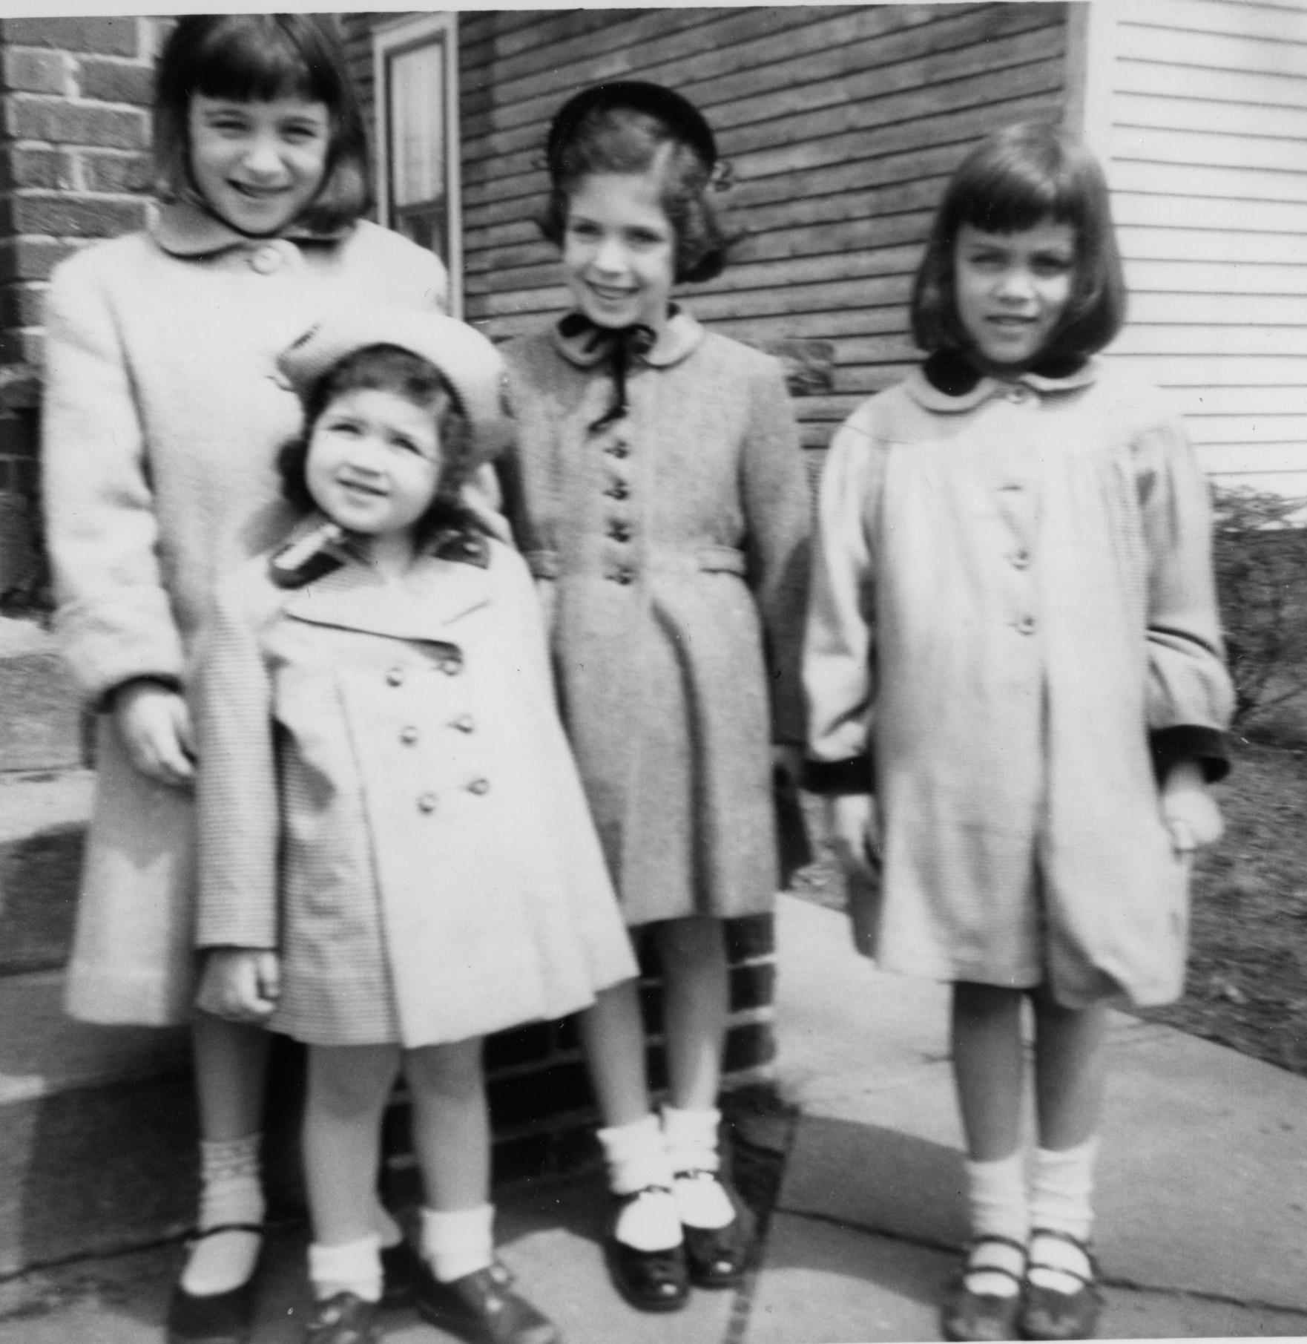

When I was about 5 or 6 my mother took Sheryl and me on the train to visit the relatives in Toledo. It was our one and only visit that I remember. From left to right, Sharon, Sheryl, me and Miriam.

Miriam and her sister Sharon -- the children of my mother's sister Sarah -- lived in Detroit, and they went to Toledo regularly -- went to Passover seders and just visited. They felt comfortable with my grandparents, particularly my grandfather. Miriam tells this story,

". . . Runny eggs were another aversion, one which I still have. This was something that my mother just couldn’t understand. I don’t think there was a runny egg that she didn’t love—soft boiled, sunny side up, runny, barely cooled, scrambled. For years I thought that I hated eggs, other than hard boiled, when it was, and still is, the mucous like texture that I abhorred. Rather than experiment with trying to find a way to cook the eggs I’d find more palatable, she’d continue to serve me these dishes, which I would barely pick at. At least she wouldn’t force me to eat them. She’d just shake her head saying what a picky eater I was.
My grandmother in Toledo, however, couldn’t stand to see me waste the food, or to be so picky. Although her food, boiled eggplant or tongue would have made anyone a picky eater as far as I was concerned. After one too many times of watching me not eat something that I hated she told my mother that she should force me to eat and not let me up from the table unless I did. So my mother did just that. She made me some of her runny eggs for breakfast and said, “Sit here until you eat everything.”
I sat and looked at the eggs, no toast or anything, just runny eggs congealing on my plate, getting cold. I don’t know how long I sat there, but at some point my grandfather, zeyda, came into the kitchen for a glass of tea and saw me sitting there.
“Come outside and sit with me on the rocker,” he said.
This was one of my favorite activities I shared with my grandfather, just sitting there on the wraparound porch, watching the world, or what there was of the world on their street, go by. If we were lucky we could see the train at the viaduct at the end of the street, on its way to Detroit or just sit there and rock. There was nothing I would rather have done.
“No I can’t. I have to finish these eggs,” I said.
This was an outrage. Maybe it was to protect me or to assert his authority in a household where I think he usually felt overruled or maybe it was a combination of both.
“Don’t tell anyone,” he whispered.
He grabbed my plate, went outside and threw the eggs amongst the tomato plants so no one would see. Then we went out to the porch, with me leaning against him on the rocker. I felt so loved. I wish I could have protected him from the ravages of disease which struck him later.
Every one of my memories of grandpa is tender. I share his love of tomatoes and Vicks, his bad feet and his love of rocking chairs. I still love potatoes, although now they have to be cooked. And I absolutely won’t eat an egg that has even a hint of runny yolk.

I wish I'd felt comfortable with my grandfather. But the one good memory I have -- that we all have -- was how much he liked cats. As near as I can tell, many of us in the family --myself included -- are lunatics over our pets. Miriam's sister Sharon says that she attributes her love of cats to our grandfather. Grandma used to say that when he took a walk, she always knew which way Grandpa went because the cats would be facing in that direction. I can picture him smiling in our back yard as he played with a litter of our kittens. He picked one up and showed me how to hold her, but that smell of Vicks kept me far away. Too bad.

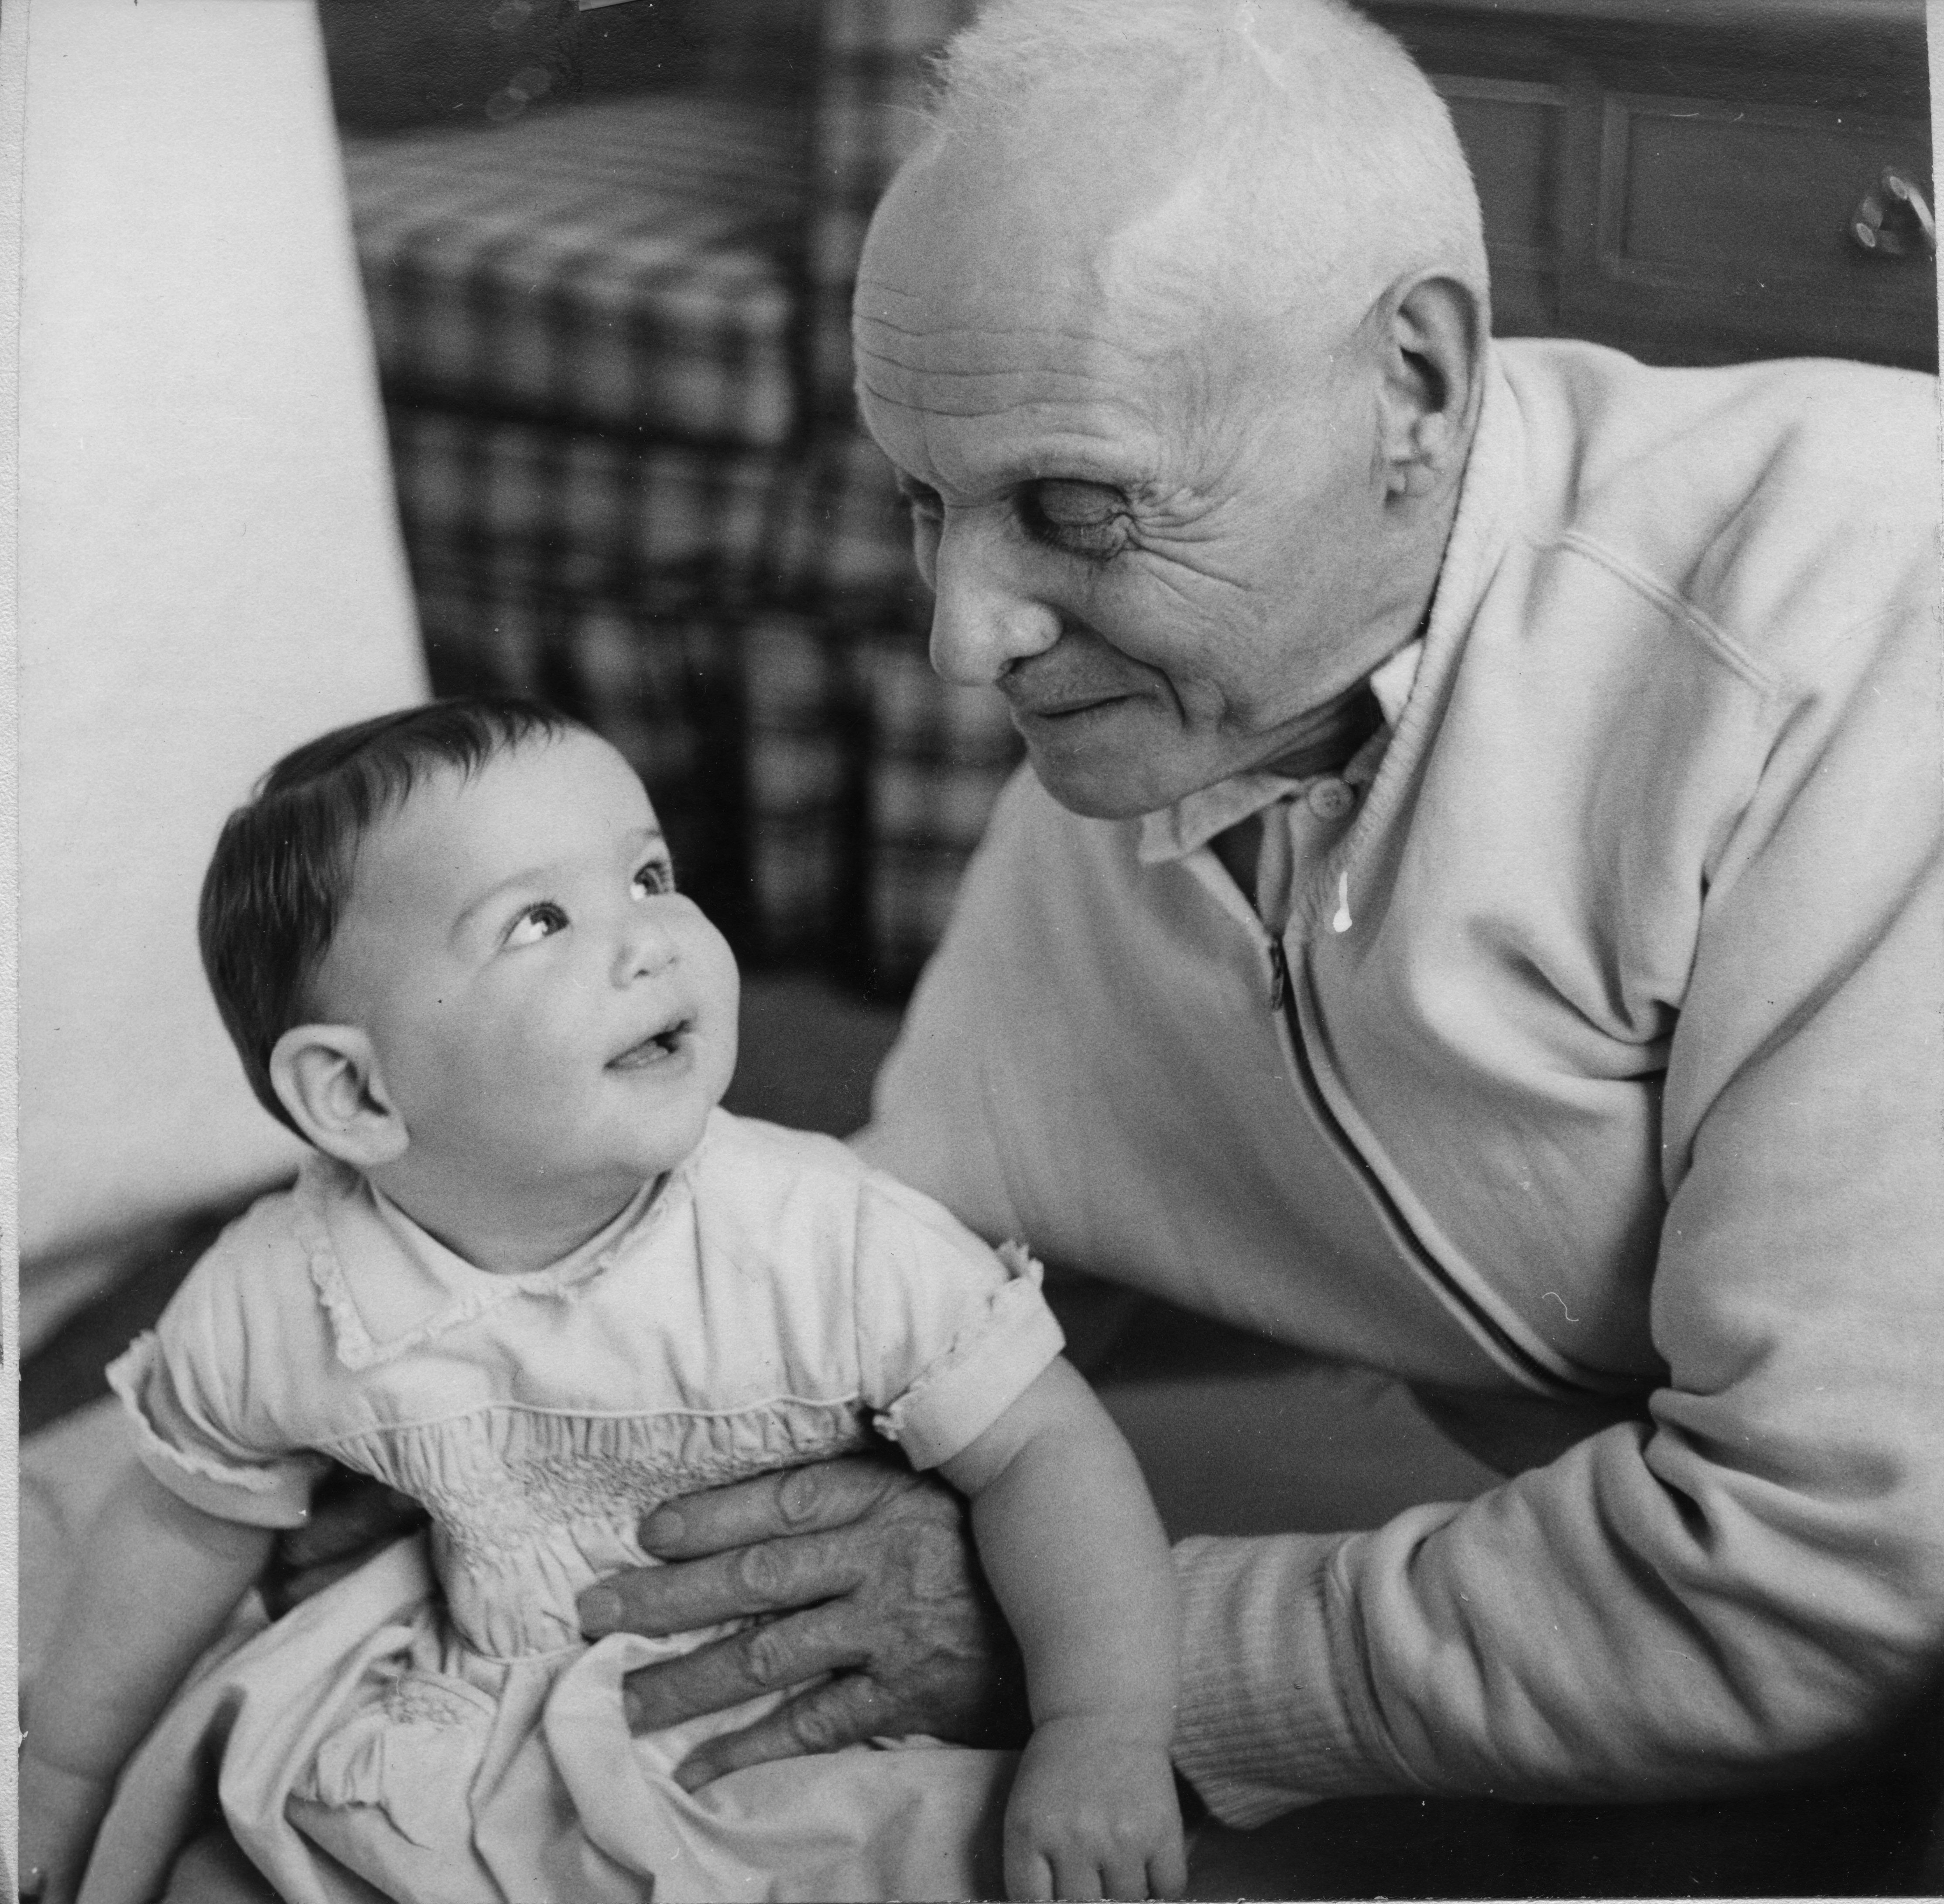This is my grandfather Lipa with my cousin Robin Matthewman -- She is the daughter of Sema Schub.

Both of my grandmothers were from the old country and they both had heavy accents. But my grandma Sara -- my father's mother -- was the one I was close to as a child -- partly because she lived closer and we saw her more often, but mainly because she adored me and made a big fuss over me. When my "Grandma from Toledo" came to visit, I'm sure she was glad to see me, but she had places to go and people to see and wasn't interested in doting on me. She was more abrupt than my Grandma Sara.

But when she was needed -- she was there. After my sister Sheryl was born, she and my mother stayed in the hospital for the routine two weeks. In the hospital, Lil was infected with Rocky Mountain Spotted Fever and had to return to the hospital for a couple more weeks. And throughout it all my grandmother was there, taking care of first me and then Sheryl and me together. It couldn't have been easy -- being in an unfamiliar city (the Bronx) and in charge of a brand new baby as well as whiny three year old me, who blamed my grandmother for my mother's absence.

Cousin Miriam reports the same thing -- my grandmother was tough, not particularly touchy feely, but when Miriam's mother was in the hospital with a hysterectomy, my grandmother came to take care of the household. And Cousin Sharon remembers the summer that she went to sleepaway camp and begged her mother (Aunt Sarah) to let her come home. My aunt brought her home, but wasn't happy about it, so my grandmother invited Sharon to stay with her in Toledo.

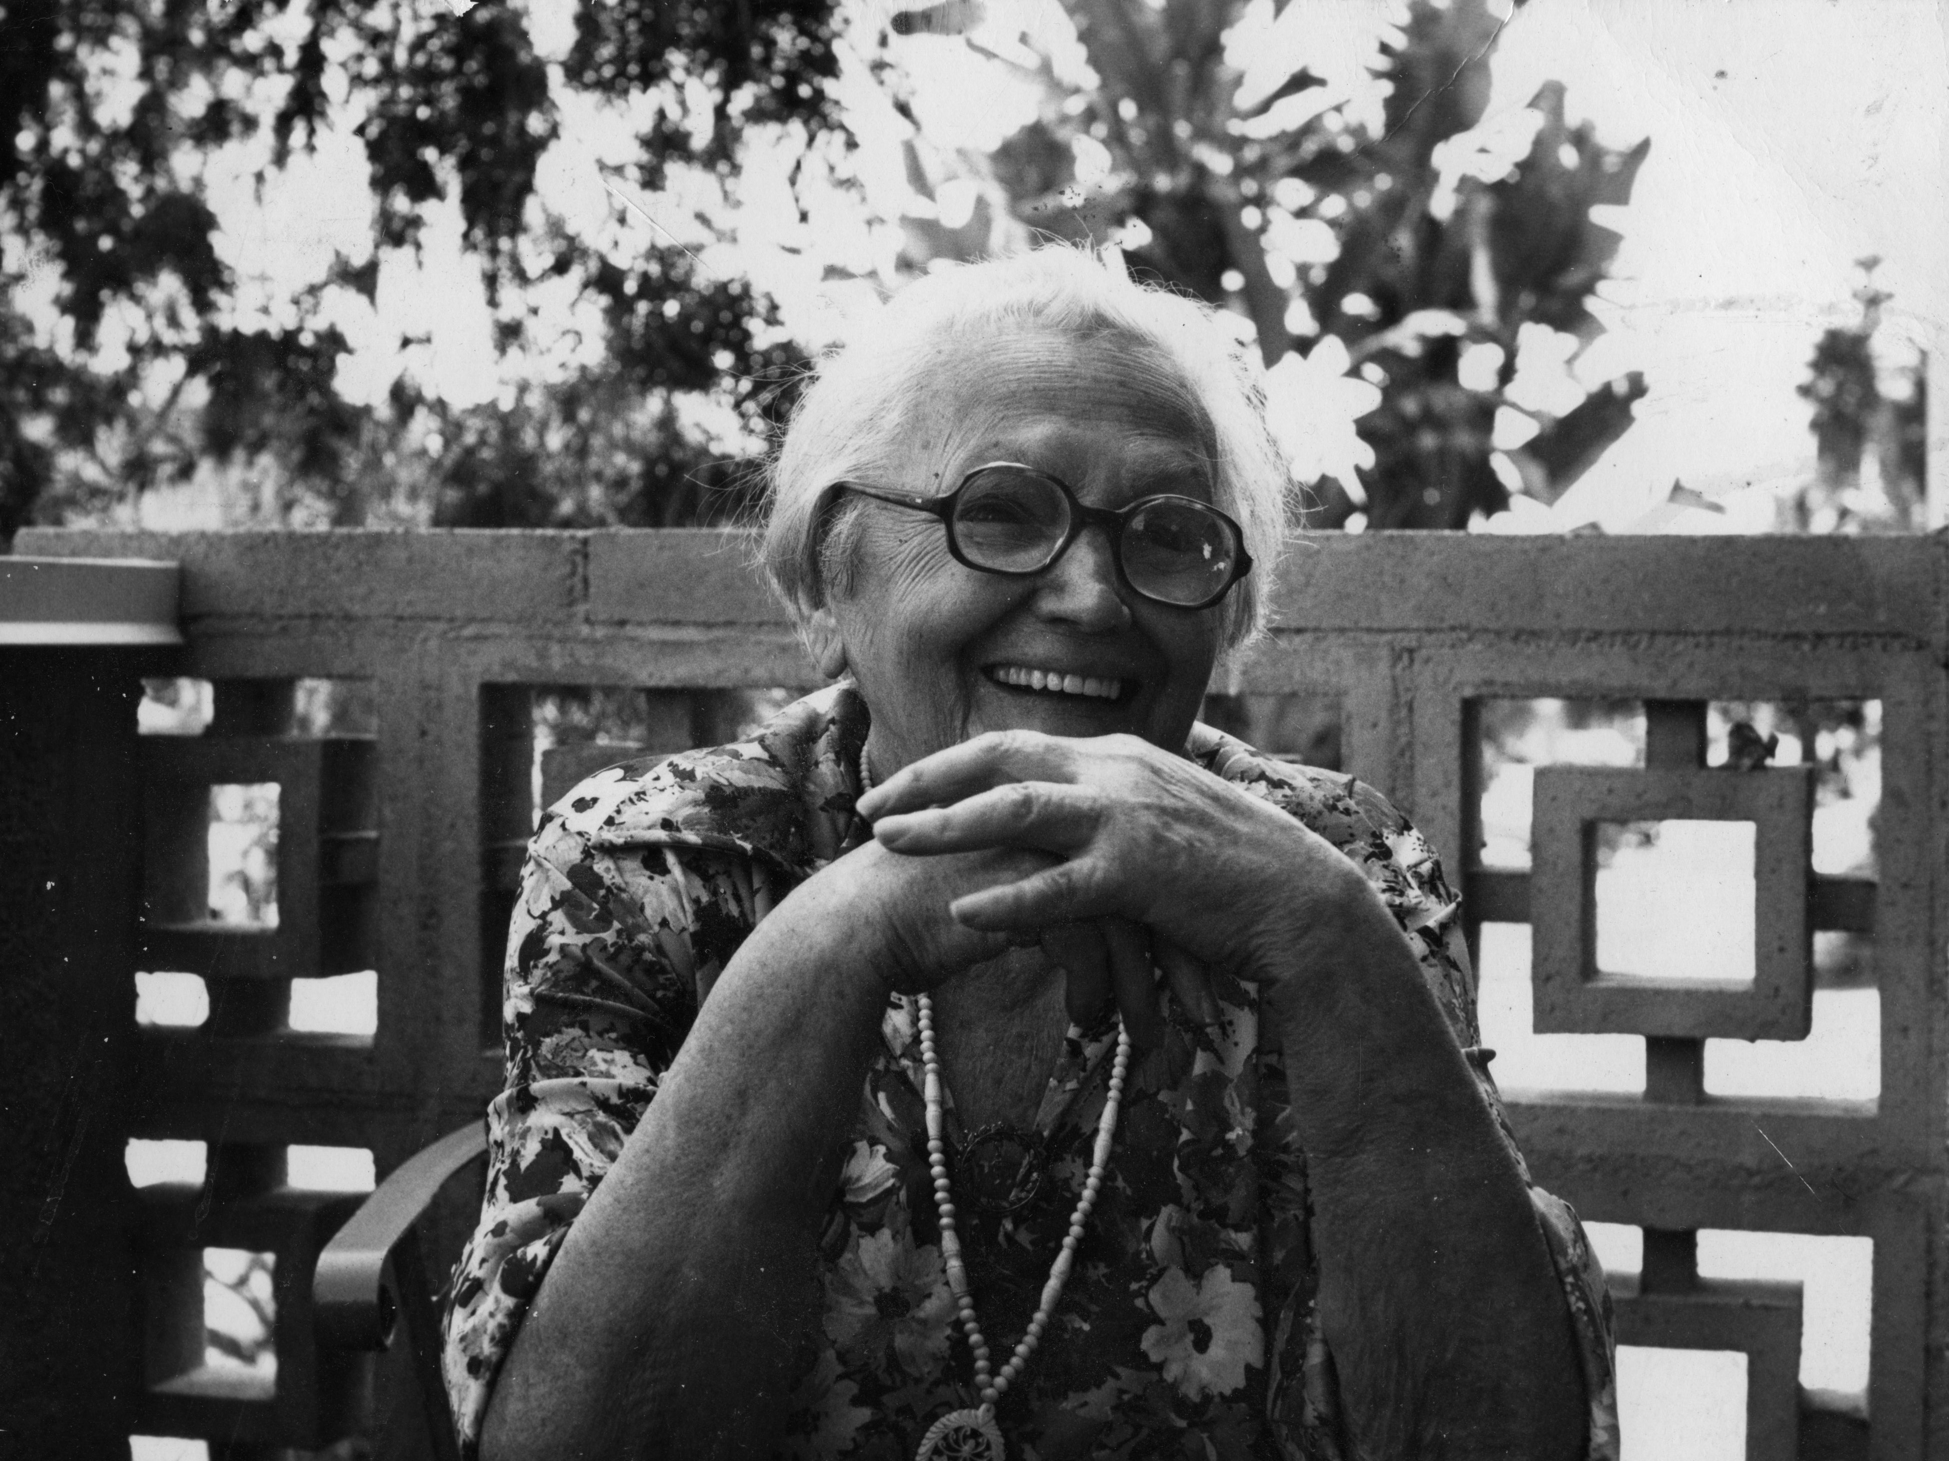

a little information about our great grandfather moishe

Our great grandfather Moishe drove a horse and wagon to buy and sell "junk." According to Cousin Irv, in the winter he sold his horse so he wouldn't have to feed it, and he bought a new one in the spring. He would only speak Yiddish and insisted that everyone else speak Yiddish. (Earl said that he had to learn English from his siblings.) My mother tells me that when she was in her twenties, she went to see Moishe in the hospital. As she entered his room she was astounded to hear him speaking to the nurse "in fine accented English," and she cried out,

"Zeida, you're speaking English!!."

He responded in Yiddish,

"Zugda mama loshen!" ( Only speak the mother tongue!)

He died in 1943. Hinde took care of him when he was ill with the cancer that killed him. I don't know how much he had to leave, but in his will he left his money to Basha, Sam and their sister Sarah and nothing to Hinde, who was deeply hurt.

My grandfather said that it was wrong, and he saw to it that the money was divided four ways, saying it was the only fair thing to do. According to my mother, Uncle Sam didn't think it was so fair, but my grandfather prevailed, saying that if necessary he and Basha would give up her share.

...............................................................................................

Little Zeida died in 1937. My mother told me that he set his beard on fire accidentally. Earl said that because Little Zeide was unwaveringly observant, he would never turn on a light on Shabbos. So, in the night, he took an already burning candle to go to the bathroom and that is how the accident happened. Earl remembers him being in the hospital and I think he died soon after.
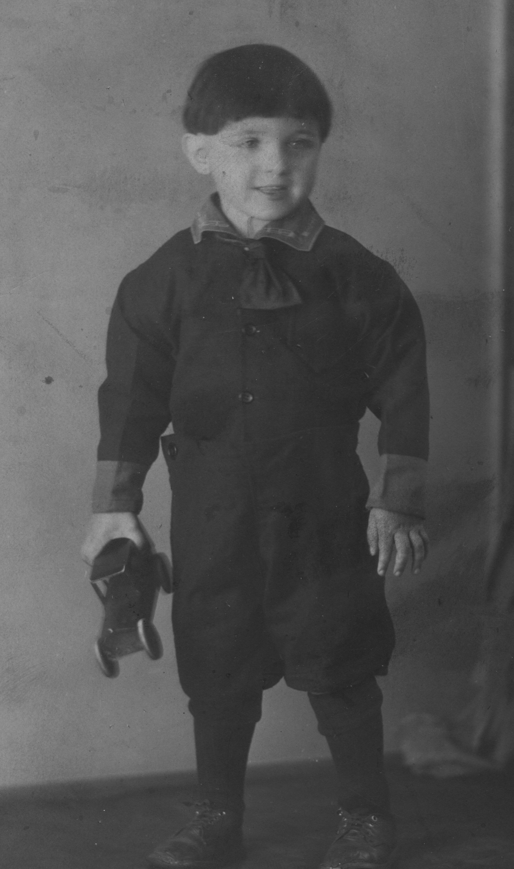My Uncle Earl in an undated photo. I think he looks a little like my son Loren in this picture, although I've never noticed the resemblance before.

LIL TAKES OVER

"I don't remember my childhood."

My Minyan once had a teaching about "lashon hara -- the evil tongue." We were taught that we are not supposed to gossip about others. The woman sitting next to me commented that if she didn't talk about others she'd have nothing to talk about with her mother.

I can relate.

When we weren't gossiping about people we both knew, my mother would talk endlessly about people I didn't know. Often she talked about people that even she didn't know -- for example, the husband of the daughter of a cousin of a friend. It was partly for that reason that several years ago when I came for the yearly visit, I told her I wanted to interview her and write down the story of her life. But for someone who liked to talk endlessly about other people, she was reticent to talk about herself.

"Who would be interested?" she asked, or, "I don't remember much about my childhood."

Nevertheless we spent a solid week talking about her life, and I only wish that I had pushed for more details.

I also wish I'd asked her to teach me what she knew about the stock market.

According to Lil, Basha continually told her that she wasn't very pretty -- said that she'd been an ugly baby and compared her unfavorably to Lil's sister Sarah. My mother told me that she never learned to swim because she was ashamed to be seen in a bathing suit.
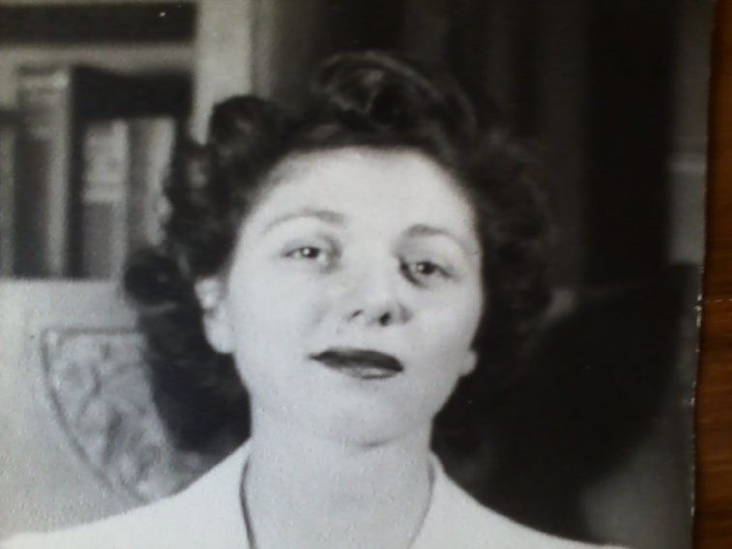

Once, when they were adults, Lil told Earl how she'd always felt unattractive, and he said,

"You were very pretty -- my friend Iggy fell in love with you because you were so pretty!"

Lil said that she avoided boys because she didn't think they would be attracted to her.

"When I worked at Port Clinton and later went overseas, there were a lot of men attracted to me but I didn't know how to react to them. In Hawaii, I went to a doctor and he invited me to the Officer's Club. I didn't know how to act; I felt out of place."

Lil's self consciousness about her appearance is really too bad. For one thing it wasn't true. But even if it was true, you certainly don't tell that to a child. For another thing, since my mother grew up with a terrible body image and I grew up with the same flat chest, I also felt terrible about my body for a very long time.

When I mentioned to Irv Alloy that Basha had always told Lil that Sarah was the beauty of the family, he said that he was not surprised Basha said this, because Sarah looked exactly like Basha and, in his opinion, was very much like Basha, while Lil was different.
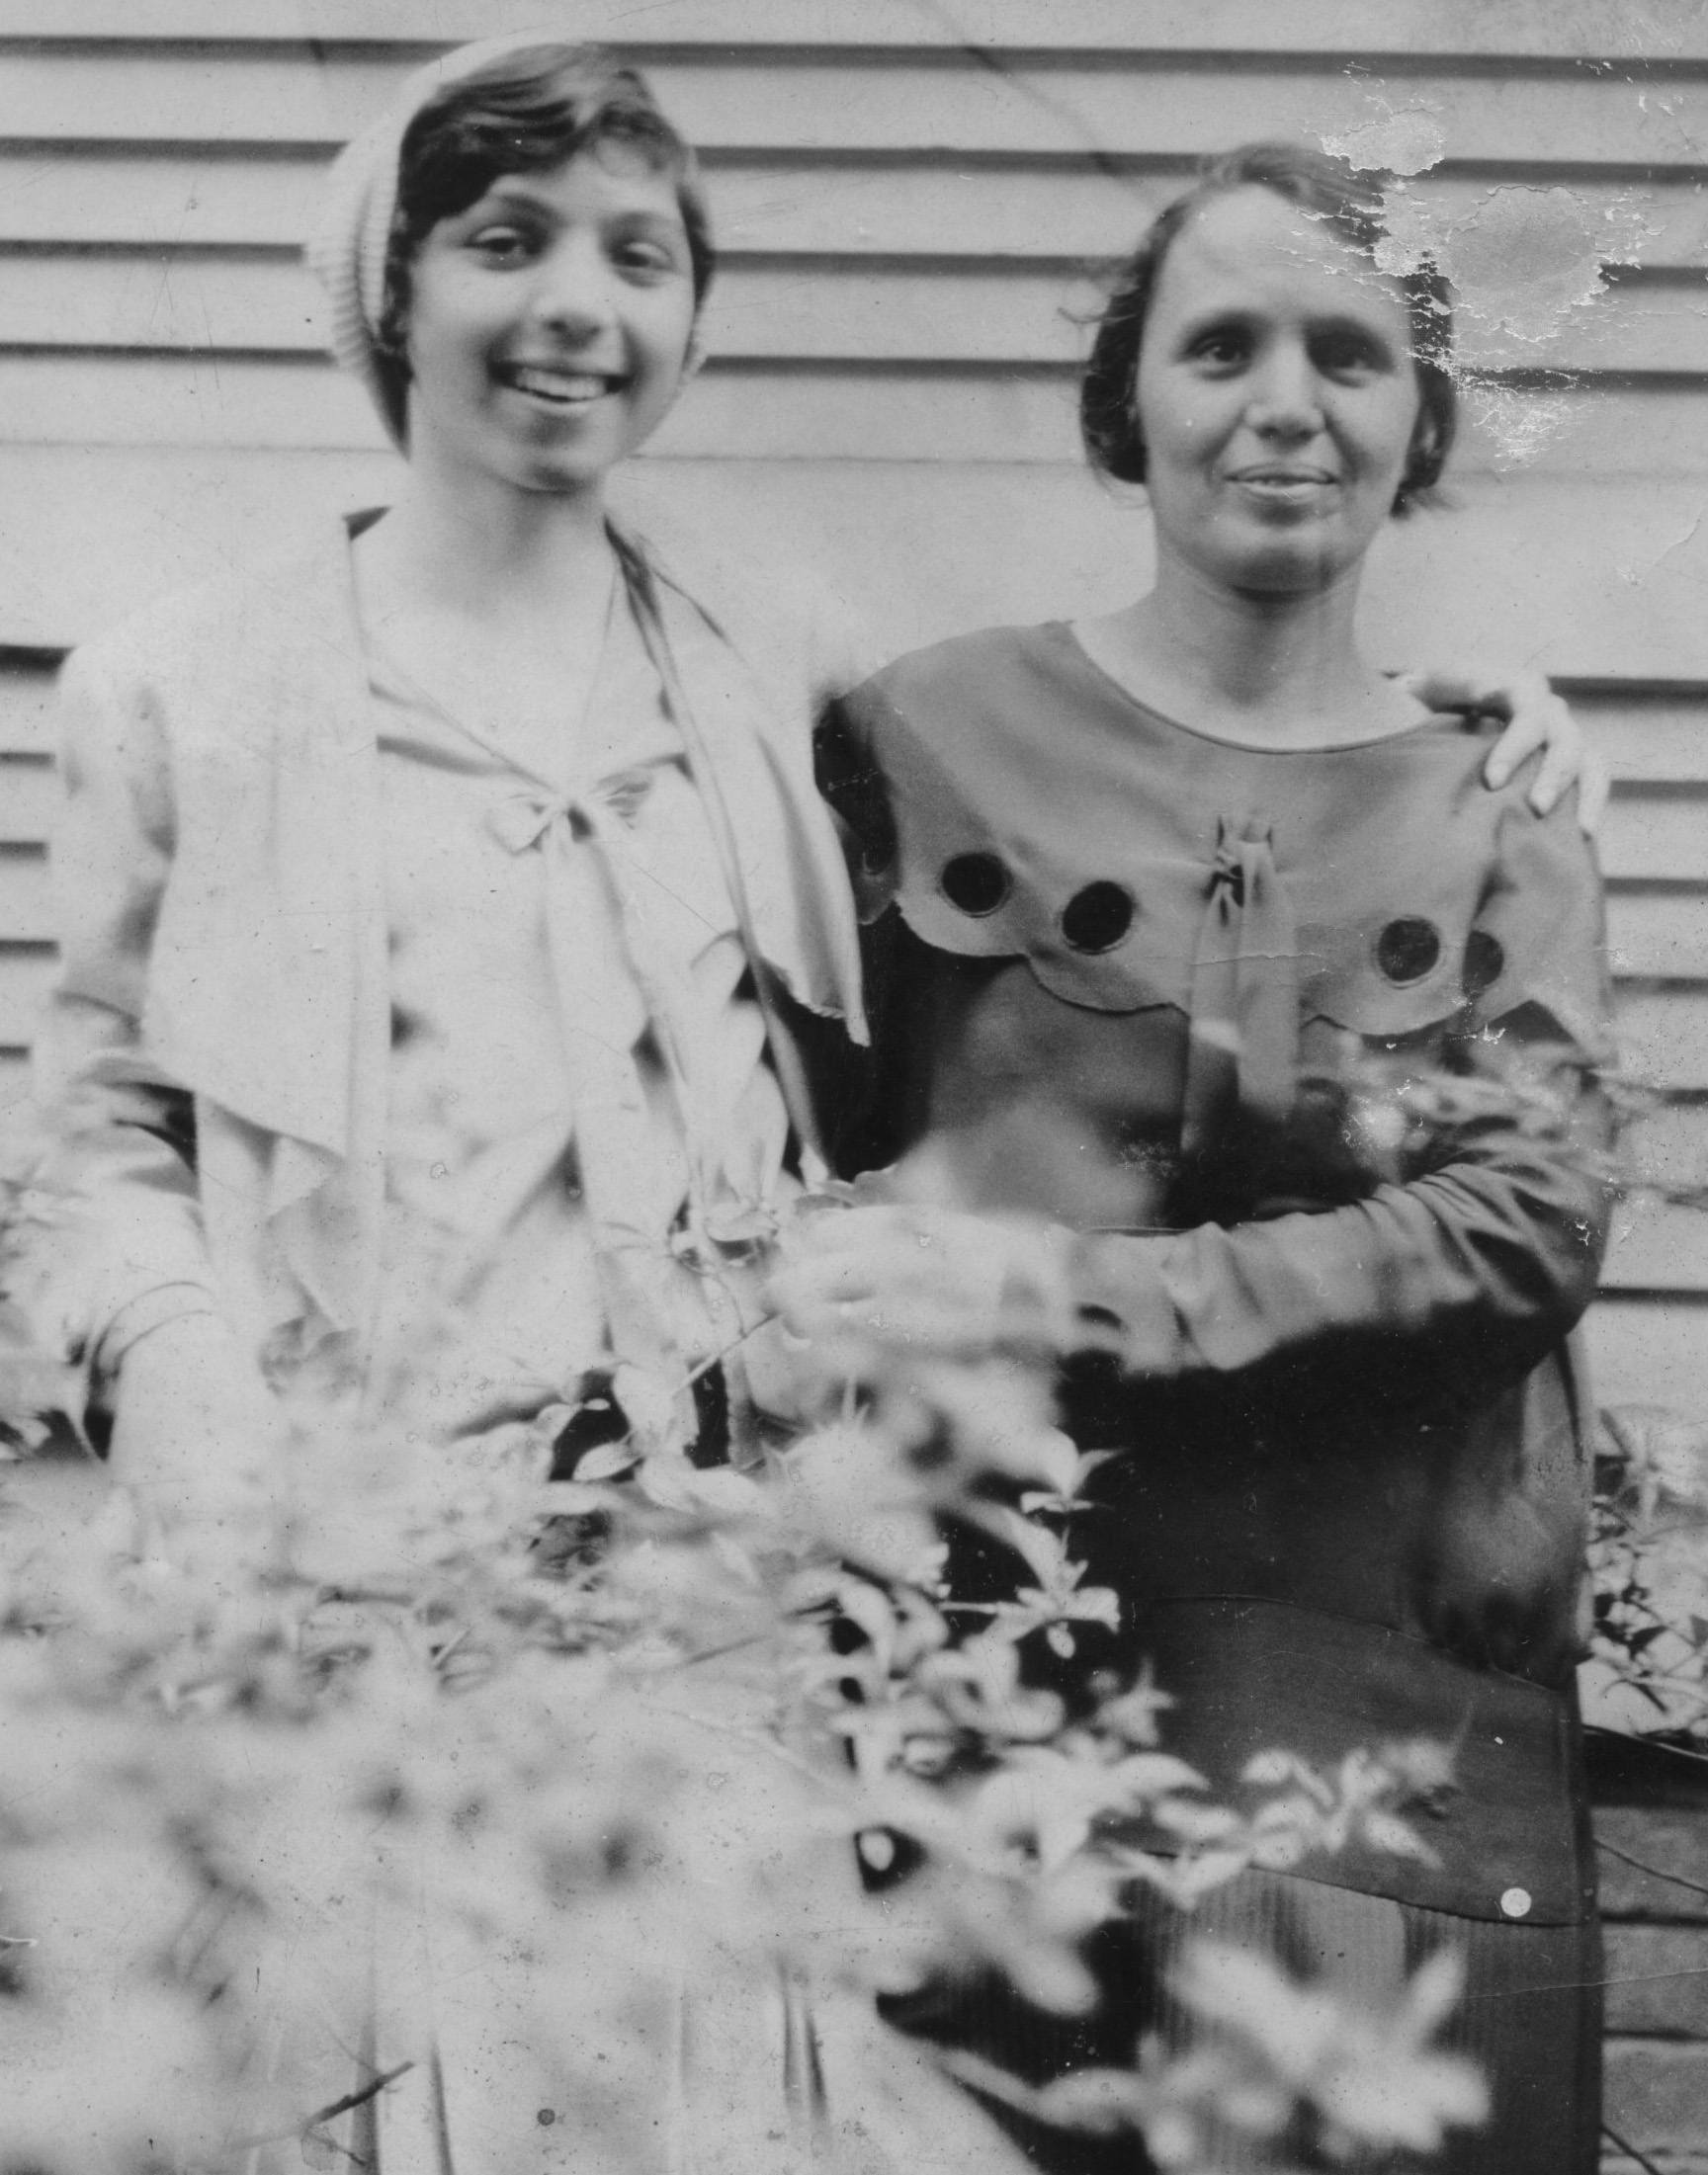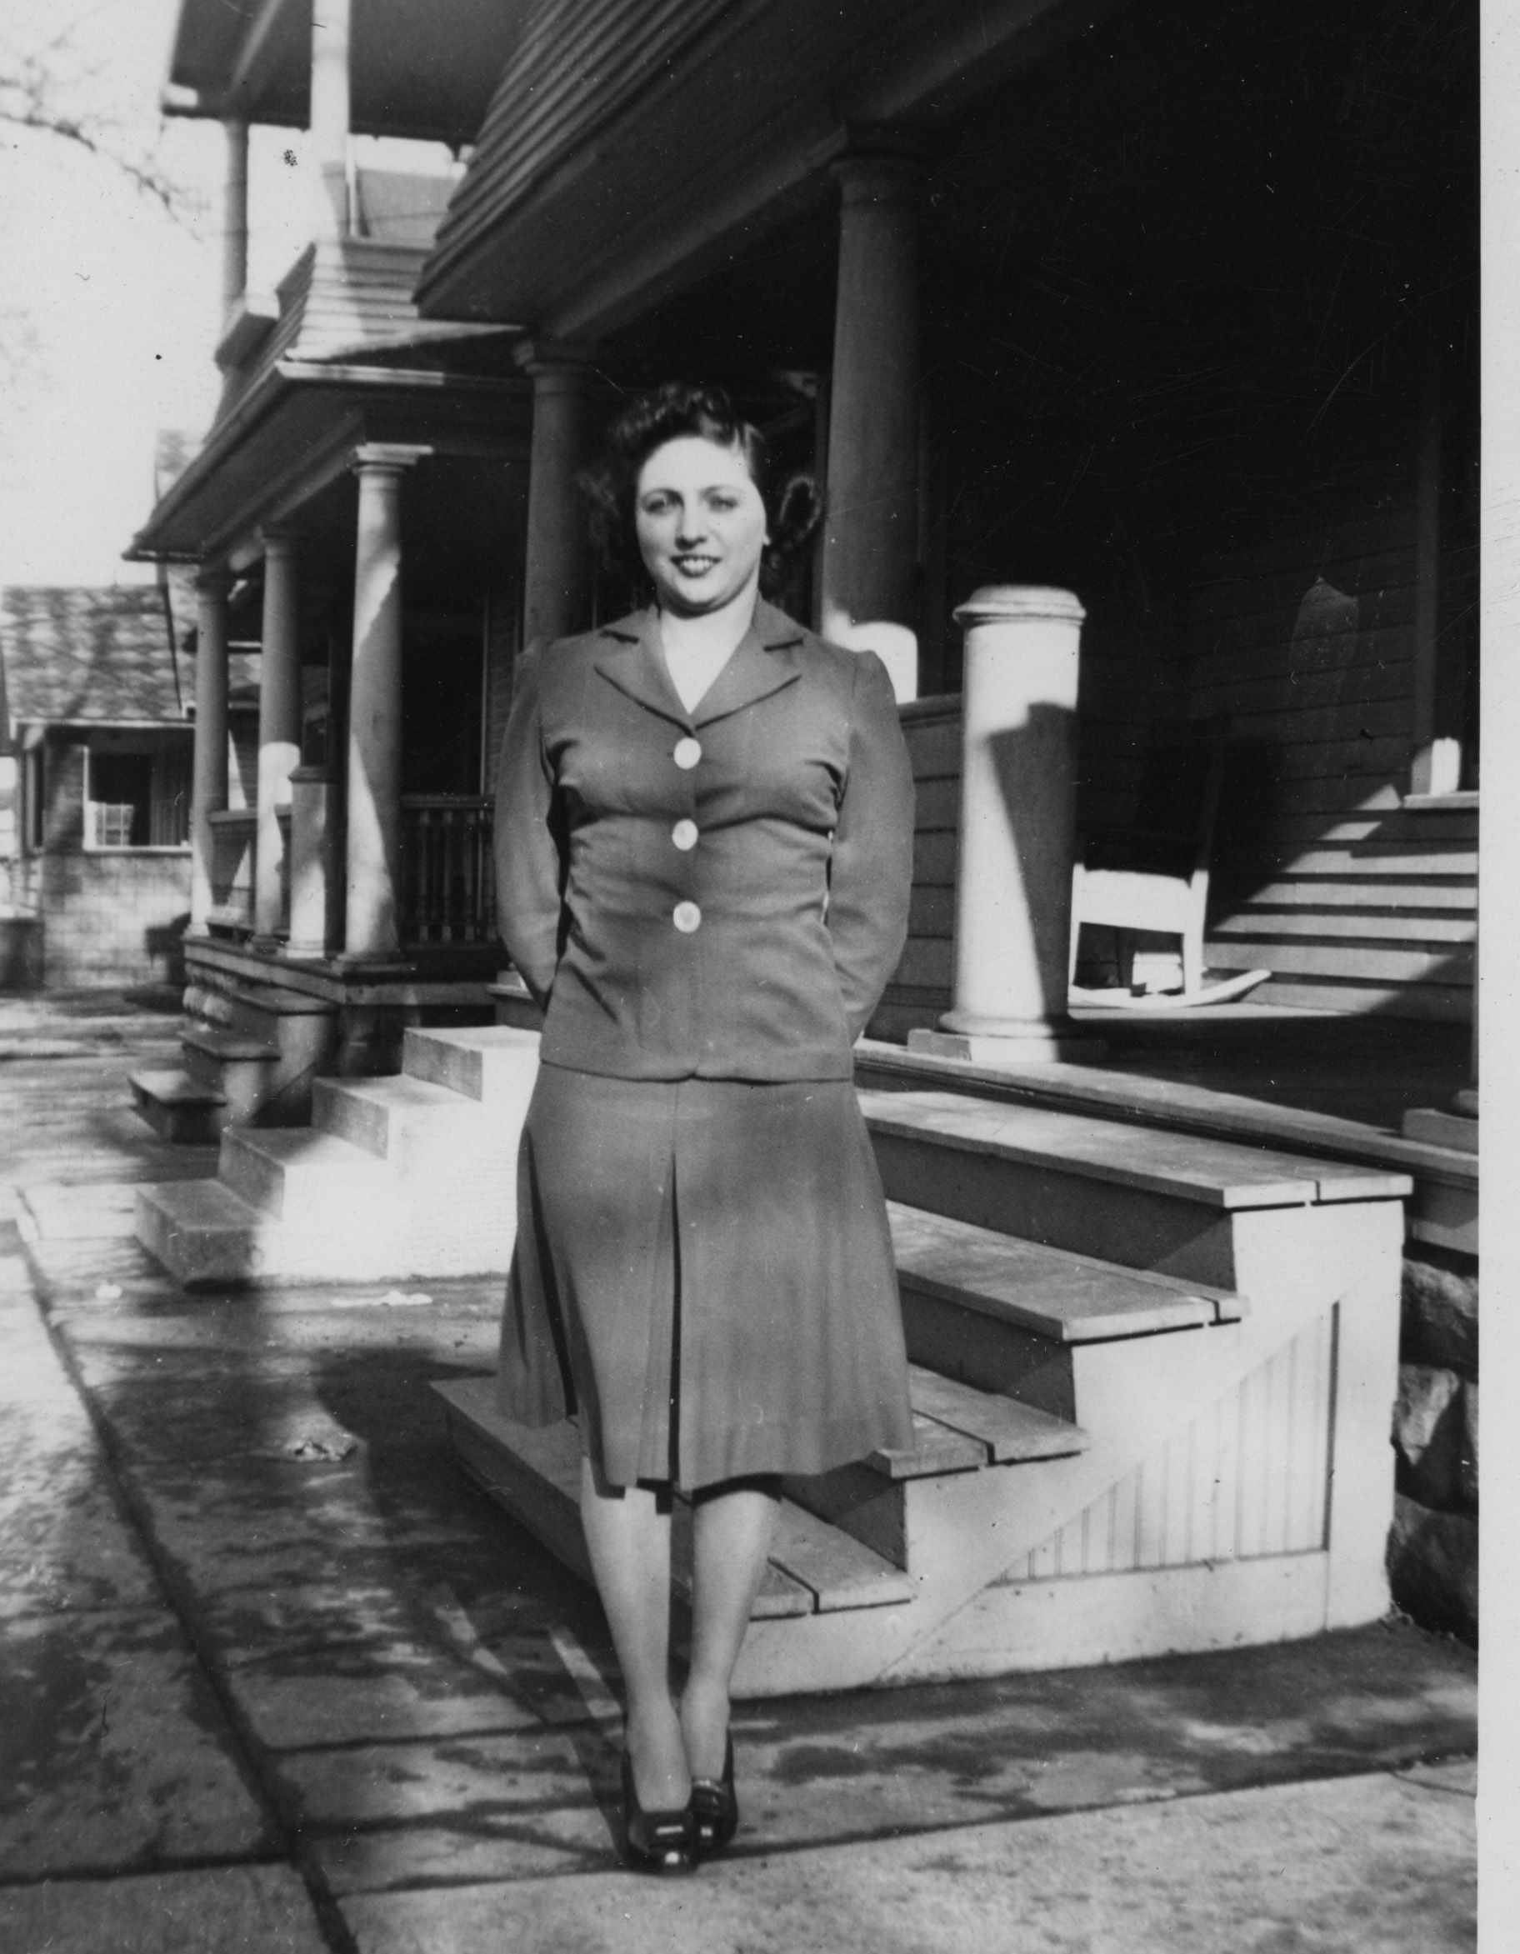
Lil and Basha (undated) Aunt Sarah Greenberg Applebaum Mazer

LIL TAKES OVER

When my mother was 12 years old, she took over the management of the house. Lil said, "My mother needed to escape."

By all accounts my grandmother was not a great housekeeper. I've been told that she was too busy "going to meetings and joining organizations" to keep house properly. I remember how in later years it drove my mother crazy when my grandmother's apartment was not clean or Basha's clothes didn't match or her slip showed or her stockings were wrinkled.

I sympathize with my grandmother. As someone with five children of my own, I understand how things can slide And my grandmother had two grandfathers living with them in a small house, not much money, and discord between her husband and her father. I can see why she wanted to escape. There are more exciting things to do than clean the floor.

As for her appearance -- who knows? Was it her lack of familiarity with American clothing? Her vision problems? When a mother has small children who make messes, she can get out of the habit of wearing nice things or even paying attention to appearance at all. And some of us never get back in the habit. After my kids were born it took me years to start taking pains with my clothes again. (If my mother were here to join in this conversation she'd probably debate that I ever cared in the first place.)

Nevertheless, I can also understand how conflicting it must have been for my mother. My first generation parents wanted to fit into America, and they wanted their families to fit in as well. That meant looking and talking the part. My first generation aunts on my father's side were forever correcting my English, my first generation father was a stickler for manners, and my mother AND my father AND my father's sisters cared tremendously about the way everyone in the family dressed and spoke. I remember my cousin Jerry saying that it didn't matter WHAT he said -- it mattered how he pronounced the words.

"I could be explaining my philosophy of religion and Rose would turn to Gus and say, 'Look how he wiggles his nose when he talks.'"

Both Basha and Lipa went to night school to improve their English, but they always spoke with heavy accents, and at home only Yiddish was spoken. Did that embarrass my mother and her siblings? I don't know.

"I WANTED MORE THAN WHAT WE HAD"

"Our life was so different [from the way it is now] We lived from hand to mouth."

I grew up knowing that my mother's family was poor. She told me stories about having one dress to wear to school -- which spurred her on to learn to sew. She made a lot of my clothes. It was really irritating when we'd go shopping and I'd pick something out and she'd say,

"It hurts me to pay so much for something I could sew."

But the clothes she sewed never looked like the ones off the rack. And she wouldn't let me spend my babysitting money on store bought clothes if she deemed them too expensive.

That does sound like whining. A first world problem. Sorry Mom.

The clothes thing pretty much changed when I went to college and Lil felt badly because she knew how disappointed I was to be going to Albany State instead of Boston University. Suddenly I could have anything I wanted including an open ended clothing allowance. When I ran out of money, I just called home for more. There was one tense vacation when I came home wearing one of the first tie dye shirts ever seen, with a pair of jeans. Lil cried. Literally.

"Only farmers wear dungarees, and that shirt looks like a rag," she wept.

But the clothing allowance continued, and I made a point of mailing home a pair of jeans to my sister Sheryl.

.................................................................

By the time she died, my mother had put together quite the stock portfolio. She told me once that even when she was a child she saved money.

"Even in third grade. People always came to me."

She also said she learned not to borrow, and recounted an incident when she'd borrowed a dollar and forgot to pay it back until months later when the lender reminded her. This is something she taught me well -- I've never considered paying interest on a credit card and to my knowledge, neither have any of my children.

"RELIGION AT THAT TIME WAS WHAT YOU WERE"

"I know the whole service by heart because I've been going to services all my life.

It hits me now for the first time that my mother came from an Orthodox home -- Not only was the kitchen kosher, but Shabbos was strictly observed. Passover seders went until midnight and the grandfathers went daily to the shul down the street. There were three Orthodox shuls, with one Rabbi between them, but the men all knew the service.

My mother told me that she went to "cheder" at the Orthodox shul. The women were only expected to go on the holidays, and my grandmother Basha was the only woman who could read the Hebrew Siddur. (Basha also read newspapers in Yiddish and English)

Cousin Irv mentioned that services were completely in Hebrew or Yiddish, but he remembered one time when the Rabbi gave a sermon in English.

"The old people walked out."

I wonder if my great grandfathers were among them.

"I enjoy Reform."

"Even as a teenager I could understand it. The Hebrew meant nothing to me. As far as I'm concerned, if they would look into the Bible the whole thing would look like Reform. Reform grows with the times. Orthodox is overdone. They're not living with the times by not letting women be part of everything."

My mother's mantra: " It's not what you don't do, it's what you do that counts."

She would say that and then add,

"I don't judge anybody. Everyone does what's right for them."

My mother didn't like the Orthodox service or the rules. There was a Reform Temple on the other side of town "where the rich people went." Lil used to sneak out of the house on Friday nights because she liked to listen to the Rabbi. When she was a teenager she became president of Junior Hadassah, and she stayed a Hadassah member all her life. In her will she left some money to Hadassah, but after the Bernie Madoff scandal, Lil regretted that decision. Hadassah had invested with Madoff, and she thought if they were that stupid to invest with him she didn't want to leave them any money. My sister informed her that it would cost more to change the will than what she'd left to Hadassah, so that was the end of that.

. . . . ....................................

CHARLIE

"It killed my mother."

I think Lil completely broke away from Orthodoxy due to the family and community reaction when Charlie married a gentile woman. "All of a sudden one day he announced he had a wife and child and my grandfather Moishe sat shiva."

Irv told me that it was a real shiva -- the mirrors were covered; people came to express their condolences.

Although Lipa and Moishe did not get along, my great grandpa Moishe was like a buddy to both Earl and Charlie. But after Charlie's marriage, that was the end.

My grandfather Lipa, on the other hand, told the family that they'd have to accept it.

I wonder what Lipa did while his father-in-law sat shiva.

"Charlie never got over it."

When Charlie's little boy, Jerry, was two years old, he died. Charlie wanted to bury him in the Jewish cemetery, but the Rabbi wouldn't allow a non Jewish baby to be buried there. Lil told me,

"I begged him, but he would not relent. I never had anything to do with that Rabbi after that."

we don't forgive and we don't forget

My mother never forgave the Rabbi.

25 years later Basha ran into him, and when he asked her whether Lily had ever forgiven him, my grandmother replied that she had. When Basha told my mother, Lil was furious

"How could you say that!"

When Lil told me about it she said that any time someone in the family had an issue, Basha would think "the other person was right."

Charlie and his first wife had two more children -- David and Judy. One day, Charlie's wife left him, brought David to her parents and took Judy with her. She ended up leaving Judy with another family but Charlie never knew where she was. Charlie sued for and got custody of David. When David grew up, he conducted a search, and eventually Charlie and David were reunited with Judy, who was now married to a Mormon. She had no idea that her father was Jewish.

My mother's sister Sema and brother Earl lived in the NY metropolitan area when I was growing up, and we saw them fairly often. My Aunt Sarah would occasionally come in from Detroit. But my Uncle Charlie was not part of our life. I saw him maybe once when I was growing up.

There were issues.

Lil thought Charlie had been pushed into school too soon. He was a tall boy and started kindergarten a year early, even though he wasn't really ready. She said that all his life he was trying to catch up -- schoolwork didn't come easily to him.

Family folklore says that Charlie was frightened of a dog that lived on the path to school and Lily had to walk with him to run interference.

She told me once that she felt pretty bad about something with Charlie. She'd had a collection of silver dollars in her room and one day either some or all were gone. She suspected that Charlie had taken them, and she told my grandmother, who did nothing. Years later, she mentioned it again to my grandmother, but this time my grandmother told her that it was almost definitely the old lady who lived upstairs,

"She was always coming in and taking things."

"Why didn't you tell me?"

My mother felt awful.

I don't know much about my mother's scholastic life except that she got good grades. Lil signed up for the college prep classes in high school, but when my Uncle Charlie told my grandmother about this, my grandmother insisted that my mother switch to the business classes that would train her to be a secretary.

She would always regret that she didn't go to college. After the war there were jobs she couldn't get solely because of the lack of the credential. My Uncle Earl was the only one in the family who graduated from college. He even got a Masters from Columbia. He worked his way through, and Lil was proud of him.

Earl credits my mother for keeping him out of the active fighting during World War II. She urged him to go to electronics school, which he did, and as a result he spent the war in the Brooklyn Navy Yard, teaching electronics. She never told me that she was the one who advised him what to do, but he is grateful to this day.

Earl told me that Charlie started going to the local university, tuition was paid, and then it was learned that he wasn't going to classes. Earl didn't go into details, but I got the sense that my mother was furious. Here she was working and contributing major support to the family, while Charlie blew the opportunity that she wished she'd had.

How frustrating it was to be a female back then.

Nevertheless, my Aunt Simmy said about my mother,

"Lil did what she wanted."

Cousin Irv said that Lil was an early feminist.

"She smoked before women smoked."

Certainly she drove before it was common for women to drive. She had her own car and took a cross country trip to Yellowstone with four other women soon after high school. Sema told me that Lil really loved to drive; she remembers taking a trip to Niagara Falls with her.

Lil graduated from high school in 1933. The trip to Yellowstone would have been about 1934. The car was a brown Chevy.

"That's all you bought. Chevy was dependable. Ford was anti-semitic."
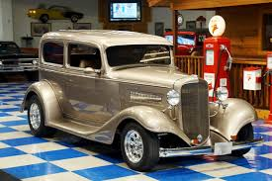
She took no pictures of her car that I could find, but she told me it was a Chevy, and Simmy told me it was brown so it could have looked something like this.

It's funny the things that people remember. Several times when I asked her about this trip the thing that was paramount on her mind was that they stayed at one room cottages where there would be two beds and a cot. The women drew straws, and for the first three nights she ended up sleeping on the cot. The fourth night she complained.

I heard that story severaI times, but I didn't get any details about scenic wonders. She did mention that one time they took a shortcut that turned out to be a scary road and one of the women almost drove them off a cliff.

The photo below on the left is Mt. Rushmore the way it looks today. Next to it is a picture of unfinished Mt. Rushmore that my mother took back in the early thirties.
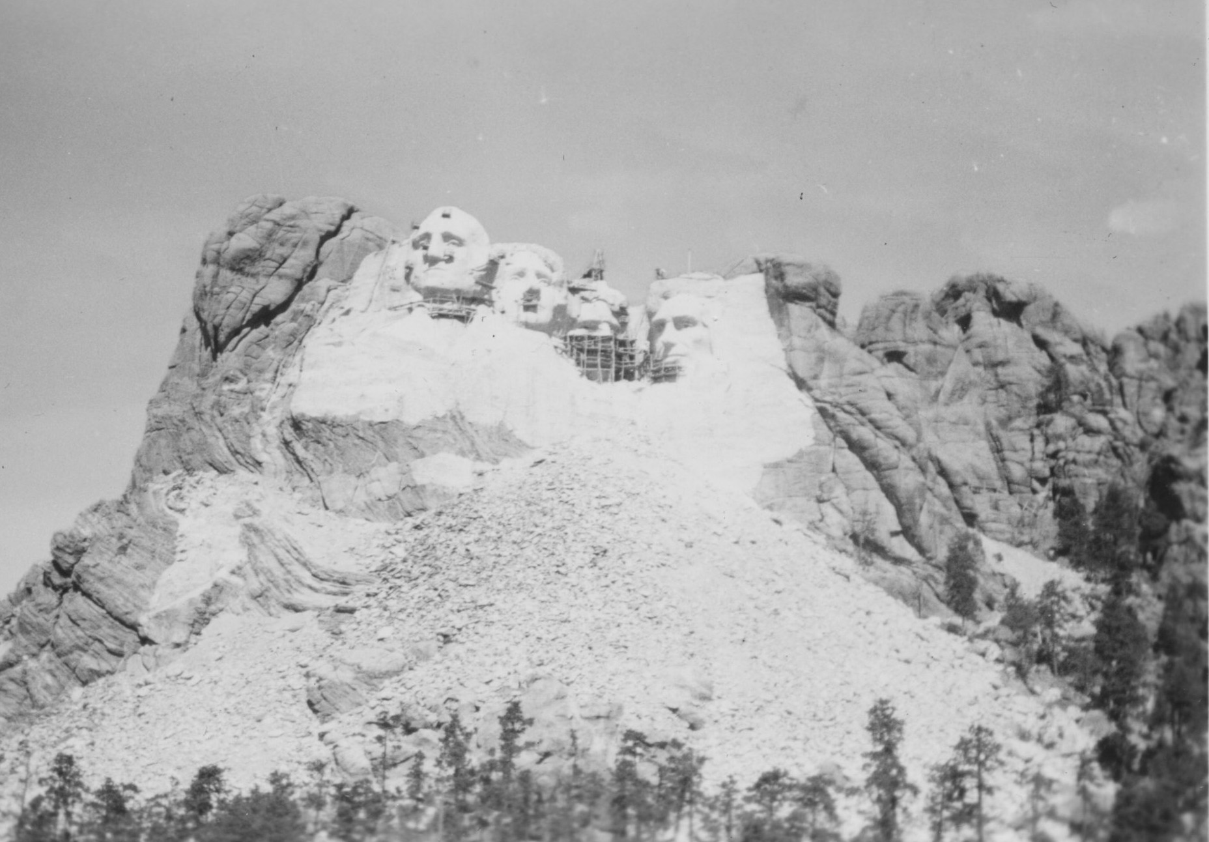

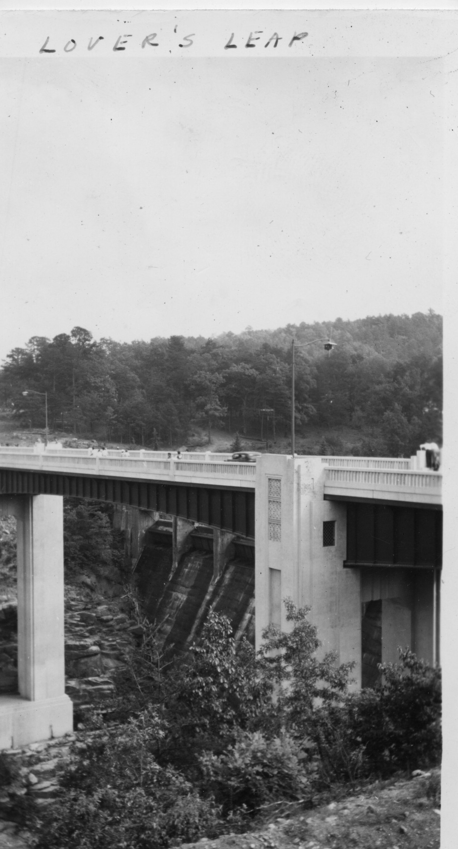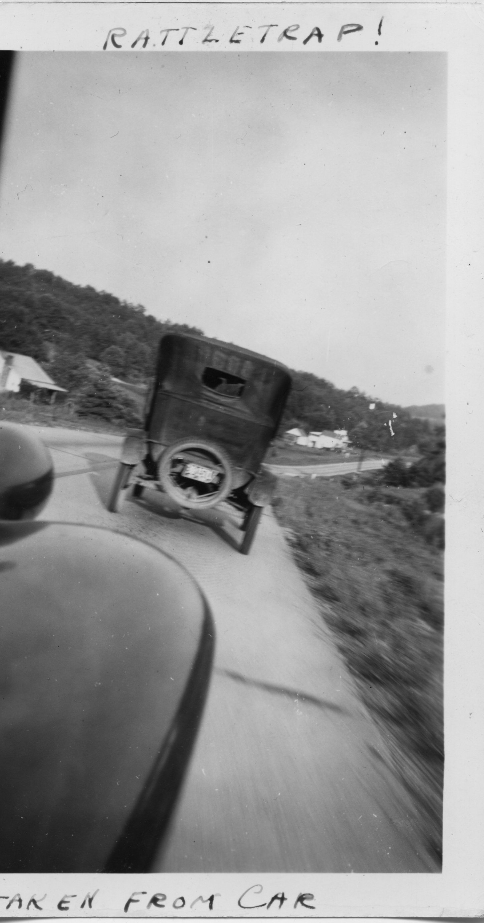
Lil didn't label most of her pictures, but I think this bunch and the ones on the previous page and the next page were from her trip to Yellowstone. There are a lot of pictures of the Smokies and I think they probably stopped in the Smokies on the way to Florida.

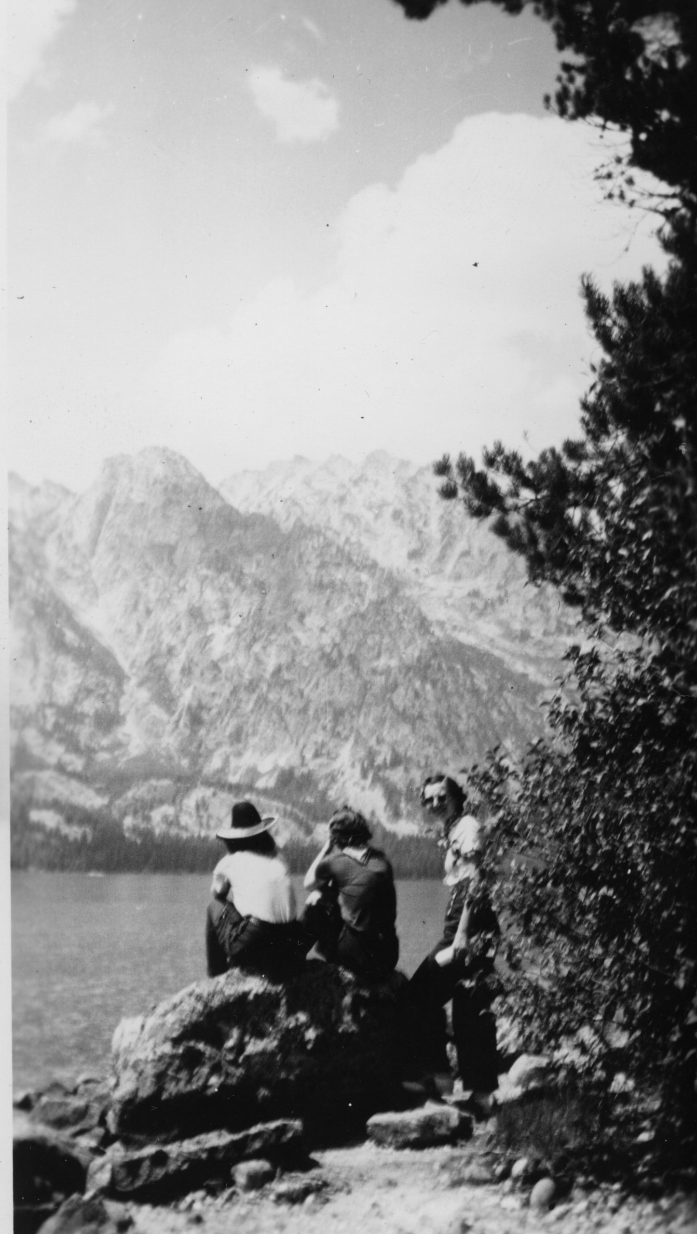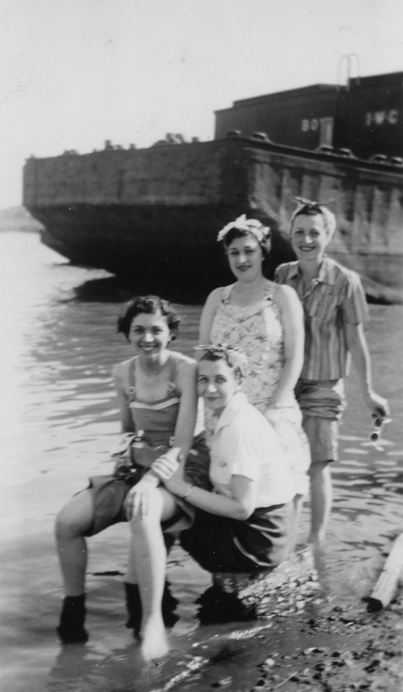

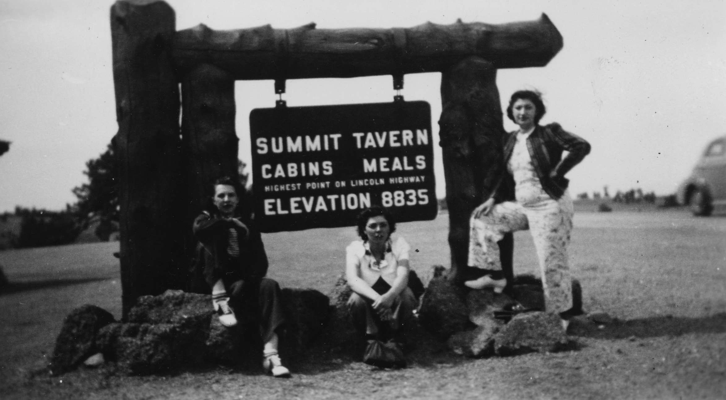

Terry and I think that the waterfall on the next page may be Bridal Veil Falls. And we're very impressed that she saw a bear up close! I was actually wondering if the bear was really in the wild, but it does appear to be. We don't know where the pool is.

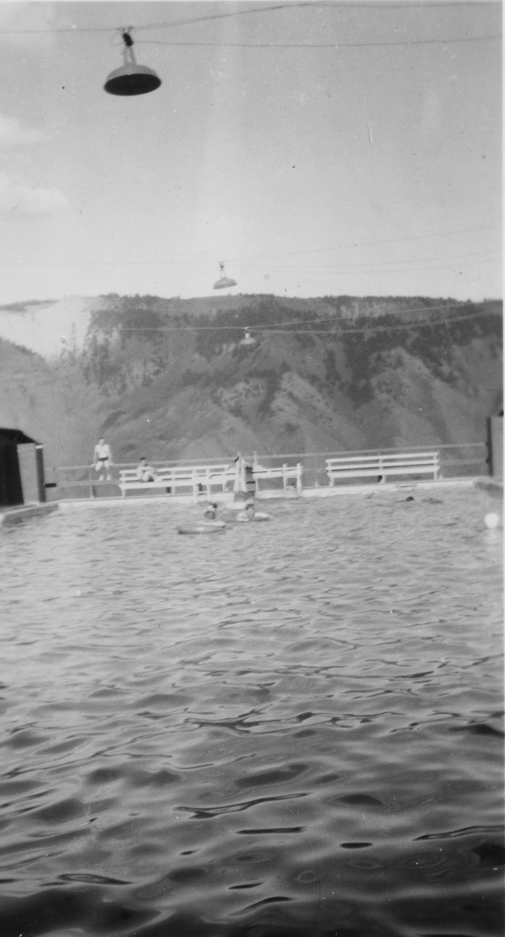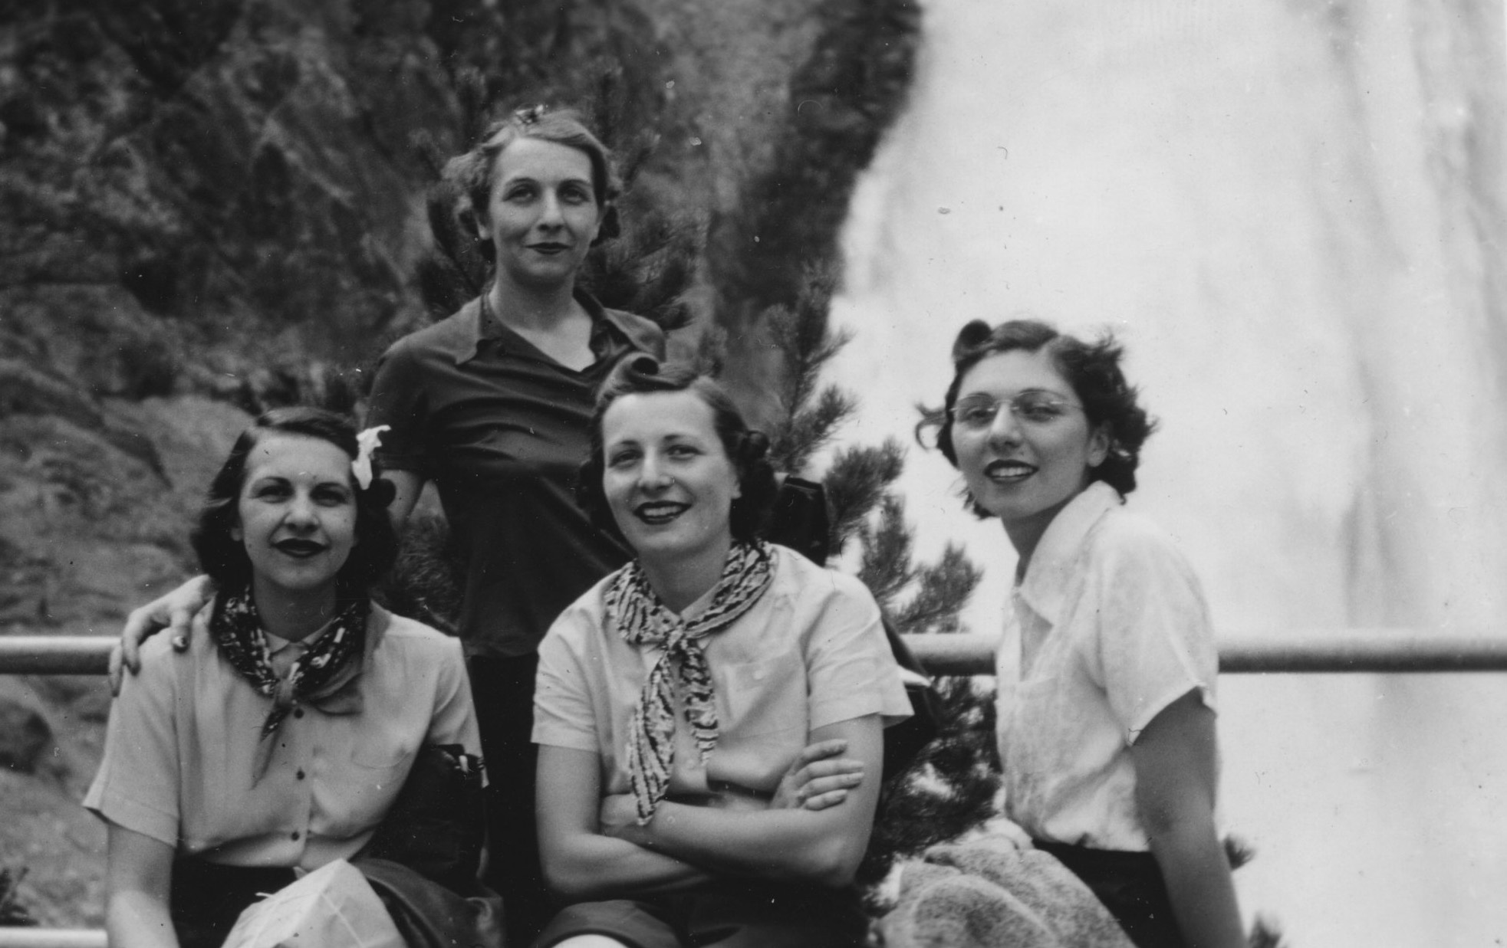

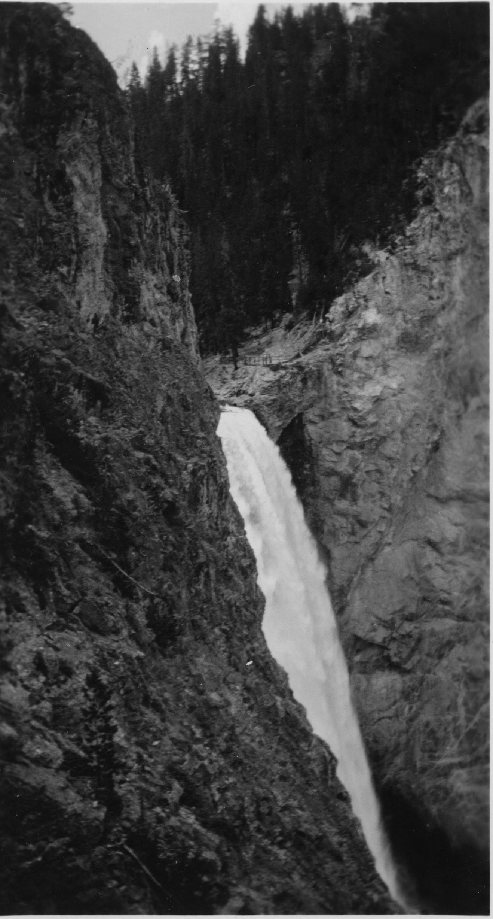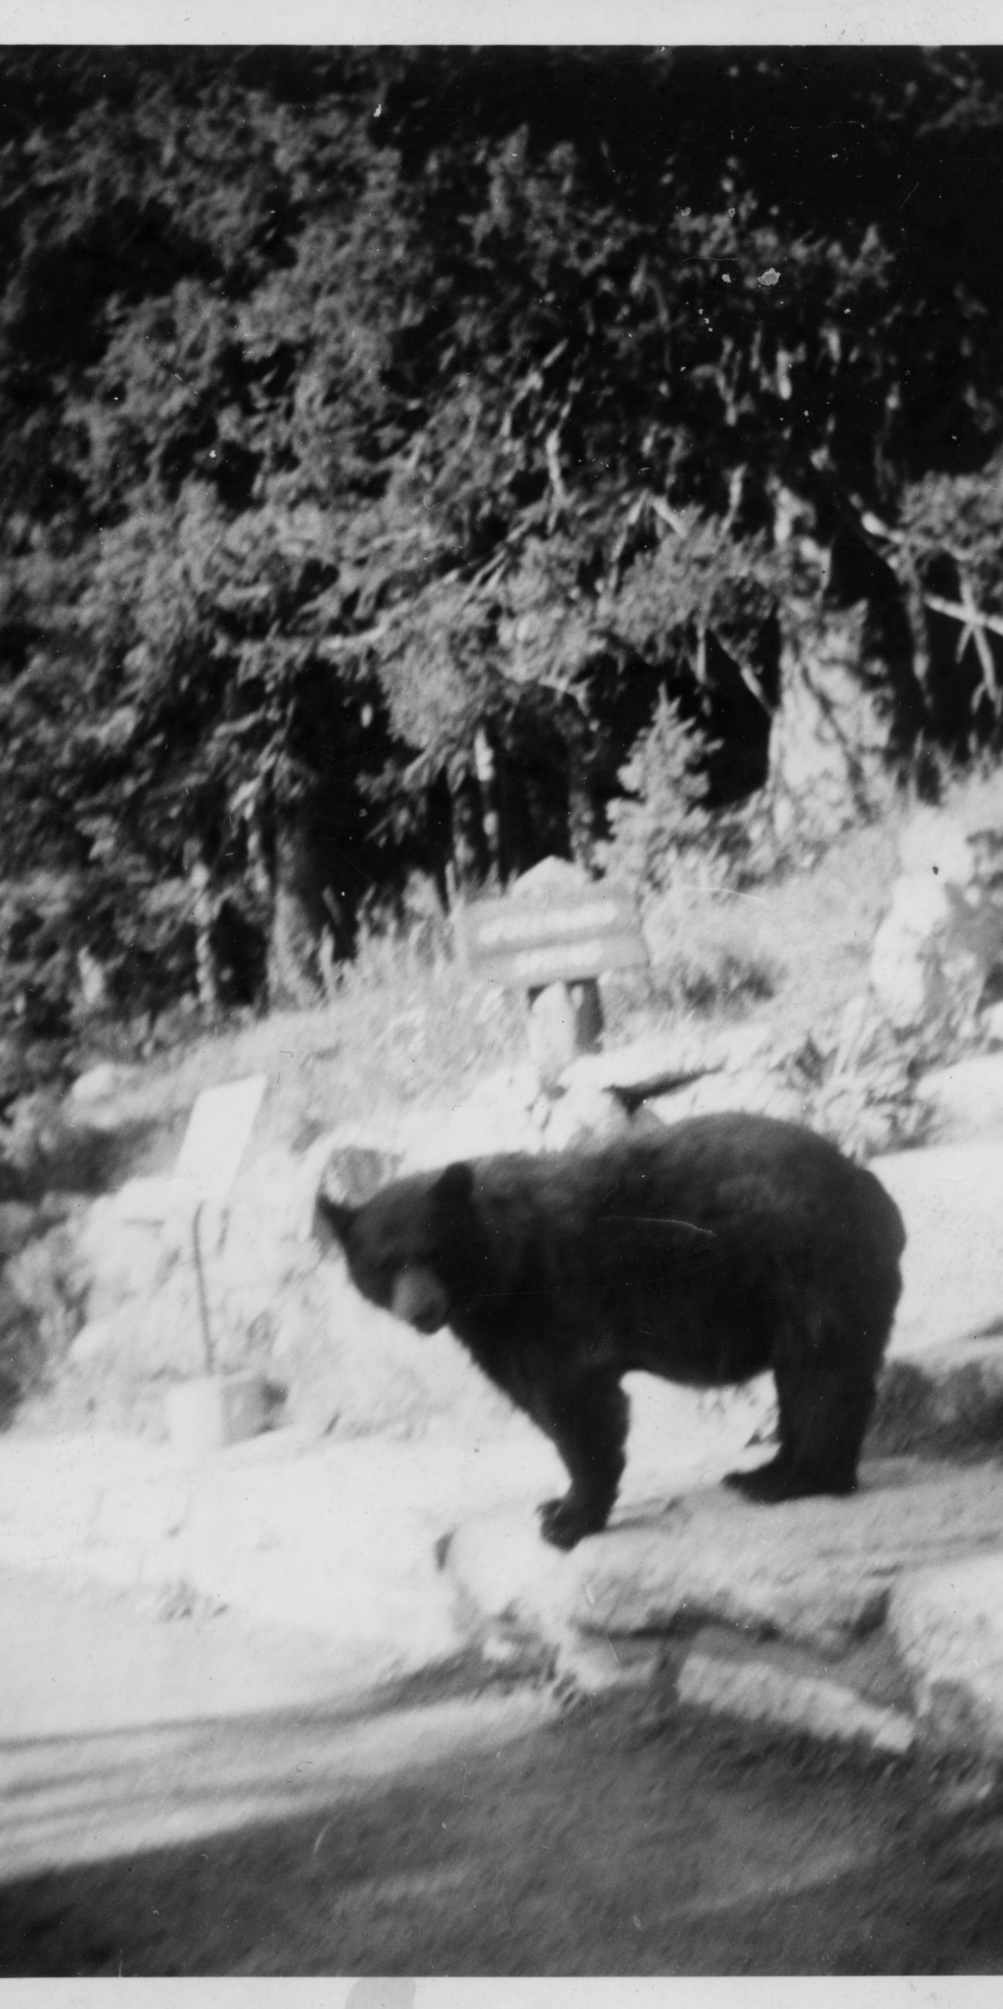

Another time the group (minus one woman who'd gotten married) went to Florida and one of them women got sunstroke. On that trip my mother and the desk clerk spent a lot of time together. She never found out if he was Jewish but she thinks he must not have been. What is amazing about that to me is that something was going on with them to the point where the hotel owner told them if they got married he'd give them a free stay. So they liked each other, but never talked about religion. Bottom line -- she didn't want to know.

Lil told me that people dated differently back then. If you dated the same boy, you married him.
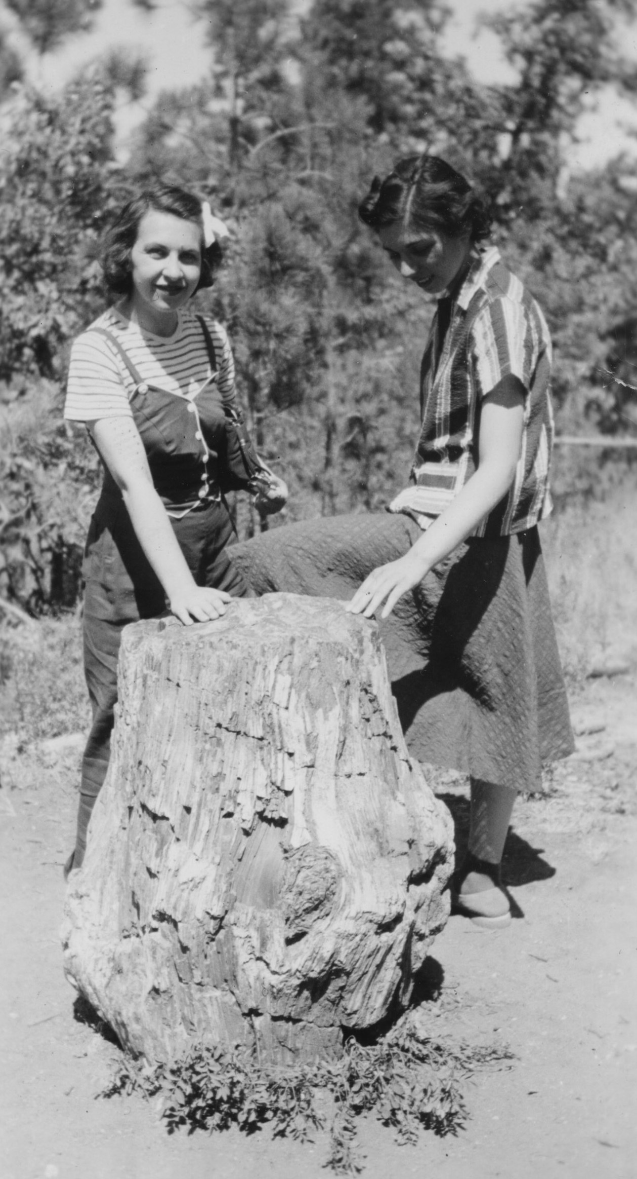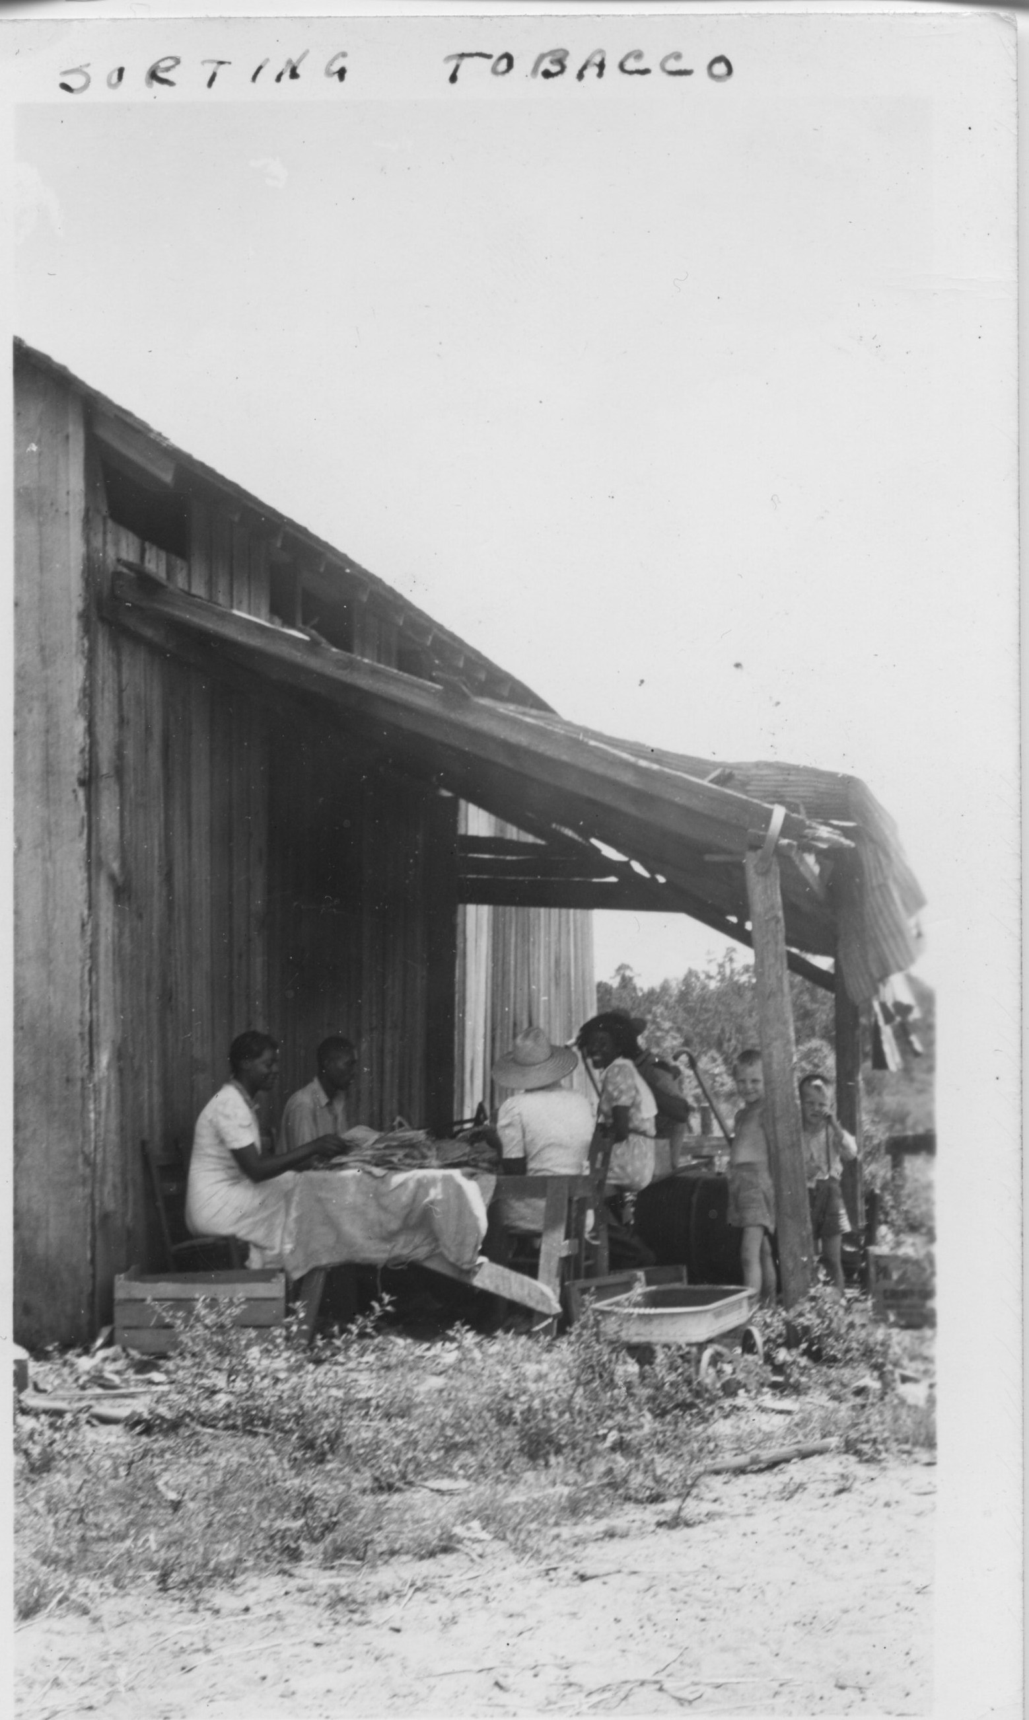
On the way to Florida Sorting Tobacco
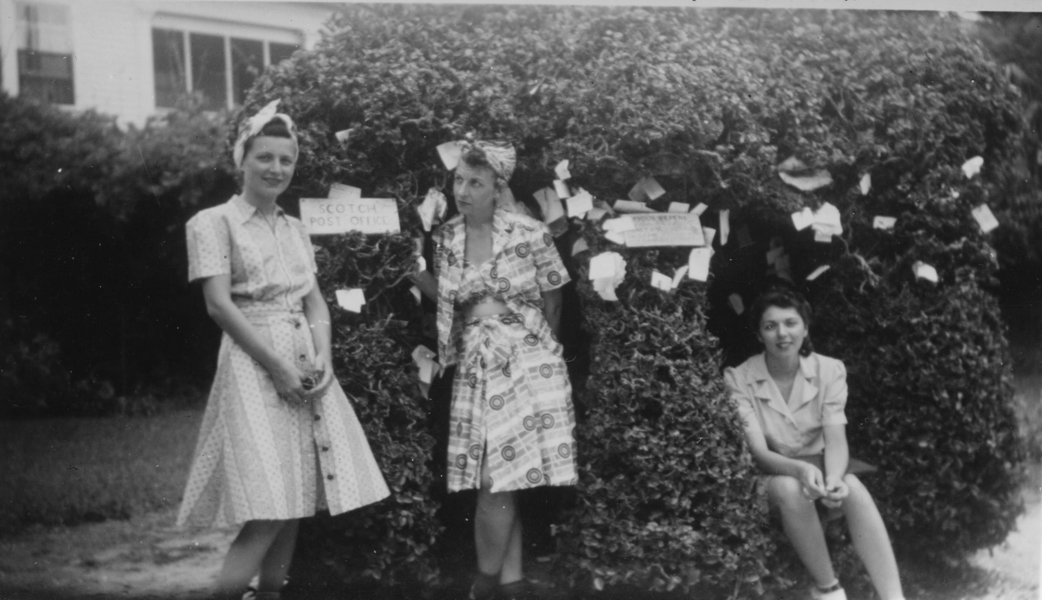 Ol
Oldest house in St. Augustine

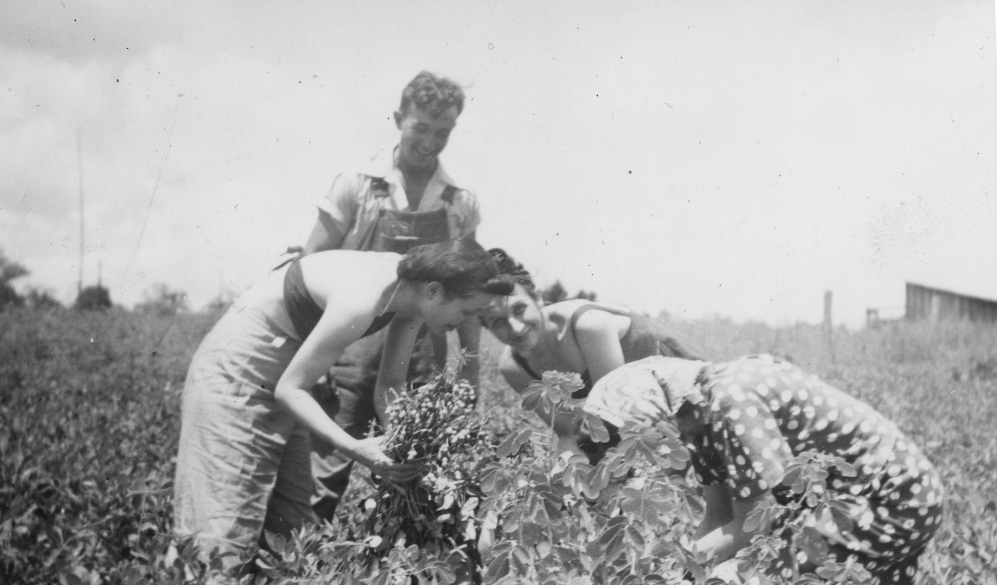
Picking Peanuts

WORKING LIFE

After the Yellowstone trip, my mother worked at secretarial and administrative assistant jobs. She ran into some anti-semitism, but the job she finally settled into at DeVilbiss Manufacturing Company was a good one, and she was able to take off the Jewish holidays.

"After high school I worked various places. 1933 no one had jobs; it was the heart of the depression. I got a job in a jewelry store -- it was to be 6 days a week, 8-6. The man wanted to train me. He didn't mention salary. He said he'd let me know at the end of the week what I was worth. I expected $25 or $20. When payday came, he handed me $15. I looked at it and told him I was leaving."

This is the same Lilian who told me,

"I never had much confidence [in my appearance] but when it came to working I knew I was good. Every job I had I was paid the top salary."

"The city would give one job to one member of a family. My mother got the money because she needed it. I went from place to place. At one factory the boss liked me, but when he heard my name he changed his mind because he said, 'Jews and Poles don't always get along.'

"I said, 'I am walking out of here and I'm going to the Anti-Defamation League and you are going to lose your Jewish customers.'"

"I didn't go. It was 1933 and anti-semitism was all over."

"LaSalle and Cook was a big department store and I got a job there. I wasn't happy, but it was a job. I was in the office and I worked 10 hour days, 6 days a week. But then DeVilbiss called. I was interviewed by the chief engineer. I was so excited. He liked me -- wanted me to start the following Monday. I said, 'I can, but I need to take Wednesday off because it is Yom Kippur.'"

He told her it was okay.

"There was only one other Jewish person and I knew her. She turned white when she saw me. The following year she observed Rosh Hashanah but only for one day. The chief engineer asked me why I took two days. I told him that different people observe differently. It didn't make any difference to him. When I thanked him for a raise he said that I did good work."

"I worked for one man who swore constantly. Once his wife heard and apologized."

"It was wartime and there was one unmarried German anti-semite who would tease me. One day he called me a 'yid.' I turned to him and said, 'That's not my name. I'll work for you but my name is Miss Greenberg and that is what you can call me.'"

"Everyone applauded. I didn't take any shit from anybody. I was proud of myself."

I stayed at DeVilbiss for four years.

USO

My mother told me that when the Japanese bombed Pearl Harbor, not only did young (and not so young) men flock to the recruiting stations, but those left behind pitched in whole heartedly for the war effort. People felt that war -- and everyone wanted to help. Lil started out volunteering at the USO functions and eventually was hired to work at Port Clinton. This led to her going overseas in 1944 with the Red Cross to Guam. She came back to Toledo in February of 1946.

" Boys who couldn't get jobs joined the army. After we got into the war soldiers started coming into Toledo. Jewish boys would come to a place in town for recreation. 99% of them had never been away from home before. I got involved, served coffee, helped with the activities. Eventually I quit my job and went to Port Clinton to work with the USO, which was about 30 miles away. I was 25 when I moved out of my parents' house. I was waving the flag! It was completely different times. Waving the flag was important."

"At Port Clinton I could make a lot of social things happen. I ran the place, and I was a secretary for the Jewish Federation We planned activities. I was there for a couple of years."

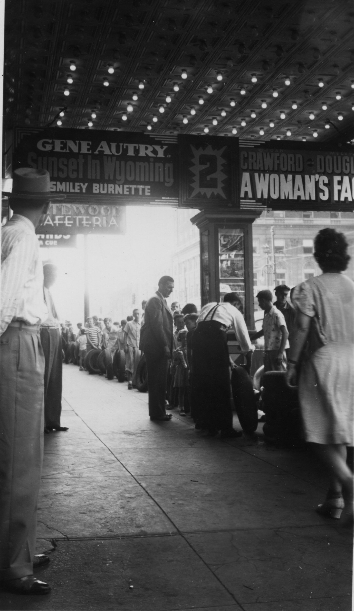
In 1941 Gene Autrey made a picture called "Sunset in Wyoming," and sometime after that Lil took a picture of people in Lexington Kentucky lined up at a movie theater to trade in tires for free movie tickets for that movie. I don't know exactly when or why she was there, but it is her photo. Perhaps she was on her way to Guam?

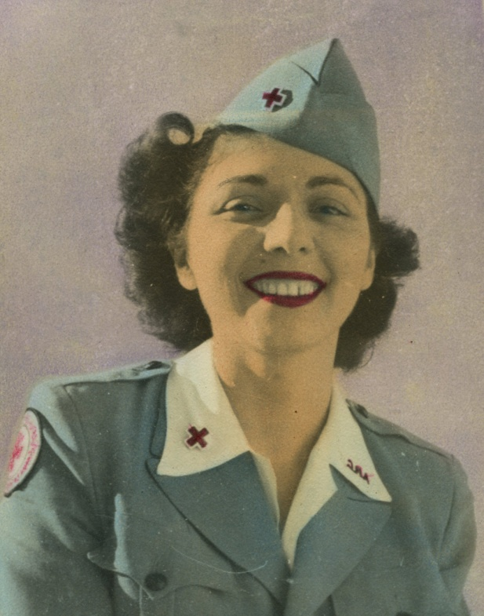

"One of my friends from Port Clinton went to England and wrote me that I should join the Red Cross. I always wanted to try new things. It was exciting, and I met so many new people. I had a couple of boyfriends -- real ones."

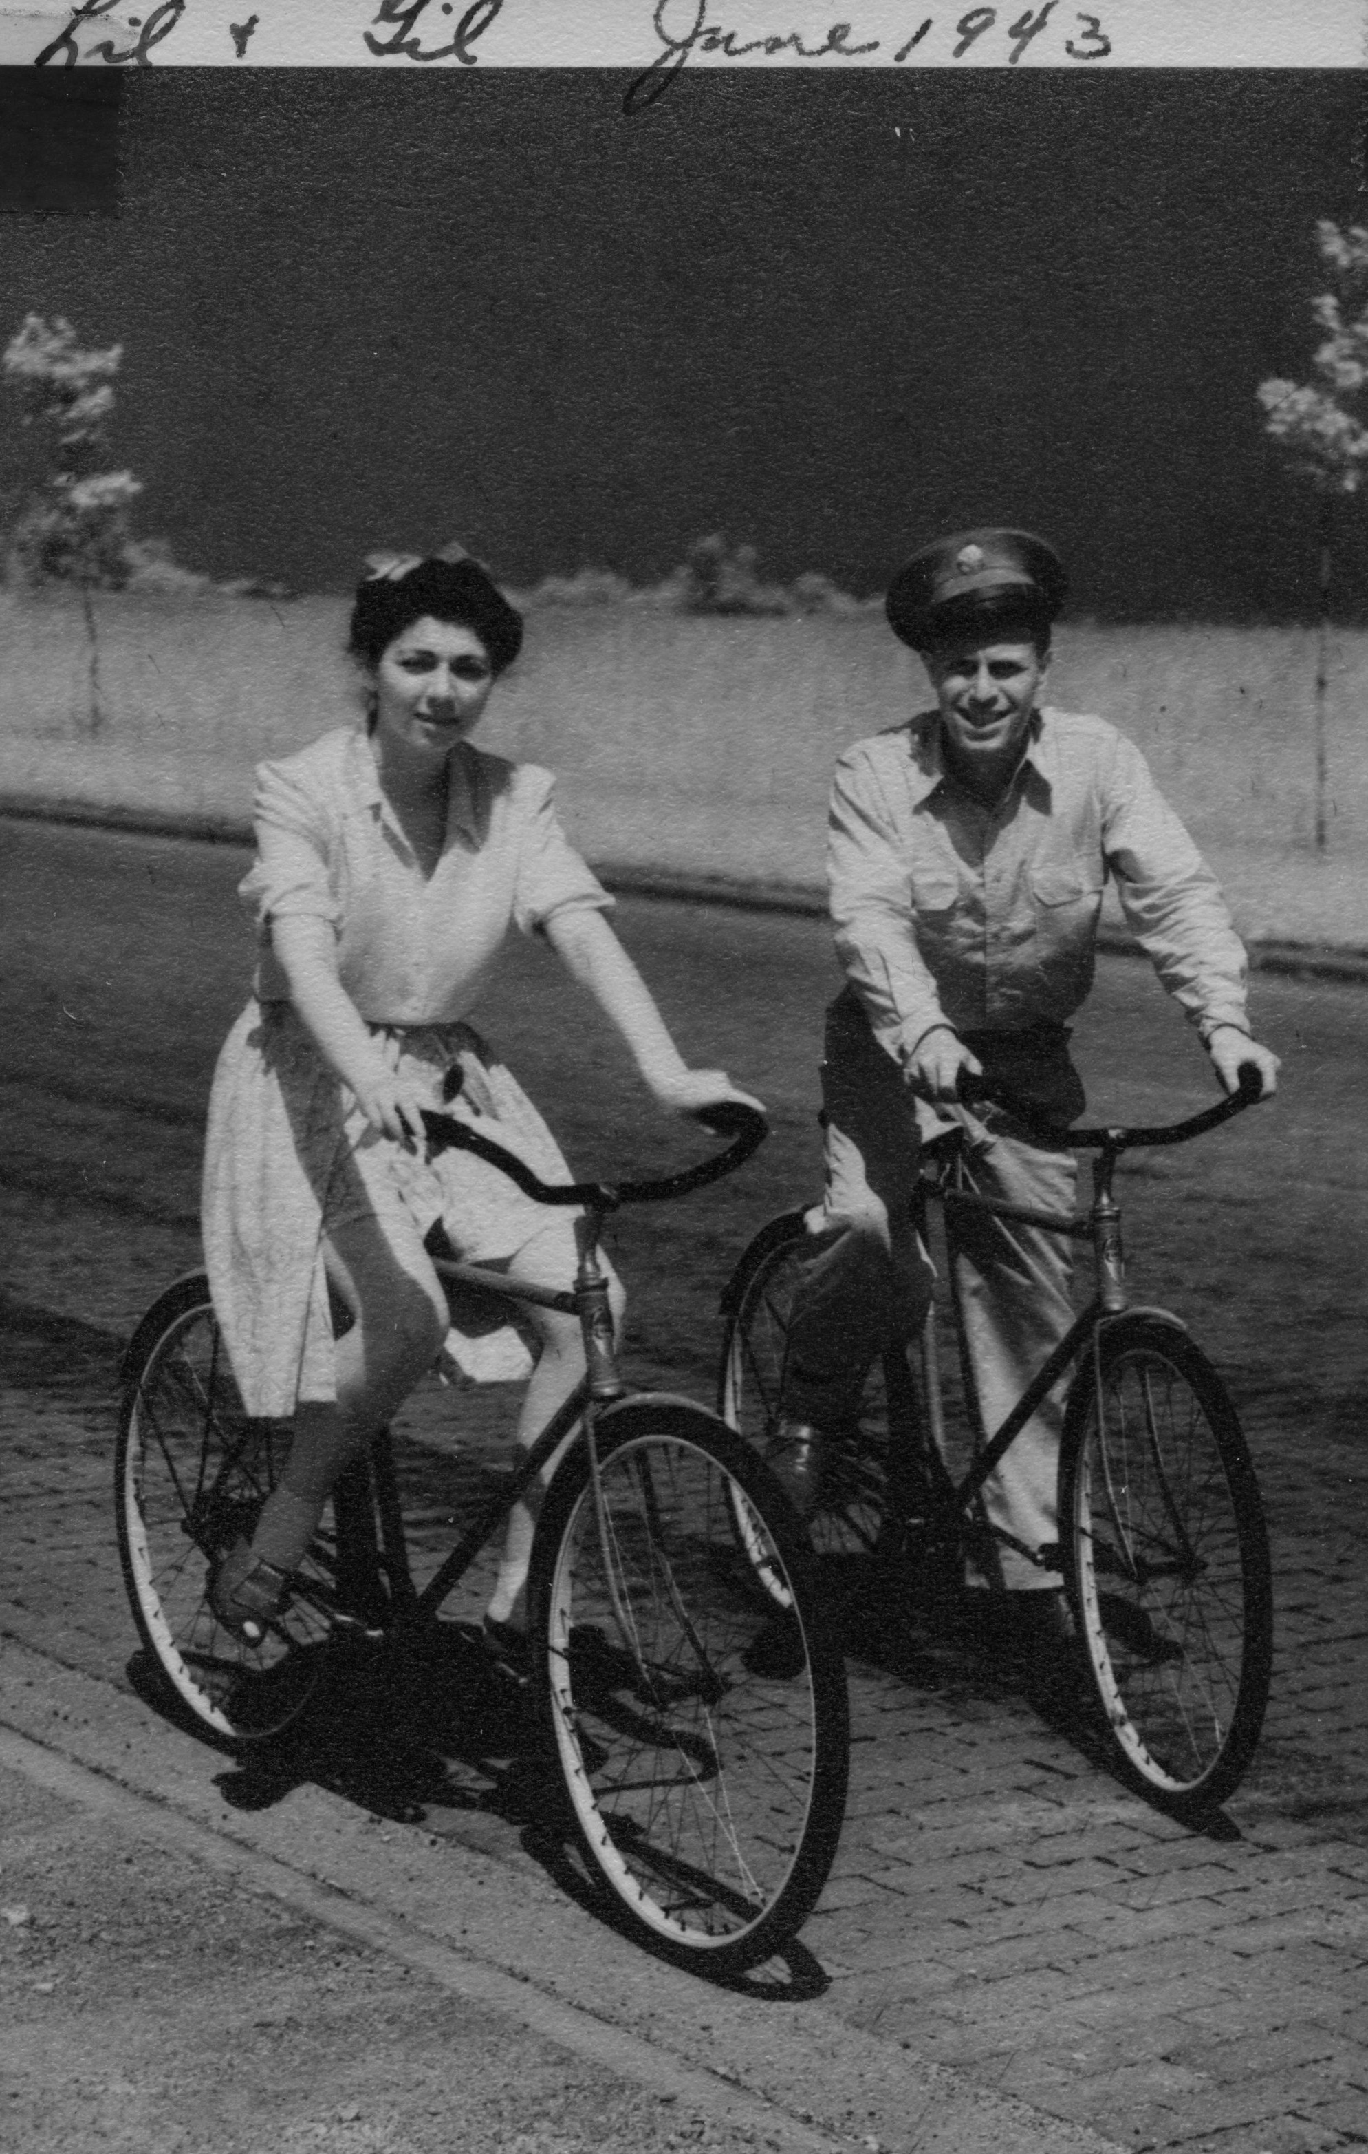This is the mystery photo. Who is Gil? and look at what my mother is wearing. Was that daring for 1943?

So my mother went to Guam with the Red Cross.

Lil gave me almost no details of her time in the Red Cross. I didn't even realize she'd been to Hawaii or Japan as well as Guam. I did some googling and found some first person accounts of what it was like to join the Red Cross from a woman who was in Guam. She might have even known my mother.

"Margaret Kelk joined the Red Cross in 1948. Like all Red Cross women going overseas, she went through a few weeks of training in Washington, D.C. where she said she was told to "take care of the enlisted man. He is the one who is facing the guns and fighting the war." Female Red Cross workers overseas were civilians but were given honorary officer status so they would be treated more charitably if they were taken prisoner." [my emphasis]

Guam was a US possession that was captured by the Japanese on 10 December 1941, following the attack on Pearl Harbor. On 10 August 1944, after two months of sometimes fierce fighting, American forces took Guam back from the Japanese army. After the final battle, Guam was turned into a base for allied operations and it was here that the Red Cross sent my mother. Although organized Japanese resistance ended and Guam was declared secure, there were still Japanese soldiers at large. On 8 December 1945, three U.S. Marines were ambushed and killed.

And on 24 January, 1972, Seargeant Shoichi Yokoi was discovered by hunters. He had lived alone in a cave on Guam for 27 years.

I wonder if my mother was ever afraid.

Jean Archer, a schoolteacher from New Jersey described her life on Guam in letters she sent home in May 1945.

"Did I ever tell you about the restrictions under which we live? After six in the evening, we have to be accompanied by two officers, one of whom is armed. We have to be in by ten and no exceptions. That suits me fine. In the first place, I work every evening but one, and then we have to get up by 6:30 to get breakfast.

"My 'work' consists of taking turns at doing everything in the club. Right now I'm working on a soldier talent show for Thursday night. . . The sailors are grand and they certainly appreciate the club. It is always full, never enough chairs for all. We are busy every single moment, playing cards, Ping-Pong or just talking. . . we never stop talking and listening. I've seen hundreds of pictures of best girls, wives, children. . . . I wouldn't be any place else. It is the hardest and most tiring job I've ever had, not even a rest hour, but it is also the most interesting and satisfying." [my emphasis]

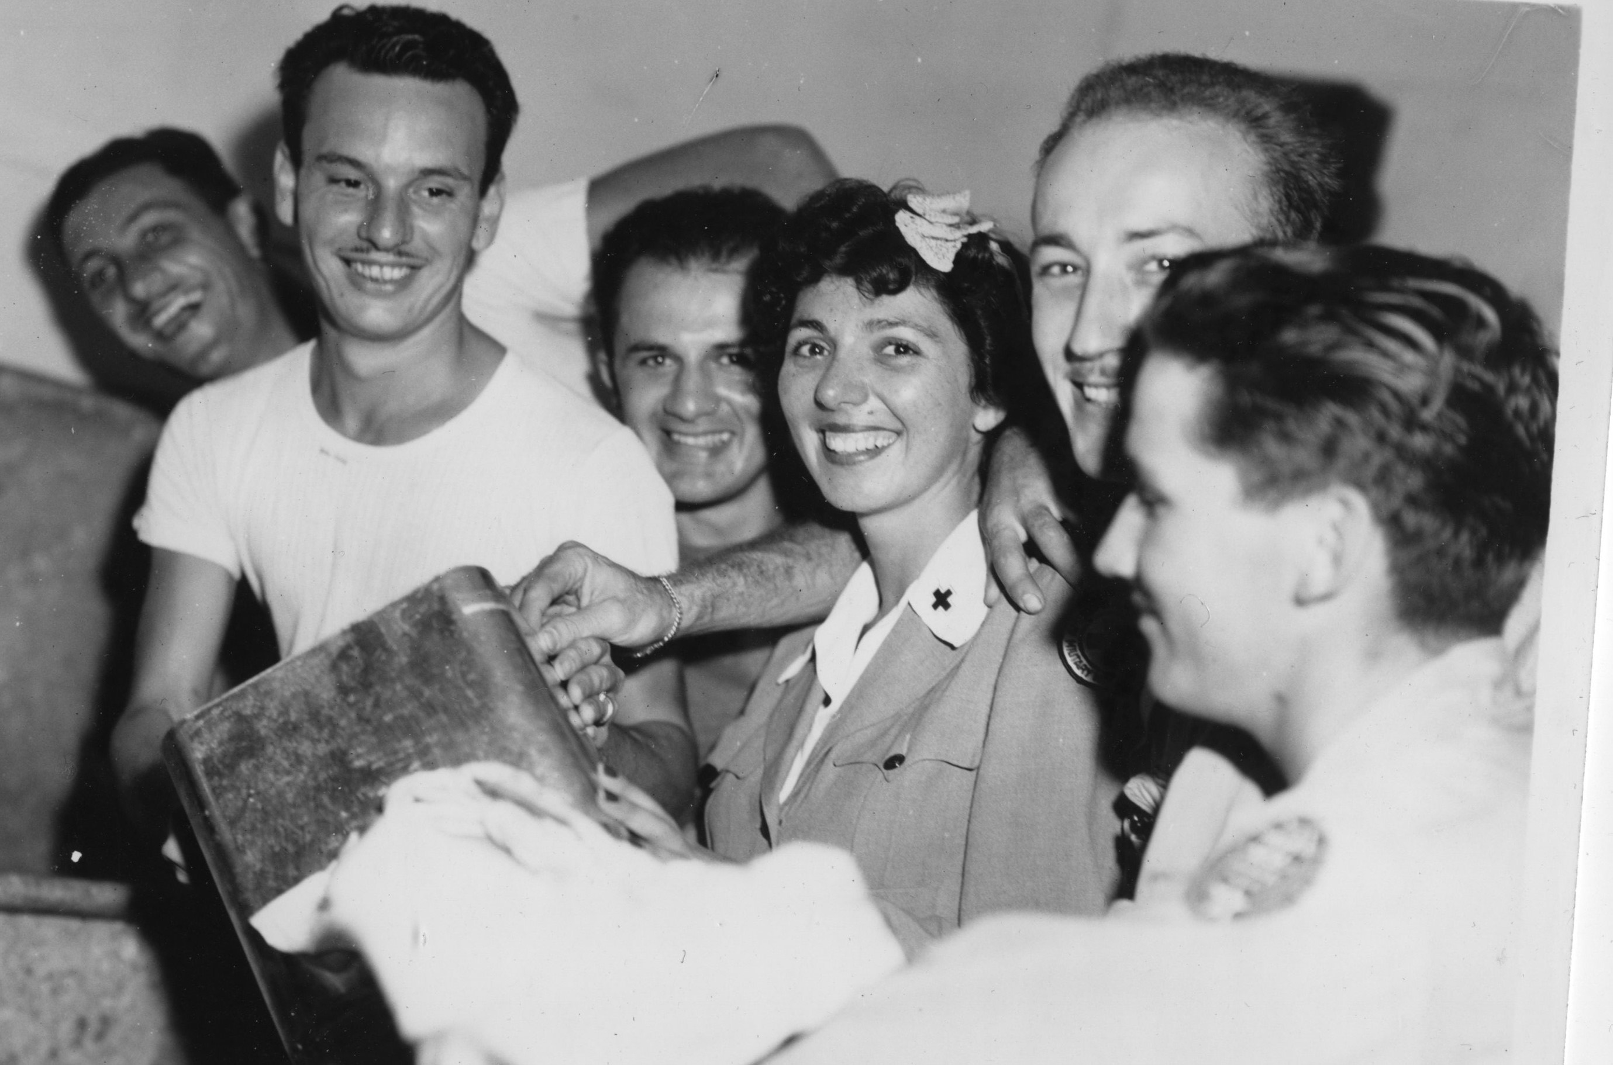

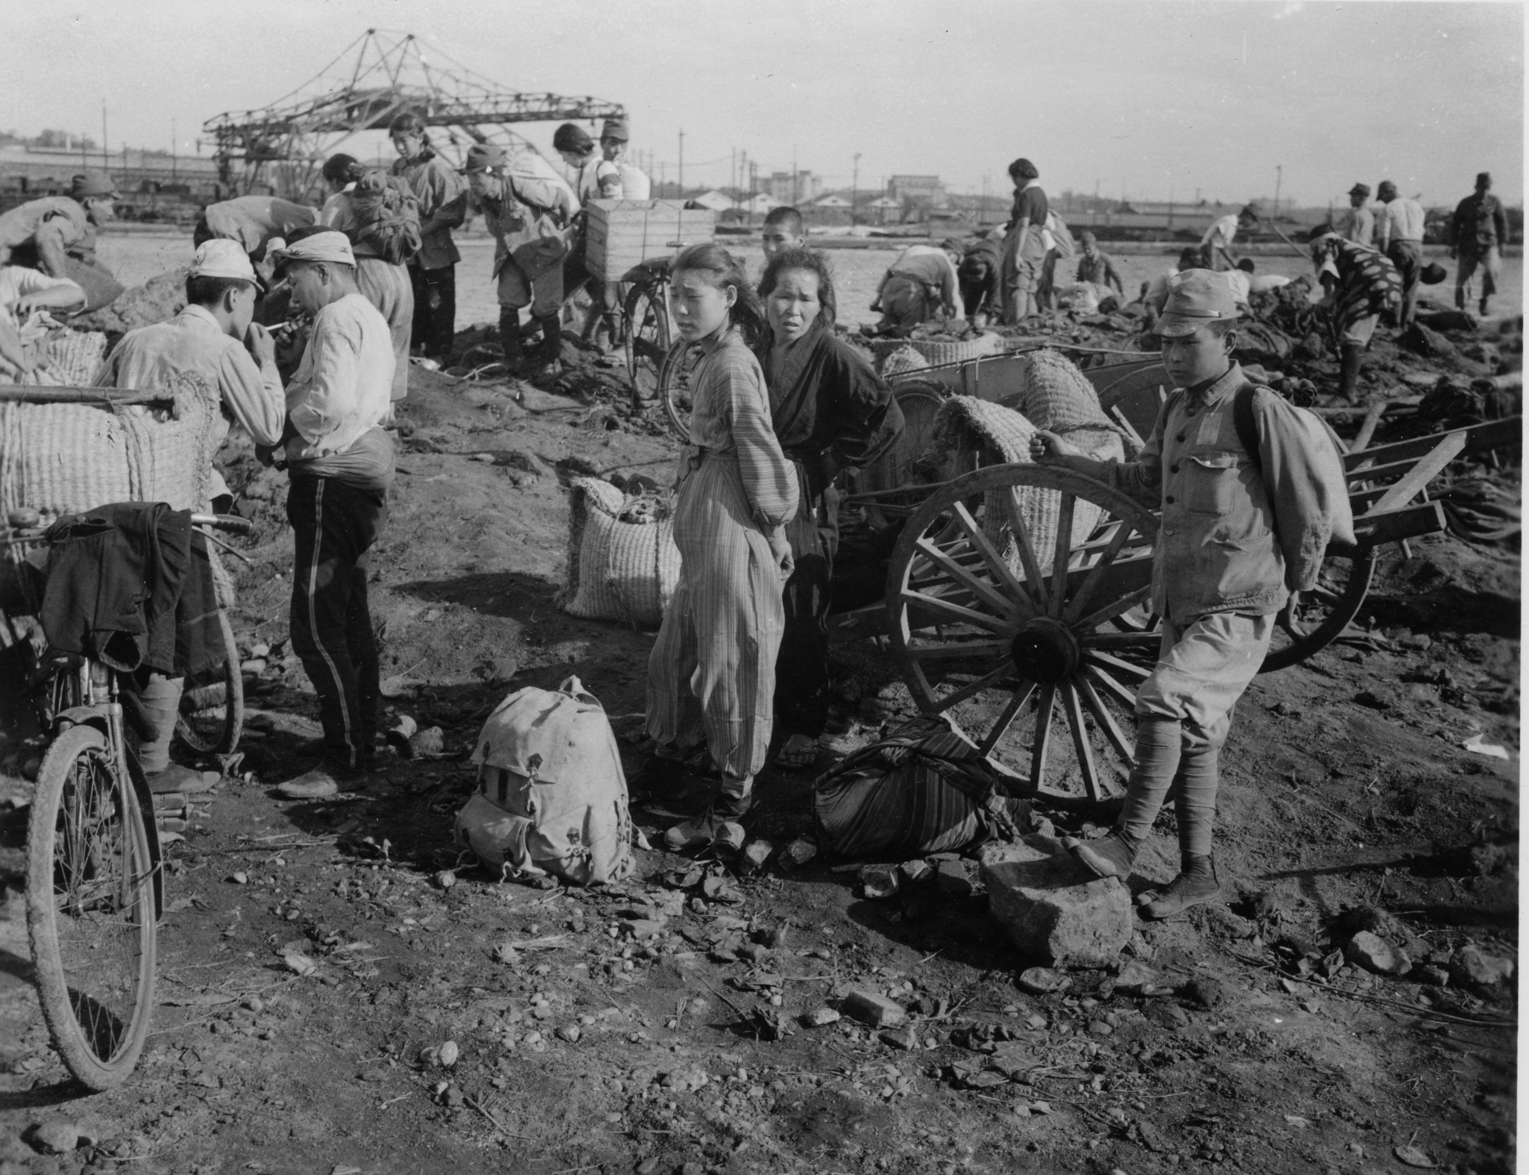

AFTER THE WAR

"The most important thing was to find out if anyone was left that belonged to you."

Bashe's father Moishe was the son of Chaim Itzhak Zorach -- my great great grandfather. Moishe's older sister Hinde emigrated ahead of him to Toledo, Ohio. According to Phillip Alloy, Moishe had 6 older brothers -- my mother says they were very tall -- whose names are unknown. Phillip Alloy wrote that one of the brothers emigrated to Palestine but my mother thought they'd all stayed behind.

Lil said that one of the uncles had a daughter who was a Zionist; her goal was to get to Palestine to establish a kibbutz. First she received some kind of training in Warsaw. After 9 months she returned to her home (this was 1938) for a brief time, and then was called up to leave for Palestine. She pleaded with her family to go but they wouldn't leave. She did establish a kibbutz and married the man who'd run the training program for recruits. Years later my mother met her on a trip to Israel, and she asked this cousin for details about her wedding. She replied,

"I knew him."

With the exception of this woman and two younger cousins, the entire family -- six brothers and their wives and children and grandchildren-- were murdered by the Nazis. The two younger cousins were spirited out of the country separately, but found themselves on the same boat to Palestine. The girl was 14 or 15 and the boy several years younger. She saw him crying in a corner, recognized that he was her cousin and took care of him for the remainder of the trip. He was afraid because of "the awful things" that had happened back home.

MOVING TO NEW YORK CITY

I can only imagine what a let down it must have been to return to Toledo. Oh, my mother was as glad as everyone else that the war was over, but in a way she'd been liberated in Guam -- doing important work, seeing new places, meeting people and now she was back, living in her parents' home, and to her great dismay could not get a job with the Jewish Federation doing the same kind of social work she'd done during the war because of the lack of a college degree.

I don't know what finally decided her to move to New York, but move she did in 1947.

Meeting Morty

While my mother was in Guam, my father was drafted into the army -- I believe in 1942. Mortimer Sidney Friedner was born in 1909-- the fifth child and first boy -- to Sara and Saul Friedner. My Aunt Rose Rosenberg, my father's second oldest sister, told me that they were from Austria originally, although there is some debate about that. Saul was a tailor and Sara cleaned houses before the children were born. According to my Aunt Rose they were fancy houses -- and Grandma Sara learned there about "fine things." My father and his sisters grew up to pay great attention to their clothes and their manners and their English pronunciation. Yiddish was spoken at home, but my father, as the youngest, heard mostly English from his siblings and friends, and didn't have the same fluency that my mother had in Yiddish.

My cousin Suzanne Kushner -- the only child of my Aunt Gus (the middle child and third sister) and Uncle Nat -- tells me that my grandparents adored each other. Saul died before I was born, but my aunts and my grandmother would all heave these great sighs and say, "How Papa would have adored you."

Unlike my 'Grandma from Toledo' my Grandma Sara was a homebody. She loved to cook and bake and generally be with her children and grandchildren. Suzanne tells me that she never went anywhere without one of her children. My mother said that one time when she and my father were first married, my grandmother came on her own to visit my mother during the day. She had to take two buses and when my father found out,

"He turned white."

When Suzanne was a young adult, she realized how embarrassed my grandmother was that she not only couldn't read, but had to sign her name with an 'X'. So Suzanne took my grandmother to night school. She never did learn to read, but she at least learned to sign her name

As the youngest child -- and probably more important -- as the BOY -- my father was doted upon. It has been absolutely sworn to me that he really did go along on sister Tess Sanford's honeymoon when he was just a few years old. (Tess was the oldest sister, only a few years younger than my Grandmother Basha)

"How can I leave the baby?" she is reputed to have said.

I have always wondered about this story.

According to my aunts, my father was gorgeous with the most beautiful black hair.

"The girls were crazy about him."

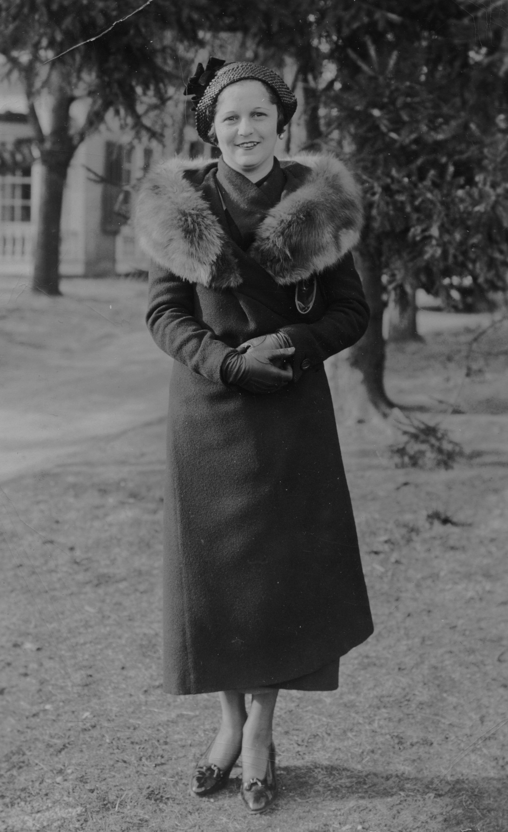
In the box of my father's pictures I found this one from Eleanor, who wrote "not just an acquaintance."

My father did not appreciate the adulation of his family. His reaction to being treated as the Crown Prince was to turn into a father who made a conscious effort NOT to get excited about my accomplishments -- but he would tell my Aunt Lil -- the youngest sister -- complimentary things about me. At least that is what she repeated to me and I choose to believe it.

"Ruthie is so sunny and happy," he told her.

Even though I don't always feel sunny and happy I prefer to believe that is my true nature.

Morty was the only one in the family to go to college, while all four of my aunts "went to business." Afterwards he attended podiatry school in Harlem. He told my mother that if it wasn't for the $25 down payment he would have backed out of the whole thing. I'm pretty sure that there were other things he wanted to do with his life -- it was mentioned he wanted to be a medical doctor but there wasn't enough money. It was also mentioned that he wanted to be a performer, but that was out of the question.

But while my father was ambivalent about being a foot doctor, it was a thrill to his own father, Saul, who "became an expert on feet." The family bragged endlessly about having a doctor in the family -- which was a source of great embarrassment to my father.

He lived with Grandma Sara and Grandpa Saul on Sheridan Avenue in the Bronx and had an office in the two bedroom apartment. He must have practiced about seven years before he was drafted.

Morty's father Saul died of lung cancer during the time my father was in the war. Morty was stationed somewhere with his cousin Dave Kerner, who broke the news to him. Although I never met my grandfather, I have a mental picture (as well as a real picture) of a very proper Austrian who was the respected head of the family. My aunts would always say,

"Oh, if Papa were alive he would make such wonderful clothes for you." (I'd be willing to bet that irritated my mother, who was alive and who did make clothes for me.)

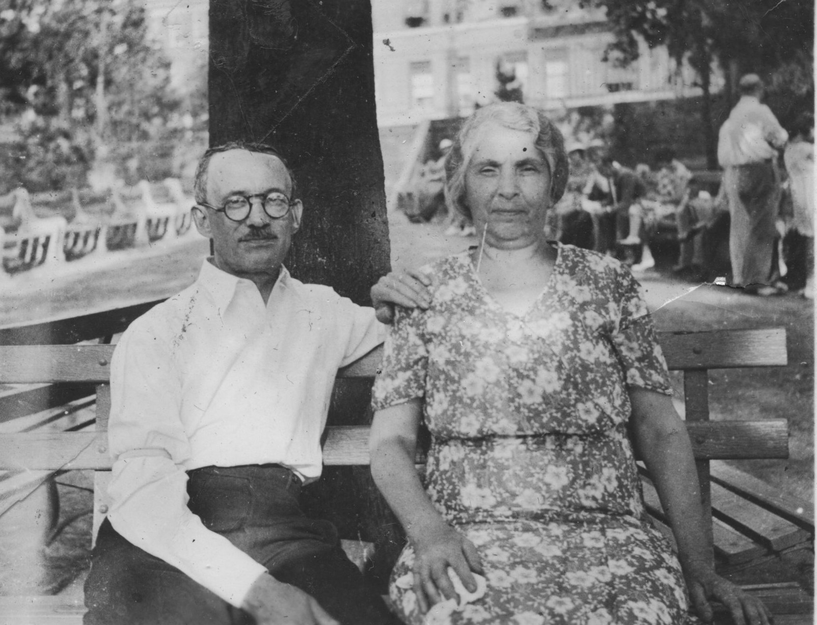

Lil told me that Morty hated every minute of every day except for the time period he was in Georgia where there were WACs. She also told me that at some point he jumped from a small boat and landed on a beach where he went to sleep in a pup tent. When he awoke his hand was in deep water.

Something happened in the war that took away his sense of smell. Lil said that every now and then he'd complain of an odor that reminded him of cinders. Mustard gas?

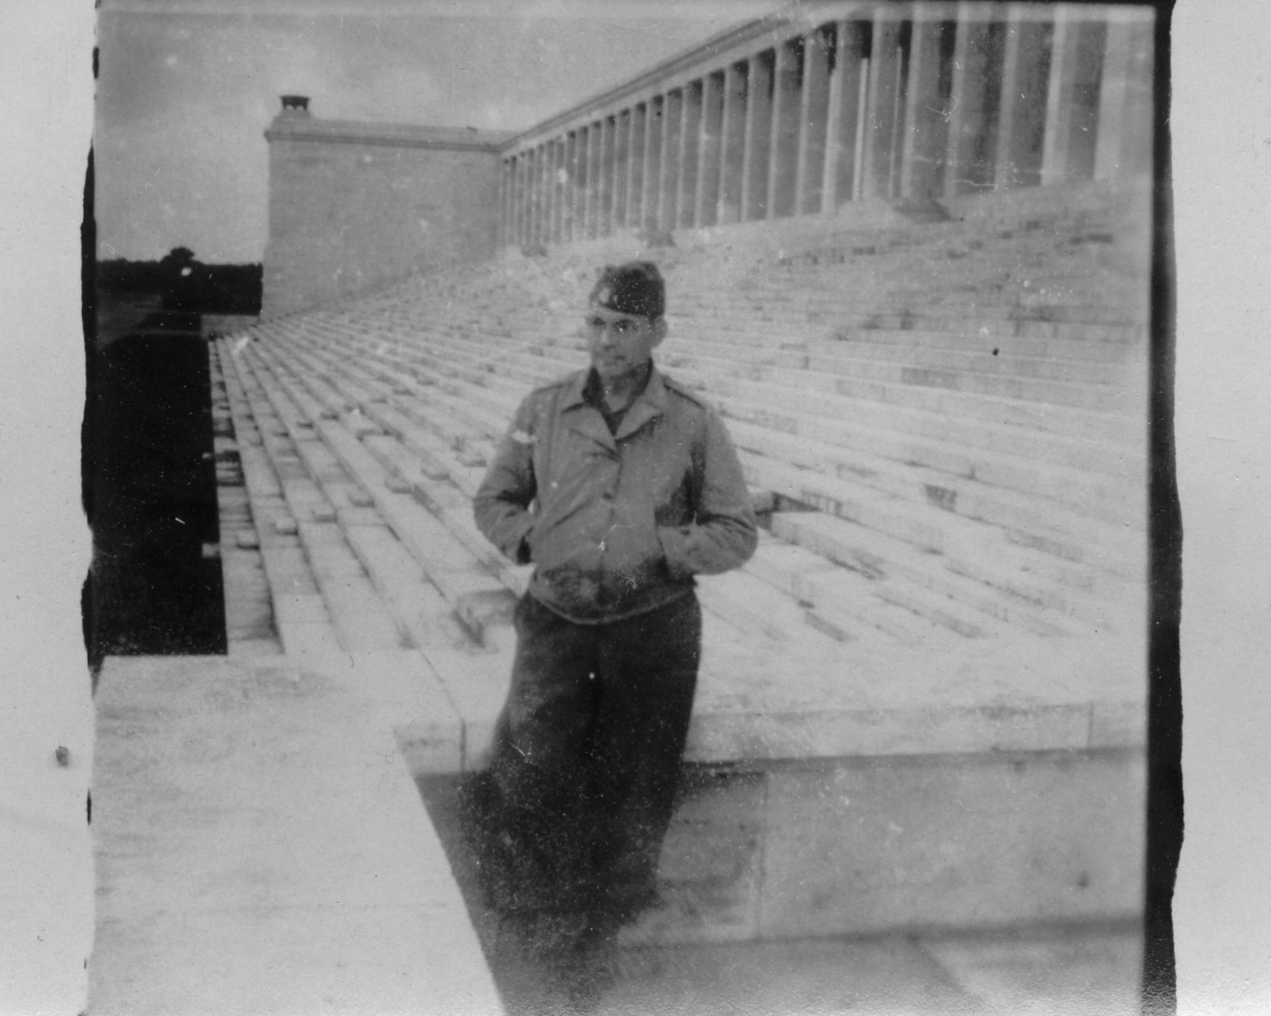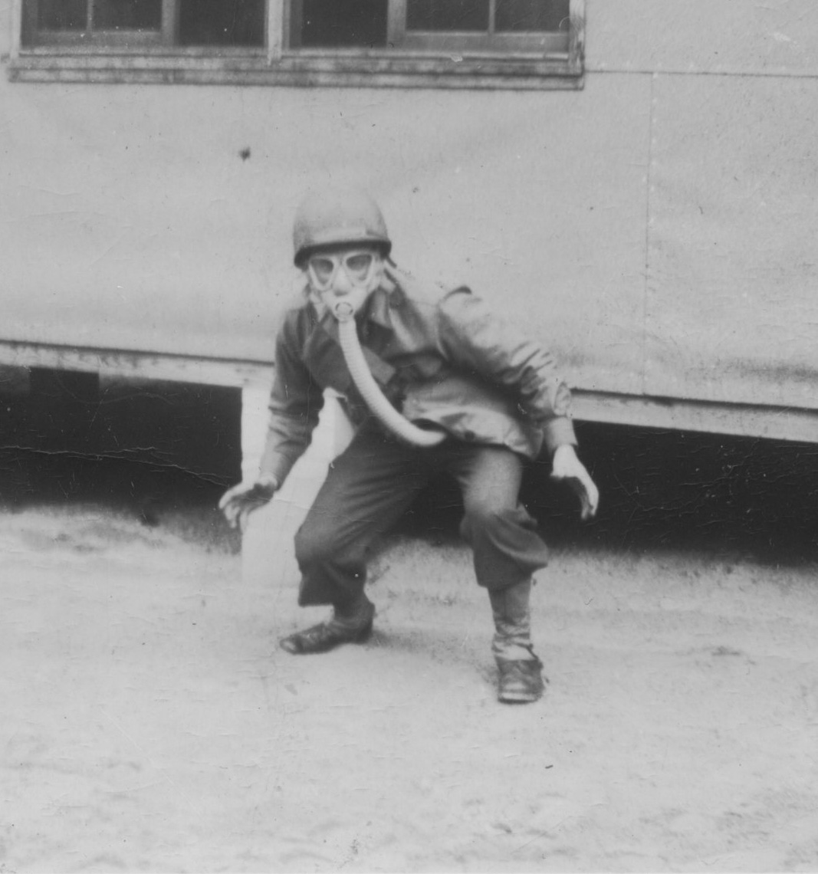

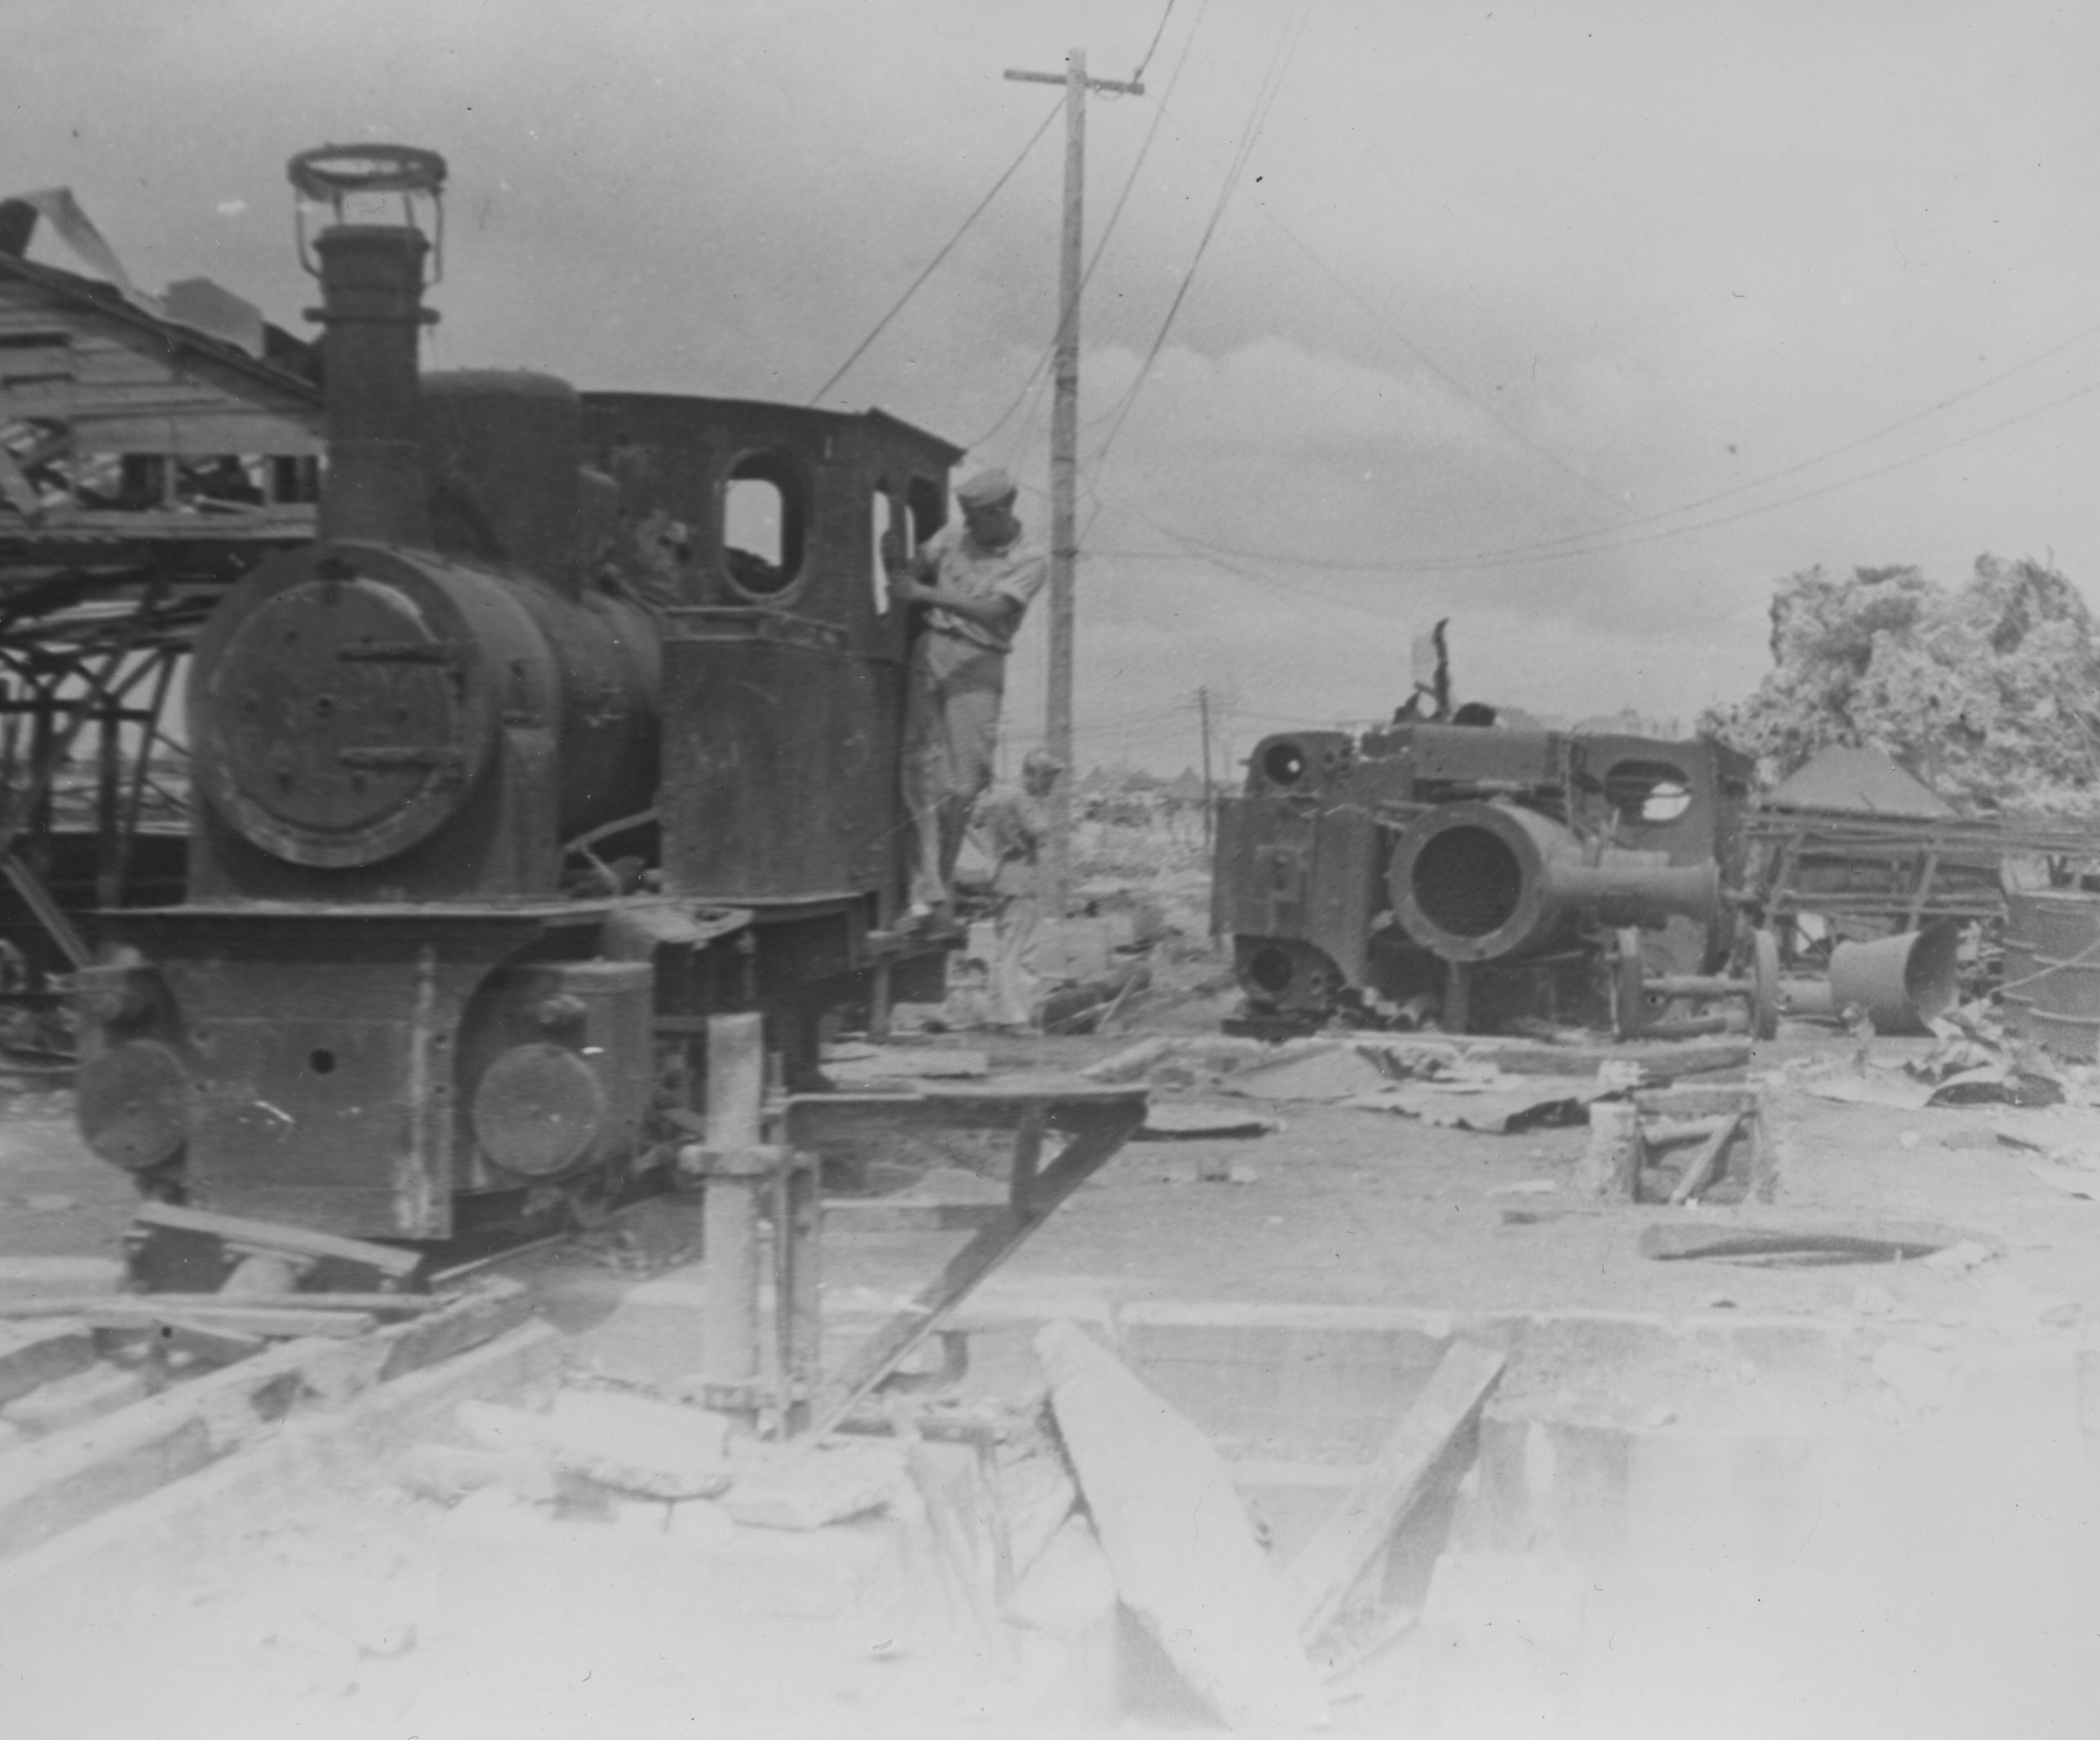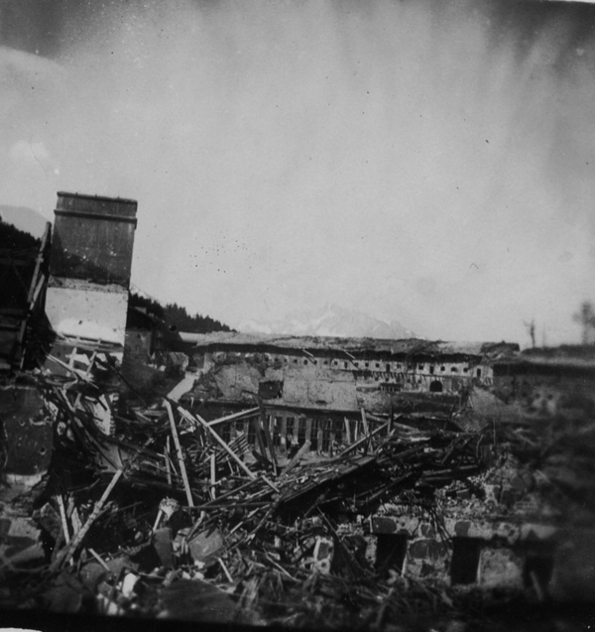

Morty in front of Dachau

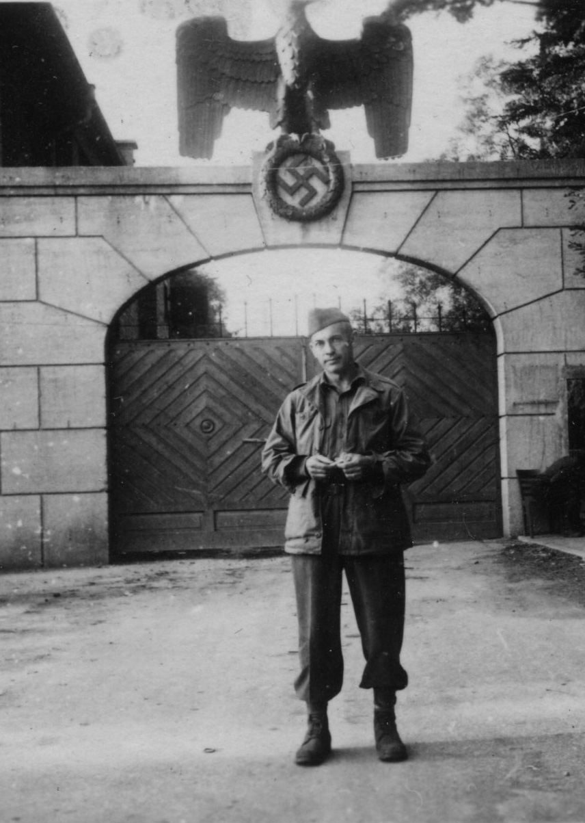

My father was a medic --He told me once about a young German P.O.W. who died in his arms, saying, "Danke Schein." My father cried, and I cry every time I think about it.

My cousin Suzanne Kushner tells me that when Morty returned, he was depressed. He moved back in with his mother -- my Grandma Sara -- except that now my Aunt Gus Mintz (the third sister and the one with a great sense of humor) and Suzanne were living with my grandmother in her apartment. My grandfather had died and Gus's husband, Uncle Nat, had to leave New York very quickly for reasons that have never been fully explained -- something to do with borrowing money and bad people. By the time I can remember anything, he was back.

So in this two bedroom apartment lived the three women and my father, and he tried to start his podiatry practice again, putting up a curtain in one of the bedrooms to make an office. When his practice didn't take off like a rocket, my Aunt Lil's husband (Uncle Harry) got him into the corrugated box business and my father became a salesman.

It totally suited him. He'd go to a factory, make friends with everyone and get orders for large quantities of boxes. His time was his own, and he usually got home early. My mother said,

"Everyone thought he liked them, but the truth is he couldn't stand anyone."

Some of my happiest memories are dinner times when my father would regale us with stories of his customers, leaving us choking with laughter. It's funny really because some of my least happy memories are also dinner time when my father would endlessly correct my table manners. Night after night he would make fun, correct and needle, until I would get up from the table, scream that I hated him and run upstairs. My mother would moan about how hard she'd worked to make the meal and my sister would take notes about what NOT to do.

SO HOW DID LIL AND MORTY MEET?

My parents met on a blind date. Two weeks later they were engaged, and two weeks after that they were married on November 16, 1947. I think my father's family was a little scandalized.

Growing up, a two week engagement was my idea of normal. Do it quick before the glow wears off

So here's how it happened.

In 1946, Lil moved to New York City, lived with cousins in Brooklyn and got a secretarial job. I don't know why exactly she moved to New York City, but as she explained to me,
"All the young men and women found themselves in new places [during the war] -- saw there was another world out there. When they came back they realized there were other places to live."

Sid Empel, my mother's office mate, was friends with my Aunt Lil, and Sid gave my mother's phone number to my father, who carried the number around for several months before calling her.

When he finally did, things happened fast. There was no place for them to be alone, my father was 38, my mother nearly 32, they were still reeling from the war, and both their biological clocks were ticking. My mother lived in Brooklyn and my father lived in the Bronx -- a geographical pain in the neck. So according to her he started pressuring her after the second date to marry him. The story goes that they were taking a walk and he bought a raffle ticket. He said if he won the car, he'd take it. If he won the mink coat, she'd get it and if they won the television they'd get married.

They lost the raffle but got married anyway. He said to her on their second date,
"Let me know now if you're going to marry me. Don't waste the best years of my life."
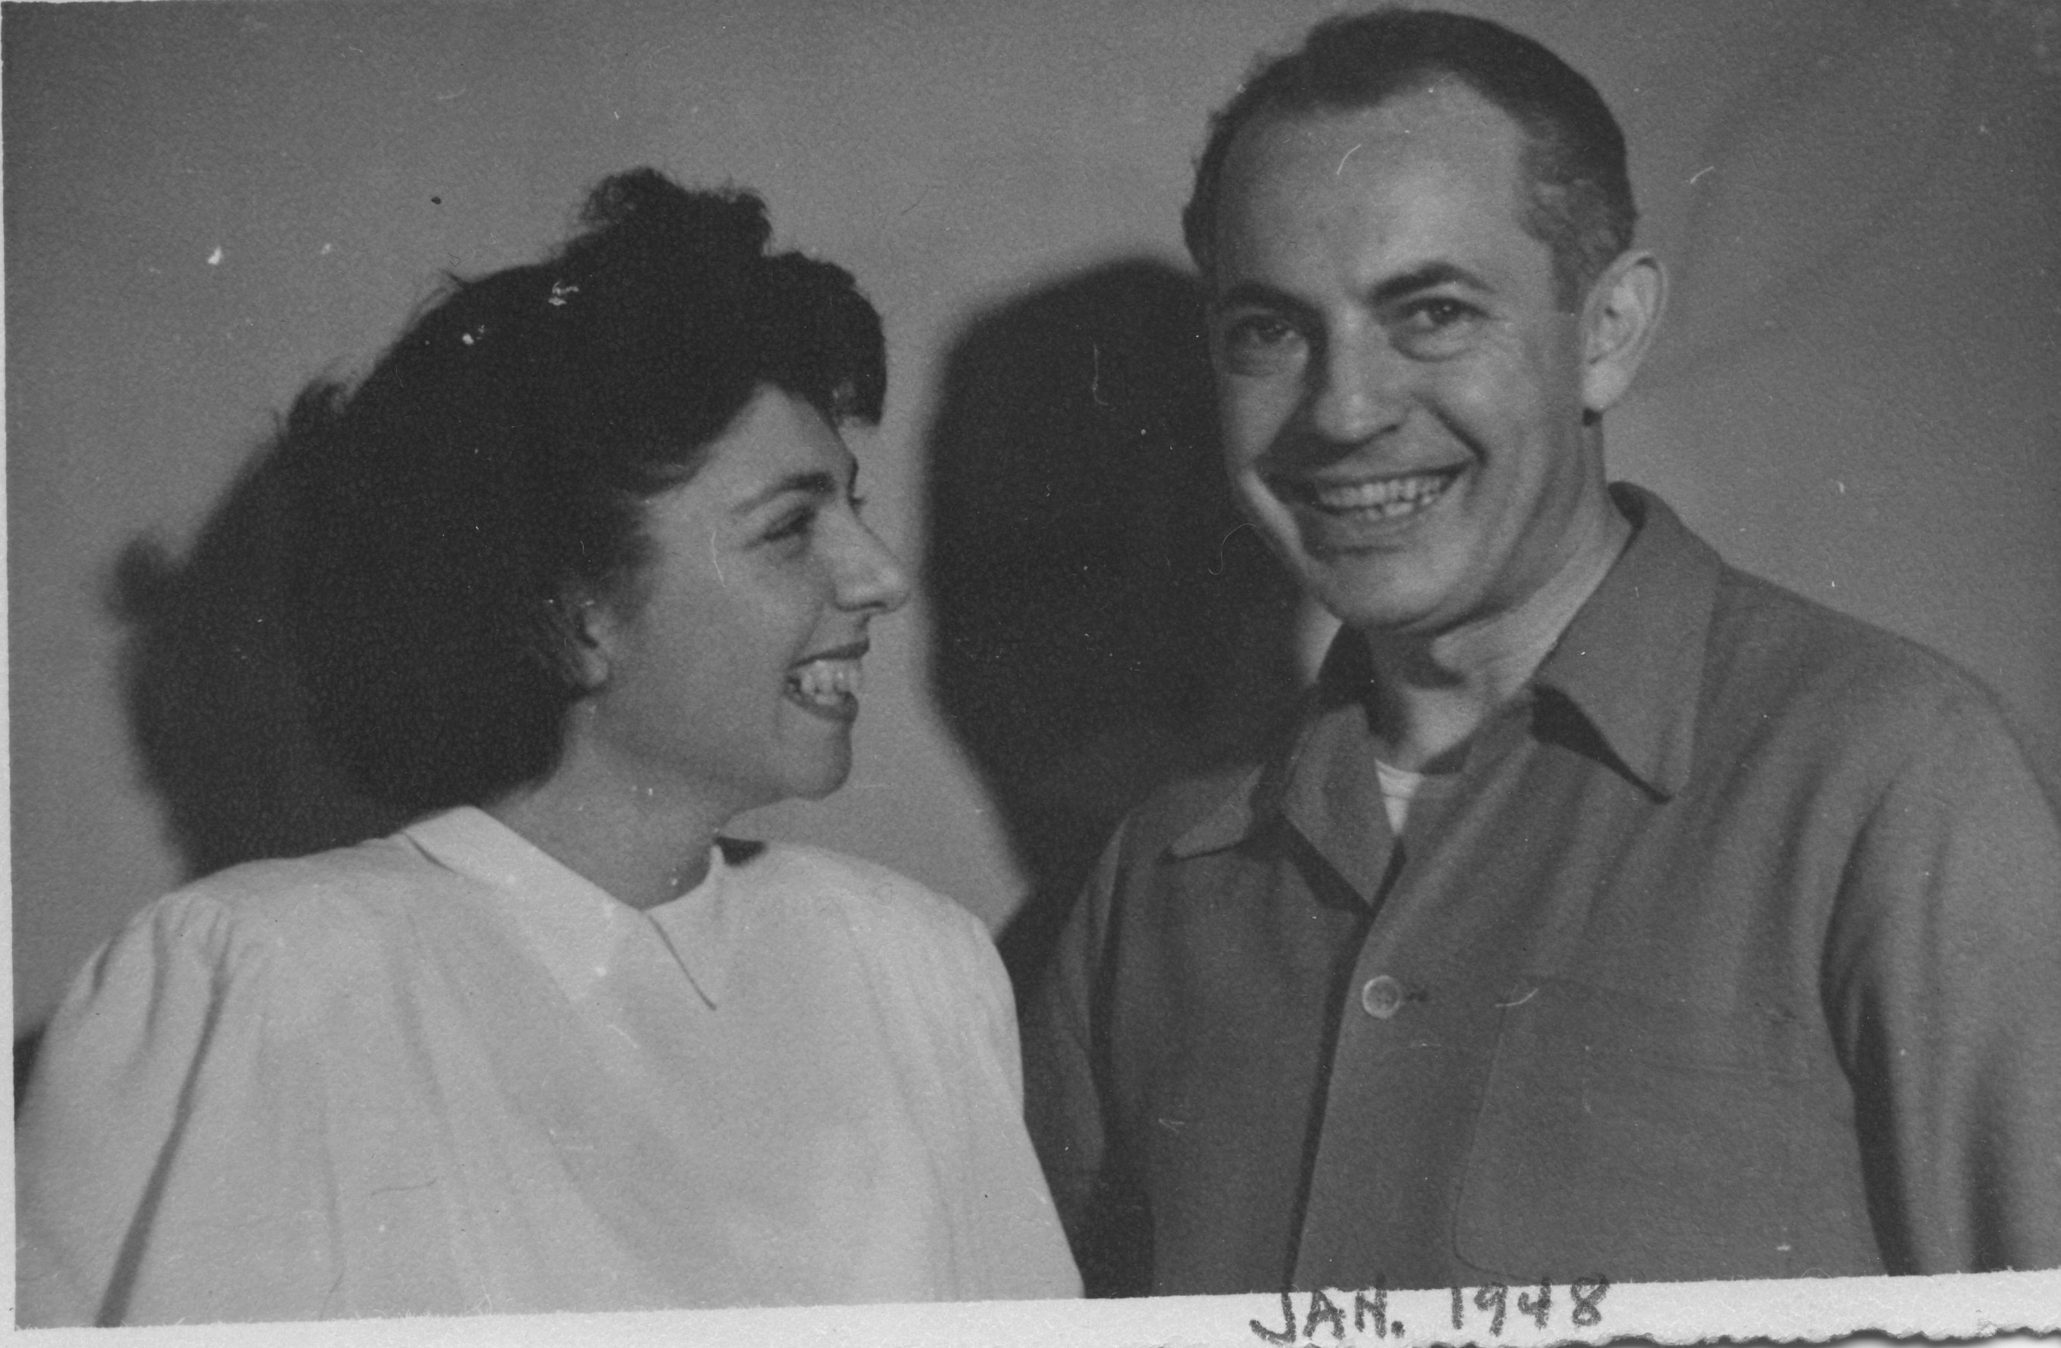

My father's family made a "tea" for my mother and 55 cousins came. I think Lil was overwhelmed by it all -- four older sisters-in-law -- and her used to being the oldest girl in the family, as well as the boss. As for all those cousins -- we rarely saw any of them.

The wedding took place in my Aunt Lil and Uncle Harry Cohen's apartment near the Grand Concourse in the Bronx. According to my mother, my aunt said the house was too small to have a lot of guests, so my mother was unable to invite the cousins with whom she was living, and she felt really bad about that. My aunt also didn't want to invite one of my father's nephews, so she invited none of them -- the result being that there were not ten men present, and the orthodox Rabbi would not conduct the wedding ceremony without a Minyan. So, my mother says, they had to pull in a couple of strangers from the street. At the end of the wedding Lil Cohen told my father that he owed her $30.

This was the beginning of my mother's difficult relationship with my aunt.

My mother thought my Aunt Lil Cohen was possessive of my father. After he proposed, my mother walked into the office with a box of chocolates for Sid Empel and thanked her for introducing her to Morty. Sid later called my Aunt Lil, saying,

"They're getting married and it's not my fault."

I asked my mother how she knew and she said that Aunt Lil told her.

"Now that I was part of the family Lil thought it was her duty to repeat gossip to me."

MORAL TO BE LEARNED FROM PRECEDING ANECDOTE:

We may not forgive and we may not forget, but we
stick together

Until the day she died, my mother resented my Aunt Lil. She felt that the sisters all looked down on her because they thought of her as a country bumpkin from the midwest, but she particularly felt it from Lil. It didn't help when my aunt said things like,

"I feel that Ruthie is really my child, but you gave birth to her."

My aunt totally doted on me, and she also doted on my father and wanted his attention. This drove my mother wild. Every argument that I remember was about my Aunt Lil or some other member of my father's family, but mostly about my Aunt Lil.

Nevertheless, I think that my aunt saved me. When my parents were criticizing my every move, she told me I was wonderful and beautiful and talented. It was my Aunt Lil who noticed I could sing and said I should have voice lessons.

Today I understand that my aunt played favorites and some were hurt by this, but all I understood then was that I was special.

For their honeymoon my parents went to a place in the Catskills where my father had spent time with his buddies on many long weekends. When they checked in, the receptionist asked,

"Morty, who's the girl?"

"My wife."

"Come on, Morty, it's me. Who's the girl?"

First thing that happened was my mother threw her back out and they came home early. She said she was anxious to start married life in their own place.

I was born nine months and six days later.

For the next six years they lived in the Bronx. Lil stopped working when I was born and I don't know much about what she did. In fact, the truth is, in writing this chronicle I realize that I can't say I really knew my mother. I think Lil was like me -- excellent at drawing people out, learning their stories, while painting a portrait of the way she herself -- and her family -- to appear. The words that would make me crazy would come after I'd done something noteworthy and she would happily say,

"Now I can brag."

So in brief: Lil got Morty to move to New Jersey -- she wanted a house and I'd be willing to bet my house that she wanted to get away from the relatives. They joined the temple in our mostly gentile town, she joined Hadassah, Morty joined the Men's Club, they learned to play Bridge and they went to the Catskills for get-away weekends with their Bridge friends.

Somewhere along the way she joined an investment club and learned about stocks and bonds, for which I am eternally grateful.

And starting in 1951 she began to lose her hearing.

Sheryl and I only remember our mother as being hearing impaired. We have no idea whether this made her more impatient or quick to anger. We grew up knowing that when we went into a store we'd need to interpret for her because no one ever spoke loudly enough.

We moved to Spring Valley, New York in 1964 and Lil went back to work as a secretary. Morty was worried about a bigger mortgage, but she asked him just to give her ten years in the new house.

He did. Exactly.

Once again they joined a temple and found Bridge players, and in addition to his corrugated box business, my father began to work again as a podiatrist. A large part of his work was at the Hudson View Nursing Home in Yonkers owned by my cousin Bernard. My cousins Jerry and Scott eventually joined the business and one by one, several of my relatives passed through -- my Grandma Sara, my Uncle Harry, my Aunt Tess.

When my father was diagnosed with terminal cancer just before Labor Day in 1974, my mother insisted on keeping it a secret. She didn't think he could face it and she didn't want to deal with his sisters' presence. And she was also in denial, praying for a miracle.

So between Labor Day and his death, just before Thanksgiving, she and he never spoke of it. Eventually it was impossible to keep the secret, but she discouraged the relatives from visiting. With the help of Josie, a wonderful worker from Hudson View, she kept Morty at home until just before the end, and I took a leave from my job in Boston to stay with them. Lil was very brave. My father was in agonizing pain and hallucinating and this one day he announced he wanted to go home.

"Dad you are home," I told him.

But he insisted. So my mother helped him on with his coat and hat-- which emphasized how much weight he had lost -- and we drove around the block a few times, pulled back into the driveway, and she said,

"We're home."

He was content.

For the next two weeks she sewed the suit she would wear to his funeral and my father withdrew into his pain. I learned to give him injections of demerol for pain relief and my mother suggested I play the guitar for him.

First time she ever suggested that and first time he ever listened.

The last words he said --

"I love you. Tell Lil I love her."

24 hours later he died in his hospital bed with Josie beside him and my mother and I smoking cigarettes in the lounge.

Later on she regretted the secrecy -- regretted they had never really said good bye.

He was the love of her life.

Five years later my mother sold the house and followed my sister out to San Diego where she worked in Sheryl's office, played Bridge and met Harry Suslow, her second husband.

I always thought my parents were very romantic. They were affectionate, they did so many things together -- they danced, played golf, played bridge -- and the story of their whirlwind romance set them apart in my mind. Even their violent arguments when they would scream at each other and throw things -- did not dispel my romantic idea of them.

Harry was different from my father and, truthfully, I was not the greatest stepdaughter in the world. By the time Lil married Harry, my daughter Sarabeth was two years old and I was pregnant with Jake. I should have been ecstatic for Lil, but Harry was a shock to me -- he was a Republican, he didn't tell good jokes and wasn't as attractive as my father. It amazes me now that as a thirty three year old woman I was disturbed about my father's "replacement." What I wish I'd focused on is that he was so good to my mother. They travelled all over the world and when my mother began to lose her vision he did his best to take care of her, emotionally and physically. It wouldn't have killed me to be a little nicer.

And then one day,

". . . .Harry forgot to wake up."

He left my mother financially well off, but alone in San Diego. So Lilian moved to Laguna Woods, a gated community with clubhouses, a bus system and 20 minutes from my sister. She was 82 years old, couldn't see and couldn't hear. In her future were two knee surgeries, two mastectomies, worsening colitis, blod clots, a stroke and deteriorating vision and hearing along with a very strong will and an intact mind. When she bought her house she wanted it to have an extra bedroom and bathroom for family to visit -- and she also thought about the day that she might need live-in help.

Not that she came to that choice willingly.

Grandma Basha lived to 99 and Lil wanted to beat her to 100. She told me around her 98th birthday that she wasn't ready to go. Just before her 95th birthday it became obvious that she needed live in help. Without visual and auditory cues her cognitive understanding of the world around her diminished, and while she had some dementia it was exacerbated by the loss of those cues. When she was in her early 90's she visited me one time when my house was filled with people. We were sitting in the dining room, which was open to the living room where my kids and their friends were laughing and singing and the noise was reverberating off the walls. When we walked the ten steps into the living room, she said,

"I had no idea there was a party going on."

Welcome to her world.

The summer before my sister and I realized that Lilian absolutely had to have live-in help, Sheryl suggested that we celebrate an early 95th birthday at my home in Prattsburgh, New York. Most of my kids and grandkids were there, as were Lil's sister Sema and brother Earl. Nieces and nephews came from New Jersey and MIchigan. It was a three day food fest with time out for a 5K race for the young people, attended by Lil. I will be forever grateful to Sheryl for coming up with the plan and to my relatives who travelled hours to attend. It was Lil's last trip east.

The complexity of my relationship with my mother is something I'll leave to a later time. Suffice it to say that in our family we don't give up on each other, no matter how mad we get. We had our ups and downs but I called Lil regularly and visited once, sometimes twice, a year. From the phone calls, I knew she was declining -- it became almost impossible to communicate with her. Last summer, when I was in Montana visiting Jake, I got the call that she was in hospice, and I left Terry to drive our trailer 2000 miles back east alone, while I flew to California to help ease Lil's transition into death.

She didn't die so quickly.

When I arrived she was lying in a hospital bed in the living room, hooked up to an oxygen tank, wakening periodically, usually with no understanding of why she was in bed and begging to get up. Occasionally she looked at me with real recognition, usually not.

I spent a little over two weeks in California. When I got there Lil hadn't eaten for two weeks. The caregivers, who'd been with her for going on four years were devoted -- waking up with her in the night, massaging her feet, keeping her clean and paying attention to every physical need. They didn't appreciate me coming in and telling them that they should turn off the oxygen machine -- it was loud and annoying and I didn't think it was necessary. They didn't appreciate my telling them to stop urging her to eat. And they definitely didn't like my idea that morphine might ease her pains -- pychic as well as physical.

That wasn't pleasant.

I wrote on my blog,

Life is surreal. Yesterday I was wishing Woody Allen was here to film the hospice crew — there’s the social worker, the pastoral counselor, the case manager, the home health aid, and the second nurse (we fired the first) in addition to my Mom’s two caregivers who have been with her for three years.

At one time or another all of them advised us to tell Lil,

"It's okay to go."

They suggested that we call the close relatives and have them deliver the same message.

When I got there I kept thinking there was some kind of construction going on outside. After a day and a half I finally realized that it was the noise from the oxygen machine. After calling one friend who was a hospice nurse and another who'd recently lost her own mother after a long decline and speaking with the case manager, I told Linda and Chris that we didn't want the oxygen -- It was my feeling that we shouldn't do anything that would artificially prolong Lil's life, and of course there were conflicting ideas from the hospice team and Chris and Linda and my friend the hospice nurse as to whether oxygen would in fact prolong Lil's life.

No one actually had a definitive answer, but I knew that I couldn't sit next to her indefinitely with a noise like a pneumatic drill thrumming in my head. So oxygen was turned off.

Then there was the matter of food and drink. The case manager explained that a person could live for weeks -- maybe months with no food, as long as s/he drank fluids. What we could expect was that she would gradually weaken

A few weeks after Lil's death I read a book "Can't We Talk About Something More Pleasant," by Roz Chast -- a memoir of her experience taking care of her aging parents until their deaths and so much of it was spot on to my experience with Lil. If you can imagine this -- the book was poignant and sad and funny!!! What I particularly remember is her comment that the health aides became "human feeding tubes."

My mother had a do not resuscitate order, but what no one had ever thought about were the "life saving" measures that had nothing to do with machines or technology.

After three weeks of refusing food, Linda finally got my mother to start eating again -- and she was so happy about it! I on the other hand saw no reason to rejoice.

My mother called her stockbroker every day of her later years up until she went into hospice care. She wanted me to learn about stocks. When I was younger she handed me a typing book and told me to learn to type. I did. As a teen she gave me recipes, left the house and told me to cook. That worked.

But stocks were different. At one point she gave me $5000, told me to consult with her stockbroker and I lost it all. I know that she gave stock advice to my cousin Marcia Sandford, but either she didn't try to talk to me or I wasn't interested or a combination of both. Now that she's gone I feel her talking to me from beyond, encouraging me to learn.

In September of 1976 my husband Terry and I moved to New Jersey from Boston and I was Depressed. Terry had lost his job at M.I.T. and accepted a job at Rutgers University. I'd loved my job at a rehab center in Newton, Ma -- I was good at what I did -- teaching skills of daily living to newly blinded adults and congenitally blind teens -- We both liked Boston, but it never occurred to either of us to stay because of my work. I said at the time that Terry was committed to the life of an astronomer, whereas I -- was just dabbling. When we moved to NJ I couldn't work -- jobs like mine were reserved for women who were blind themselves, and I didn't want to be a counselor or commute to NYC. I had nothing to do but think about my father's death and my unsatisfactory marriage, and I couldn't figure out why I just didn't want to see my mother.

Lil was glad that we'd moved closer. She was happy to let us stay with her while we waited to close on our house in Highland Park. We carelessly watered our plants, spilling (and ruining) her wood floor in the den, and she didn't complain. She put up with our cats. Why didn't I want to see her?

I cried a lot.

Finally in November I called a friend who knew a therapist in New York City and I began two and a half years of intense psychotherapy, traveling to New York two and then three days a week. I approached it like it was my job, which it was.

It wasn't fun.

How can I explain what it was like, looking at my life -- my relationships under the microscope. If someone had asked, I wouldn't have told them that I came from an abusive home -- but talking about that home to a stranger made me look at it differently -- forced me to hear the things that had been said to me by both my parents -- regularly.

"Ruthie has such galemke (clumsy) hands.

"Ruthie, go find the salt (tomatoes, corn, whatever) and if you don't find it I'm going to make you sorry."

"Ruthie, you are a stupid idiot."

"Ruthie the only person you care about is yourself."

"I'm going to kill you!"

"If you do that (wear your hair a certain way, walk a certain way, cut your food a certain way) all the people are going to laugh at you."

"Your friends say you look good because they're jealous of you and they want you to look bad."

There are parents who say worse things. People survive wartime conflicts, starvation, general deprivation. What right did I have to be depressed? But I was like the walking dead. I didn't feel things. Except I could feel guilt. And I could feel stupid. Those things I felt.

It never occurred to me growing up that adults should not tell children they were stupid idiots. I thought I was a stupid idiot, so why wouldn't my mother say it?

It was my father who told me not to trust my friends. That was confusing. The constant criticism resulted in my being self conscious about my manners and my hair. Also how I walked and how I talked.

Sticks and stones and all that, but my mother also smacked. In the face. There was this time I was about 10 or 11 and I'd slept at a friend's house. I called in the morning to say we were going to the movies.

"Oh, no," my mother said, "come home -- we're all going ice skating."

Now that I'm a mother I understand her distress -- she'd planned an outing and we were Going To Have Fun as A Family.

"I don't want to go," I said, but she insisted I come home. I told her that she'd ruined my day.

When I walked into the house, she took me down the basement and smacked me in the face and head because,

"You spoke like that to me on the phone and embarrassed me in front of the Halperns."

So we went skating on the lake. It was cold and I wasn't a particularly good skater.

"I would have rather gone to the movies," I said on the way home.

You would think that I would have been afraid to say squat. To this day I speak when silence would make my life easier.

When we got home she took me down the basement again and this time she smacked me harder.

I went to my room, took four aspirin and left a suicide note on my parents' bed. A little while later my father came in with the note.

"Don't let your mother see this," he said, "or she'll go crazy again."

What on earth was he doing when she was using me for a punching bag? He had a mouth -- he used it often enough -- Why didn't he stop her?

She continued to slap. One day when I was twelve or thirteen she started to hit me and I raised my hand. She stopped -- and she never hit me again. But she'd threaten -- she'd raise her hand -- even in her old age -- and I'd feel that clammy fear in my stomach. I can still picture where we were standing when I went to hit her back

Some people go to therapy, recognize their demons, examine their relationships and don't feel the need to confront their parents. They learn about forgiveness and they get empowered.

I wasn't like that.

So now it's the spring of 1977. I've been in therapy for five months. I feel moderately better. I'm in NYC for the annual Jewish Organization Luncheon that I attend with my mother and my aunt and my cousin. For some reason, before lunch I meet my mother for coffee and she takes one look at what I'm wearing -- jeans and hiking boots -- and makes a comment.

It wasn't a compliment.

This was my opportunity to tell her that I'm in therapy and she fucked me up. I cite one example after another of times that she belittled me, shamed me, called me stupid.

It wasn't what she was expecting.

Honestly, I wish I hadn't felt the need. Looking back on it, really, I knew that hiking boots and jeans were NOT the accepted clothing at a Jewish Ladies Luncheon. I was Looking For Trouble.

I think she seriously was devastated. Because my mother's intent was never to destroy me. She lashed out at me the way I think my grandmother lashed out at her. It was the way she knew to be.

We are a dramatic family. A few days later I get a call that she is in the hospital with excruciating back pain.

Terry and I go racing up to Spring Valley. She looks at him and says,

"I know why your marriage is in trouble. It's your flat chested wife."

We left.

Two days later she calls to say the doctor has told her there is nothing wrong with her and she has to leave the hospital. This is the same doctor who was considered a hero when my father was dying from cancer. Now she thinks he is a moron, but he's kicking her out of the hospital. She needs a ride home.

I tell her to take a cab and see a chiropractor.

Now the drama begins in earnest. I don't remember how she got home. It is spring break and my sister is summoned home from podiatry school in California to take care of my mother. A bell is put by my mother's bed and she rings it whenever she needs Sheryl, who now, understandably, hates me.

My mother doesn't take the advice I'd given her to see a chiropractor. She searches for a doctor who will operate on her back and she is successful in her quest. She ends up at Columbia Presbyterian in New York City.

Did she need that back operation? I don't know. My Uncle Earl thought not. I think not, but what do I really know? And does it even matter?

Should I have been woman enough to overcome my anger and stay by her side? Some would say yes. I would say yes. But I was only five months into therapy and it wasn't an option.

If only I'd kept my mouth shut in the first place.

Eventually I visited her, eventually we made a truce, but the damage was done. My extended family was not happy with my behavior and it would be years before the rift was healed, and it never totally went away because -- remember --

WE NEVER FORGIVE AND WE NEVER FORGET

So where were we?

My mother was once my confidante. I didn't tell her everything, but she knew how unpopular I was in school and she tried to boost my confidence. After the dances I'd come home crying that no one had asked me to dance and she'd say,

"Your day will come."

It came.

When I was 16 we moved to Spring Valley and overnight I went from wallflower to a girl who had a date for every dance, every football game. I was voted Best Actress of my senior class and went to All State Choir. I was finally the daughter she'd been waiting for.

She must have criticized me less during this time period -- either that or I just wasn't around enough to care. Besides which my father and I were fighting so much that she needed to play good cop.

Later on, when I came home during college breaks, we'd stay up late smoking cigarettes and filling each other in on the latest gossip. She wept hysterically when I left to spend junior year in Israel and she faithfully picked me up in the middle of the night when I flew home from various adventures.

My sister recently unearthed a letter I wrote to her from Israel asking her advice on men and marriage. I am stunned that I ever wrote such a letter, but I do remember that we talked about love and marriage. And she told me to make sure I married a man who really loved me.

I took her advice.

"The washing machine is on its last legs."

When I was growing up my mother did all the housework -- we never had a cleaning lady like my aunts and my mothers' friends. She changed the sheets on Mondays, made my bed every day until I left home, and did all the cooking. Sheryl and I washed dishes, dusted and that was it. Neither of us ever used the washing machine because she was afraid we'd break it. I never swept a floor or cooked a meal in my parents' house.

"Stay away from your mother girls; she just had another run-in with the checkout girl at the supermarket."

Every now and then Lil would get enraged when I wasn't expecting it. One day I came home from school to find that the contents of every drawer in my dresser had been dumped on the floor -- Explanation: they were messy.

Back then I thought I deserved it. I'd think how lucky I was compared to her -- maybe my clothes all came from Alexanders' Discount Store or my mother's sewing machine, but I had a lot more than she had growing up. It didn't occur to me that she shouldn't have been snooping in my drawers and I should have been making my own bed and washing my own clothes.

My sister tells me - I have no memory of this -- that occasionally on Saturdays I'd be assigned to vacuum. Lil would complain about my technique, I'd respond by storming up to my room and Sheryl would end up with vacuum duty. Sheryl claims it happened a lot.

What surprises me about that story is that I don't remember yelling at my mother -- until I was much much older. I was too scared of her temper. My father was a different story. I had no trouble yelling at him. My senior year in high school, all you had to say was car -- he wouldn't let me drive it -- hair -- he hated how I wore it, or college -- a story that rankles to this day -- and there would be fireworks. We had shouting matches that caused Sheryl to cower in the corner and they continued until after college. One memorable time it was so bad in front of the relatives that my Aunt Ruth offered for me to go and live with them

But I wasn't afraid of my father. Maybe because he didn't hit me. We'd yell, I'd forgive him and then he'd put his arm around me and we'd tell jokes.

My mother wasn't always enraged. She tried to create family experiences -- trips to the beach even though she wasn't a swimmer. Every day of my childhood summer was spent at our neighborhood beach, because she wanted us to be comfortable with the water -- and it worked. We went to the ocean, we took family vacations -- all orchestrated by her.

She was particularly loving when I was going through a hard time -- before the boys started liking me or when the girls were cutting me out -- she comforted me and told me,

"Your day will come."

At that time she told me I was pretty and talented.

But when my day came it didn't always make her happy. I don't understand how a mother can be threatened by a child's success, but I think she was so frustrated with her own lack of opportunities, that she couldn't always share in my happiness. But she tried. She really tried.

My mother knew herself. When I was a young teen she thought I needed to learn how to bake so she handed me a recipe, pointed toward the ingredients and left the house for the next several hours. She could not bear to be in the same house while I was potentially making a mess. It worked. I followed directions and learned to bake. And when I found myself living off campus in Jerusalem in 1968 my mother sent me chicken and meatball recipes.

. . . . . . . . . . . . . . . . . . .

When I tried to talk with Lil about her childhood, school, etc., she said she didn't really remember much. She said she lived in Toledo until she was 22 -- and then the war came.

Irv: "Lil was a feminist. She smoked before women smoked. She was outgoing and friendly. Her family went to an Orthodox shul where women had to take a back seat to all and Lil resented it" I'm reminded that my mother had nothing good to say about the ultraorthodox Hassidim in Monsey. I wonder if it reminded her of her childhood.

Irv: When Charlie married a gentile the family sat shiva, covered the mirrors, etc. This from a grandfather who supposedly was leaning away from th religion.

"Sara was a clone of Basha."

Basha went to funerals as a source of social life. It was her way of meeting people.

Miriam: Basha was disappointed in Louis. Compared him unfavorably to her brother Sam. That's probably why there was tension between them.

Miriam remembers playing with his rulers an carpentry things -- Rocking on the front porch and watching the world go by. Taking the train from Detroit which went right by their house and seeing Grandma from the train. Passover was either at Basha and Lipa's house or at Sam and Celia's -- Sam and Celia were more Americanized.

there was an infestation of water bugs and Basha killed them with her bare hands.

EARL:

Earl liked his Big Zeida-- he used to argue with him about religion. Earl says the Zeida didn't live with them -- he lived with Tante Hinde -- But he came around a lot. Lipa didn't get along with him. Big Zeida would pick up junk with his horse and wagon and sell it. He kept the horse in the garage and according to Irv he would sell the horse every winter.

Before the Depressison Lipa was doing well in Toledo -- he built houses, owned his own house and rented out apartments. He was bitter at his lawyer for telling him to go bankrupt after the depression. Earl says there was enough food b ut they used to buy skim milk to save money.

Lipa spoke lovingly of his first wife. He was mad at his uncle. Uncle Sam was the one who told Earl about the situation.

Earl spoke about a time when Basha wasn't home when Earl came home for lunch from school and he was so upset because his mother wasn't there. He's mentioned this a couple of times. He says usually he was well behaved. He shoveled coal -- the coal would be dumped in the street and they needed to get it to the storage for the furnace.

Irv: Eba's mother became anti-religious after her sister drowned.? Mother?Sister?

Irv: Was one of the first families to have radio. The tubes lasted 5 or 6 hours . Celia used to change them because Uncle Sam was not mechanical.

Interesting that Irv referred to his father as "Dad". my mother always called my grandfather, "pa". It's been said by a few that Uncle Sam's family was more Americanized -- probably for a few reasons. For one thing, Aunt Celia was only a baby when she came here and had no accent. For another, they lived in a different part of town --FIND OUT MORE ABOUT THIS

Lipa was born in a town we can't spell -- Batolia -- near Odessa

Lil took SEma to Niagara Falls, Broadway shows.

Lipa built ships
The year after Sema was born, Lipa had a brain tumor removed. He became more argumentative.

Sarah and Ike Gitlin were cousins in NYC. Lil stayed with them and it was embarrassing that Aunt Lil wouldn't let her invite them to her wedding.

Sema: Lil did what she wanted

Rivka was Louis's mother

When I was born he said, "Let her name her after my Bubbie."

CHAYA SARA

Basha's sister, Chaya Sarah, didn't come to this country until after Basha and her father Moishe and brother Sam came. My mother and her cousin and siblings told me that she didn't come until after World War I -- that she experienced the Russian Revolution and became a communist. One day there was a notice in a Jewish newspaper -- "The Forward," saying, "If anyone knows about 'Basha Alloy', get in touch with me. Someone saw it, and Chaya Sara ended up in Toledo. Because she was known as a communist, Lil remembers her brother Charlie saying during the McCarthy era that they should never mention Chaya Sara.

Toledo didn't work for Chaya Sara because, according to my mother, there were no like minded people there. Louis and Sam were not happy about her communist affiliations -- Sam in particular was very patriotic to the U.S. and according to Eba, Chaya Sara's daughter, Lipa was incensed when Chaya Sara spoke with Charlie about politics. Sara returned to NYC and lived with her husband to be. According to Lil, this was enough for Louis to write her off, but Basha stayed in touch with her sister. Chaya Sara had a baby girl and ended up in California without her husband. Basha once took a bus to California to visit her sister. Because of the communist affiliation but also because Chaya Sara had lived "in sin" Louis disapproved.

According to my mother, Chaya Sara's daughter grew up to be just as political as her mother. At one point they took in a friend who was in trouble and tragically, this friend murdered Chaya Sara. The cops showed up at Uncle Sam's door to tell him the news. It happened about 50 years ago. The friend (a girl) had asked for money, Chaya Sara didn't give it to her and the girl, who was obviously deranged, murdered her.

Basha's father died in 1942 and Lipa's father in 1937

Lil came back from the war in 1946

Famous sayings:

I don't judge anybody. Everyone does what's right for them.

It's not what you don't do, it's what you do do.

Lil told me that it really was Louis's uncle who pressured him the most, and while he complied, the result was that he ended up drifting away from the religion that had separated him from his first wife. But Lil said that whenever the local shul needed a 10th for a morning Minyan they knock on his window at 6 A.M. and he would always oblige.

." The common wisdom is that it is good to forgive -- the past is the past. But it wasn't like the verbal abuse stopped when I became an adult; I just went to three years of psychotherapy to learn how to handle it.

Their telephone was a party line, which meant that they shared one line with a few of the neighbors. And Earl remembers waking up one morning to laughter -- it was coming from the brand new radio. He used to listen to Buck Rogers and the 25th Century.

Lil said her father had to draw water for her bath when she was going to work. ." It should be mentioned that Basha could read Hebrew which was unusual for a woman at that time. Irv told me that after the war, he met the son of the woman who taught Basha and other girls in her village to read Hebrew. Basha also read Yiddish -- subscribed to the Yiddish paper, "The Forward," as well as English.

Lil returned from Guam on Febuary 12, 1946

We thought Roosevelt was a god

People didn't know about Jews at thtat time

Lipa's father died in 37, Big Zeide in 42?

Shabbos was kept "somewhat" I think as the grandfathers aged, things changed.

I'd visit Lil in California, usually once a year, sometimes twice, and we'd start out fine, but usually by the last day she was furious with me or I was furious with her.

What did we argue about?

Well, there was the time I confronted her about convincing my son he should go to an expensive private college, promising to pay for it and then reneging. She denied ever making the promise and that sent me through the roof.

One time I brought two of my kids with me and we spent the first few days driving Lil to various appointments. And then she asked me to drive her three hours round trip to deliver a document to her lawyer. Except it really wasn't a question -- it was a demand. I told her I didn't want to schlep the kids and I couldn't leave them home. I suggested she mail the document. She went ballistic.

On the same visit we were moving furniture and she -- who was nearly blind -- insisted that we hadn't centered the bed properly. That created a meltdown. But at the end of that visit when she hugged me good-bye, she admitted she'd been wrong about the bed and she actually said, "I'm not a very good mother." I appreciated the apology, and assured her she was a fine mother, and decided not to bring my children to California anymore because she craved my full attention when I was there.

I think my mother wanted me to be more of a friend, but I didn't trust her enough to confide in her and she knew it. I'd learned that in a disagreement she would use anything she knew about me and throw it in my face to make a point, so I learned not to tell her anything sensitive. She hated that.

She loved me -- With all this crap I'm revealing, the strange thing is I don't doubt that she loved me. She was there for me at those times when I allowed myself to need her. I didn't ask for her help when I gave birth the first time, or even the third, but when the fourth baby came I told her I needed her, and she was there the next day. She stayed for two weeks -- she cooked, washed a million dishes, rocked the baby and paid attention to the older kids. We didn't want her to leave.

She bought me things -- Big things. My first guitar.
When I needed $15,000 worth of dental work, she gave me the credit card. She also gave me the credit card to buy living room furniture.

We'd been on the phone and she offered to buy me a piece of furniture. I told her I didn't need it.

"That's it," she said, hanging up, "You never want anything. I'm not offering you anything anymore."

I thought about it and called her back.

"Mommy," I said in a falsetto, "I want a wall unit. All the other kids have a wall unit and I want one too."

"I never dreamed you'd want a wall unit," she said. Then she mailed me the credit card and told me to buy furniture for the living room.

"Buy the best," she repeated over and over

So I bought Stickley.

When I was a teenager I informed her I didn't want a life like hers.

"I will never be a slave to my material possessions," was my mantra.

Now I have two large houses and a travel trailer -- filled with possessions.

Maybe she was bipolar. It seemed to me her mood could change on a dime, and while I learned to tip-toe around her, I could never be sure what would set her off. Or maybe it was typical psychoanalytic stuff --
being shut out of careers because she was didn't have a college degree -- losing her hearing when she was 34 -- living with the embarrassment of colitis since the time she was 16. Maybe I was just a convenient target because I was as tough as she was. She knew I could take it.

My daughter has a different idea. She believes strongly that we are what we eat. My mother had colitis, thus lousy gut flora, her brain didn't get the nutrients it needed and thus she behaved irrationally. Her lousy gut flora meant that her immunity was low and she was more likely to pick up a disease in the hospital that led to Rocky Mountain Spotted fever which required antibiotics that led to early onset of deafness. It all played together.

Talk about when I was born and they put her in a broom closet to nurse me.

also talk about not being able to leave the carriage outside the store.

Little Zeida a citizen of Turkey?

Sephardim didn't eat dairy?

And maybe she did have a wonderful life. Maybe my memories are skewed. She'd say, "You only remember the bad things."

I honestly want to remember the good things. That's why I'm writing this book.

APPENDIX A

http://www.sarahsundin.com/make-it-do-tire-rationing-in-world-war-ii/

"The Japanese conquered the prime rubber producing nations of Malaya and the Dutch East Indies in January and March of 1942 respectively, eliminating 91% of America’s rubber supply. Before the war, the US had accumulated a stockpile of crude rubber – but only enough for one year at peace.

In civilian life, three-quarters of rubber was used for automobile tires, but rubber was also used for gloves, raincoats, boots, waterproof sheets and baby pants, girdles, hot water bottles, bathing caps, garden hoses, and toys. The military required rubber for vehicle and aircraft tires, pontoon bridges, gas and oxygen masks, medical equipment, boots, raincoats, shoes, and even erasers.

To ensure enough rubber for military and vital civilian purposes, tire rationing was instituted on December 27, 1941 and continued through December 31, 1945. Civilians were allowed to keep five tires per automobile, and were required to surrender any others.
From June 15-30, 1942 the United States held a nationwide rubber drive. People were encouraged to donate used or surplus rubber items. People brought in old or excess tires, raincoats, hot water bottles, boots, and floor mats. In exchange they received a penny a pound. Although 450,000 tons of scrap rubber was collected, used rubber was found to be of poor quality for military use.
Public service campaigns educated people on how to care for rubber products to make them last for the duration – protection from heat and moisture, proper cleaning, avoiding folding or crumpling, careful stretching of elastic, and speedy repair of holes or tears.
Since civilians had to make five tires last the entire war, they had to be extremely careful. People were encouraged to drive less – in fact, the primary purpose of gasoline rationing was to protect tires. A “Victory Speed” of 35 mph was instituted – tires wore out half as quickly at 35 mph than at 60 mph. Slow and steady stops, starts, and turns also reduced wear on the treads. Everyone was encouraged to use public transportation, to share rides, and to avoid rough roads. Proper auto maintenance was more important than ever – brake adjustment, wheel alignment, tire inflation, tire rotation, and early repair of holes all prolonged wear. In addition, all auto racing was banned.

So many times I'd be with my mother and she'd ask a sales clerk, a nurse, a doctor, a receptionist or even a friend to please speak louder because she was hearing impaired, and the person would stare blankly and barely raise their voice, if they tried at all. So my sister and I got used to being the go-between, which Lilian would hate, and wasn't so much fun for us, but what choice was there? "JUST SPEAK UP," I wanted to yell. Instead, no matter where we were, I would talk as loud as I could, not caring whether anyone around us was disturbed. "THIS IS HOW IT'S DONE," was what I wanted to say. Maybe, I think in hindsight, if my mother herself had yelled her words, the person in question would have gotten the idea. Maybe not. The truth is my experience with some of the hearing impaired people I know is that the worse they themselves hear, the softer they speak.
She would later share her birthday with her little brother Earl who was born in 1922 on the same date.
He was called Little Zeida to distinguish him from Lil's maternal grand father Moishe who was much taller.
He wasn't a polygamist. He was married to one after the other.
This is eerie because the same thing happened with Little Zeida's son Lipa -- Lil's father -- who was married to a woman he was forced to divorce for the same reason. I don't know anything about the second wife.
The other thing Lil told me about little Zeida is that he was a citizen of Turkey. (Uncle Earl explained that the family was from Ukraine, which came under the control of the Ottoman Empire.) Lil also said something about him being Sephardi and that Sephardic people don't drink milk. Lil was lactose intolerant and it's possible that so were her father and grandfather, but of course at that time people didn't know about such things.
I don't know why they were allowed into England. They certainly weren't English -- they'd just embarked from there.
Some might say "colonized" but that is a subject for a different book.
Some of Lipa's family stayed in Canada
Now it's Poland. It seems to get tossed back and forth through history.
Today that is Belarus
My mother thought her family was from Lithuania.
http://www.jewishgen.org/yizkor/Dokshitsy/Dokshitz.html
My mother is named for her. Lil's Hebrew name is Chana Libba and my grandfather lipa always called my mother, "Libba."
Lil's Hebrew name was "Chana Liba" so she must have been named after her grandmother -- Basha's mother and my great grandmother.
Lipa was a skilled metal worker and an expert cabinet maker.
My mother told me vaseline but I wonder if it wasn't Vicks Vaporub. As I will write later, Grandpa believed strongly in the healing power of Vicks Vaporub and other natural remedies like garlic. Maybe I got my interest in holistic healing from him.
Lil was born in North Dakota in 1915 and Charlie was born about a year and a half earlier so Basha and Louis must have married around 1912 and moved to North Dakota before the end of 1915 when Lil was born. Basha must have wanted to get away from those cousins as soon as possible and marrying Louis would have been a practical way to do it.
http://www.vicks.com/products/vapo-family/ When you go to the Vicks website they have a product that can be ingested. Back in the our grandfather's day I think it was used mainly as a kind of poultice, but i guess it wasn't so far fetched for him to want MIriam to eat it.
Gerald, Leona, Arthur, Ralph (and one more)
From Phillip Alloy, who was unsure of the exact date.
As I will describe later, Moishe came from a large family almost all of whom stayed in the old country and were murdered in the camps. I'm always curious why some people made it their business to get out of Europe, while others stayed behind.
My mother told me that Basha was uncomfortable living in the same town as the other woman.
I wonder if this was Cousin Ike, with whom my mother would live later on when she moved to New York City.
Uncle Earl tells a similar story about Little Zeide, but in his version, Little Zeide and Basha went to Canada to visit relatives and it was on the way to Canada that they had to get off the train at Shabbos. So take your pick -- one version or both?
American Craziness
Two other houses that he built were in the path of a highway and he received compensation for them.
According to my uncle, at least one of the tenants claimed poverty and then used their money to start a business.
This is an excerpt from Miriam's story in which she details how as a child she loved to eat raw potatoes.
Here I would just like to point out that my mother was infected with Rocky Mountain Spotted fever during her hospital stay but almost everyone acts like I'm the crazy one because I stayed home to have four of my babies. Just saying.
From what I can figure out, no one expected my father to do much in the way of child care or housekeeping. In fact, at one point he disappeared while my mother was in labor with either Sheryl or me
i sure wish I'd had that option the year I begged to be allowed to come home from camp. Request denied.
Technically, her saying that was "lashon hara" but honestly, if we were sticklers we'd end up being mute.
She overcame this when I was about eight or nine, going once a week to the "Y" in Paterson to take swimming lessons. She got comfortable enough to do the backstroke in shallow water.
My daughters tell me that they remember me standing in front of the mirror telling them they were really lucky to have such a good looking mother -- they said that it made them feel good about themselves to see me feeling so self confident. It's amazing what going to a therapist three times a week for three years can do for a person.
Irv is the son of Sam Alloy -- Basha's brother. That makes him Lil's first cousin.
Irv also told me that Basha went to funerals -- even if she didn't know the deceased or the family. I can't figure out why, but he thought it was some kind of social thing.
I always think I'm over this but then I start telling the story and I can feel the anger welling up. The year I was choosing schools my father stayed out of the conversations my mother and I were having, saying, "What do I know about out of town schools?'" But when decision time came around he said I had to go to Albany State -- he wanted me to be a teacher. I wanted to go to the School of Public Communications at Boston University and do public relations -- and I was accepted, but someone told my Dad that Boston was not a good place for young ladies. I've long wished that I'd had the nerve to tell him that if I couldn't go where I wanted to go that I'd move out and be a waitress. But it never even occurred to me and if it had I probably wouldn't have done it. Now I understand that I was the first female in the family to go to school out of town and it was a huge leap for my father.
Prayer Book
In those days, Lil noted, the REform wanted no part of Israel and Palestine.
By this time Little Zeida had passed away.
Because the mother was not Jewish the baby would not be considered Jewish.
Little Jerry was buried in Forest Lawn Cemetery
Charlie had two more children -- a boy and a girl -- with that first wife ("the little bitch") and then she left him, taking his daughter Judy, and Charlie never knew where they went. Charlie raised David with his second wife, who also left him and eventually married Lou and that marriage lasted until he died in his eighties. When he became an adult, David searched for Judy and found her. She'd been left with a woman who raised her as her own daughter and Judy became a Mormon, never knowing that her father was Jewish.
Not sure whether that was a good thing but I guess it was a sign of independence. I'm the only person I know who used to smoke cigarettes with my mother when no one was looking. We both quit a long time ago.
http://www.devilbisseu.com/en-gb/ It looks like they make spray guns for refinishing cars.
After the war Lil tried to work for the Jewish Federation as a social worker. Because she didn't have a degree they wouldn't hire her.
Our Mothers War
en.m.wikipedia.org
Our Mothers' War: American Women at Home and at the Front During World War II By Emily Yellin
Our Mothers War
She would have been Basha's first cousin.
For those of you who don't get the reference, in the Torah, when speaking of marital relations it says, "He knew his wife."
http://www.jewishgen.org/yizkor/Dokshitsy/dok089.html#pg94 Together with "Hashomer Hatzair" the "Hehalutz" movement was founded, which mainly included older, working youngsters, who decided to go on alyah to Eretz Jisrael. Here too there was a lot of propaganda activity. Work for the national funds, preparations for going to the movement's training kibbutzim and &emdash;finally- alyah to Eretz Jisrael. The older members of "Hashomer Hatzair" also joined "Hehalutz" as an independent body, mainly for training which was organized by "Hehalutz". The "League for Labor Israel" was formed in those days and this incorporated all the Zionist-socialist parties and movements.
My mother either did not know or did not wish to go into detail about the awful things that had happened.
Most of which was gone by the time I knew him.
Women's Army Corps
I have to admit that it still feels normal. When an idea is introduced early on it's hard to erase it. Besides that, the marriage lasted -- people who wait the normal amount of time often end up getting divorced, so who is to say? Maybe there is such a thing as love at first sight.
This despite the fact that he didn't have a drivers' license yet.
Uncle Earl's wife. What made her offer so unusual is that my family was almost never invited to their house -- I was there perhaps once in the 50 or more years they lived there. This could have been because she was uncomfortable with her critical sister-in-law. It could also have something to do with the fact that before they were married, my Uncle Earl asked my mother if she thought he should marry Ruth and my mother advised him against it. And Earl told Ruth. She may not have invited her to dinner, but otherwise my Aunt Ruth was very good to my mother -- she put up with a lot of verbal abuse in my opinion. She was also a big cheerleader for me, called me regularly and always had something nice to say. I miss her much.
http://www.jewishgen.org/yizkor/Dokshitsy/dok089.html#pg94The Yiddishist youth partly came from a working background and partly from the intelligentsia. Some of them were inclined towards the leftist movements, the communist party, and slowly abandoned the Jewish nationalist identity. Many communists decided to implement the doctrine and moved to the Soviet Union. Both my mother and my aunt and uncle indicated that because Chaya Sara did not come to the states until after the Revolution she had picked up her communism back in Europe.
In 1932, the Buck Rogers radio program, notable as the first science fiction program on radio, hit the airwaves. Rogers is a veteran of the Great War (World War I) and by 1927 is working for the American Radioactive Gas Corporation investigating reports of unusual phenomena reported in abandoned coal mines near Wyoming Valley in Pennsylvania. On December 15, there is a cave-in while he is in one of the lower levels of a mine. Exposed to radioactive gas, Rogers falls into "a state of suspended animation, free from the ravages of catabolic processes, and without any apparent effect on physical or mental faculties." Rogers remains in suspended animation for 492 years. reydn bloysz Mama Loshn)
Irving told me that going to Nickelodeans helped his father, Uncle Sam, to read English. Uncle Sam woudl go to the Nickelodean, write down the words he didn't know and go to the library and look them up. "Nickelodeans were cheap entertainment; just a nickel. Vaudeville and theater plays were not exactly expensive, but they were too expensive for the lower economic class to attend. So a nickelodeon was the first place a poor person could go to see a moving picture show, also known as a flicker. Nickelodeons were cheap to run–you didn’t need anything but some folding chairs and a sheet for a screen–and because they were silent, immigrants who didn’t speak English could still enjoy them. No, they couldn’t read the titles (that’s what they called the words that interrupted and explained the action), but many flickers didn’t have any titles at all. Even when they did, people who were illiterate or couldn’t speak English could still get the gist of the story." https://marymiley.wordpress.com/tag/nickelodeon/

